

RESEARCH PARTICIPANT INFORMATION AND CONSENT FORM
AphasiaBank

PURPOSE

We want to collect data for the study of language and communication in people with aphasia.



TASKS

You will be asked to:
- Describe pictures


- Discuss events in your life

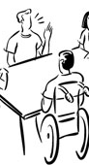
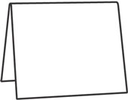
- Tell a story

- Complete aphasia tests

RECORDING

You will be:

- Audio taped

- Videotaped

Your responses will be written out.


Your name and address will not be recorded.

USE

The data from the study will go on an internet database called AphasiaBank.

Aphasia
Bank

Researchers and educators with a password will have access the data.

Aphasia
Bank


Researchers Educators

Researchers or educators may use the videos in classes or presentations about aphasia.
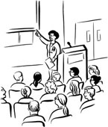

RISKS


There are NO known risks or discomforts associated with this study.


COMPENSATION
There is no monetary compensation for participating.


BENEFITS

You will help us improve our understanding of aphasia.



We can give you your test results for your files.

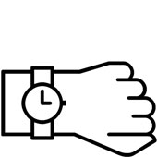
TIME

It will take 2 to 3 hours.


If you get tired, we can stop and finish another day.


RIGHTS

Your participation is voluntary.


?? Yes? No?
☑ ☒
??



You can stop at any time.


Questions about the study:

Contact

Gretchen Szabo
at

201-368-8585

or

gszabo@adleraphasiacenter.org

Questions about your rights:

Contact

IRB Chair
at

201-368-8585

CONSENT TO PARTICIPATE

The information on the previous pages has been explained to me



YES NO

I have been given a copy of this form.
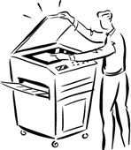
YES NO

I agree to participate in the research project.

YES NO

_______________________________ ________________
PARTICIPANT SIGNATURE DATE

___________________________________ __________________
WITNESS SIGNATURE DATE

