

Videofluoroscopic Swallow Study (VFSS)
Self-Learning Package
For Speech-Language Pathologists

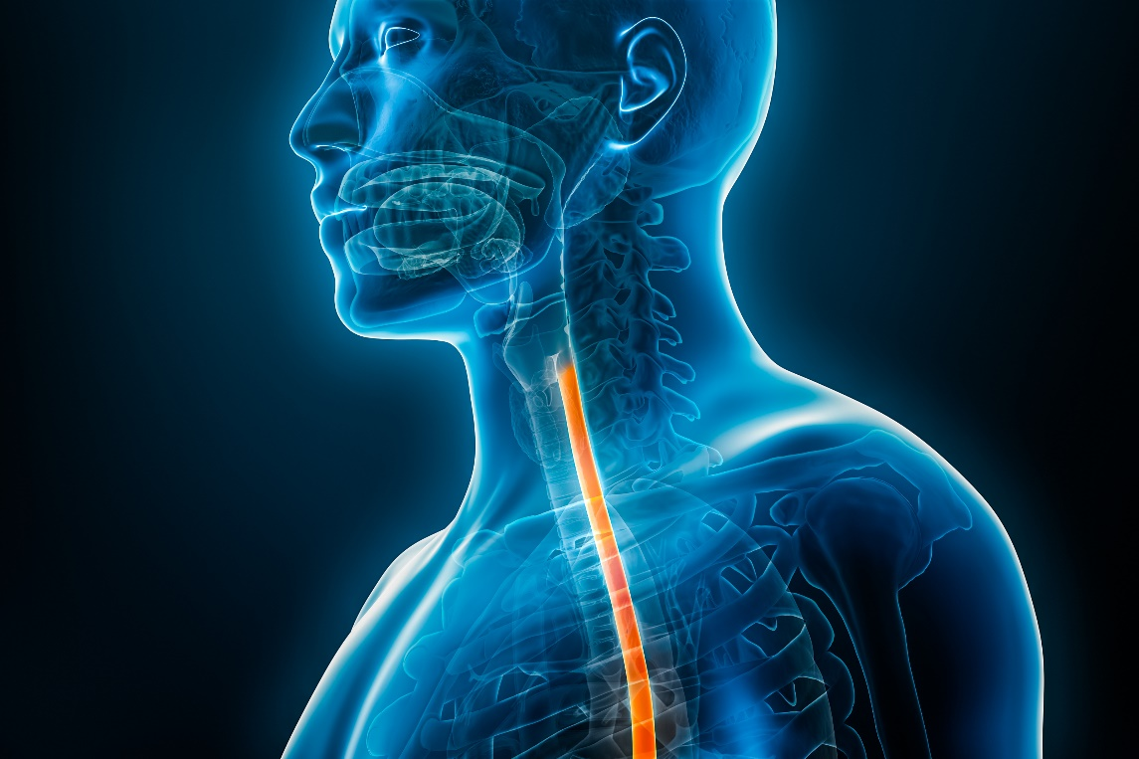

September 12, 2025
Table of Contents

Learning Objectives 5
Definitions 6
Fundamentals 7
1. Fluoroscopy fundamentals 7
1.1. The Fluoroscope 7
1.2. Radiation & Safety 9
1.3. Contrast media 10
1.4. Other fluoroscopic procedures 10
2. VFSS Fundamentals 11
2.1. Indications 11
2.2. Contraindications 11
2.3. Benefits and limitations 11
2.4 VFSS vs. FEES 12
2.5. Roles and responsibilities 12
Procedure 13
3. Best practice and standardization 13
3.1. Barium recipe 13
3.2. Equipment specifications 14
3.3. Scales and scoring 14
Assessment 16
4. Normal anatomy and physiology on VFSS 16
4.1. Aging swallow 16
4.2. Normal anatomy on VFSS 17
4.3. Normal events on VFSS 21
5. Abnormal findings on VFSS 23
5.1. Abnormal anatomy on VFSS 24
Cervical Spine Disorders 24
Cricopharyngeal Muscle Dysfunction (CPMD) 27
Diverticula 28
Tumors 29
Tracheostomy 30
Edema 31
5.2. Abnormal physiology on VFSS 31
Neurological Impairment 31
Head and Neck Cancer 34
Respiratory Impairment 36
6. Esophageal clearance 36
Management 37
7. Interventions during VFSS 37
7.1. Postural Techniques 37
7.2. Maneuvers 40
7.3. Environmental adaptations 40
8. Interventions following VFSS 40
8.1. Exercises 41
8.2 Exercise considerations 43
8.2. Outcome measures 44
Documentation 45
9. College Documentation Standards 45
10. IH Documentation Standards 45
11. Best Practice in Clinical Reporting of VFSS 45
References 46

Learning Objectives
After completing this learning package, the speech-language pathologist will be able to:
- Apply foundational knowledge from clinical swallow evaluations to VFSS
- Understand role of VFSS in clinical SLP practice, including benefits, limitations, indications, and contraindications
- Describe safety procedures required for VFSS
- Explain and apply best practices in VFSS
- Identify normal and abnormal anatomy and physiology on VFSS
- Select appropriate postures, maneuvers, or other interventions based on VFSS findings
- Comply with both college and IH documentation guidelines

After completing this self-learning package:
- Complete on-site hands-on training with your Certified Practice Supervisor

Definitions
ALS | Amyotrophic Lateral Sclerosis
Bolus accommodation | Adaptation of the swallow response based on sensory input; for example, a small sip of water will trigger a physiologically different swallow than a large piece of dense bread
Duration of LVC | Duration of complete closure of the laryngeal vestibule
Duration to LVC | Interval between first frame of hyoid burst and first frame of laryngovestibular closure (LVC)
LES | Lower esophageal sphincter
LVC | Laryngovestibular closure
Piecemeal deglutition | “Piecemealing”; partitioning off the oral bolus and propelling these “pieces” to the pharynx to be swallowed in smaller volumes
Pharyngeal transit time | Period of time between tongue filling oral cavity and bolus moving through the UES
Premature spillage | Spillage of the bolus in to the pharynx during oral preparation
Sarcopenia | Muscle loss
Swallow delay | A period of time exists between completion of lingual propulsion and hyoid burst
Swallow onset time | Measured interval between bolus entering pharynx and initial hyoid burst
UES | Upper esophageal spincter
Vallecular aggregation | Collection of bolus in the vallecula during oral transit, prior to swallow initiation

Fundamentals

Fluoroscopy fundamentals

The Fluoroscope
The fluoroscope uses ionizing radiation to make “x-ray movies” to visualize dynamic physiological processes such as swallowing. Ionizing radiation has enough energy to remove electrons from atoms, creating ions. This process can damage DNA and other cellular structures, which patients should be informed of before their fluoroscopy, and necessitates extra safety practices during the exam. Other imaging techniques that use ionizing radiation include CT scans and X-ray. MRI and ultrasound use non-ionizing radiation and have low biological risk to patients.
Read this article by Ingelby et al. (2023) for thorough overview: A Tutorial on Diagnostic Benefit and Radiation Risk in Videofluoroscopic Swallowing Studies | Dysphagia
Further information on radiation can be found on pages 28 – 36 of the IH Radiation Safety Manual: X-ray.
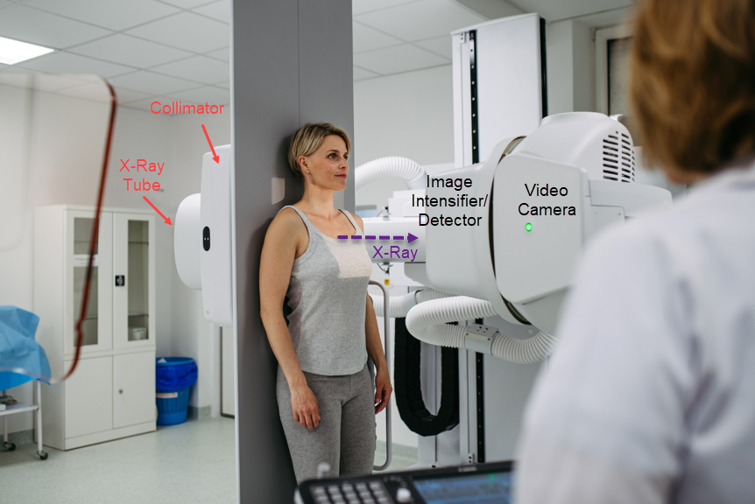
Figure 1: Woman Standing in Fluoroscope* (iStock- 2218807190)
*There are many different types of fluoroscopes, the one at your facility may look different than this picture
X-ray Generation
- An X-ray tube emits a continuous beam of X-rays.
- The collimator helps lock down a particular field of view, which is important for limiting X-ray exposure.
- These X-rays pass through the patient’s body.

X-ray Attenuation

- As X-rays pass through different tissues (bone, muscle, organs), they are absorbed (attenuated) to varying degrees.
- On an X-ray exposure (e.g., chest X-ray, barium swallow still):

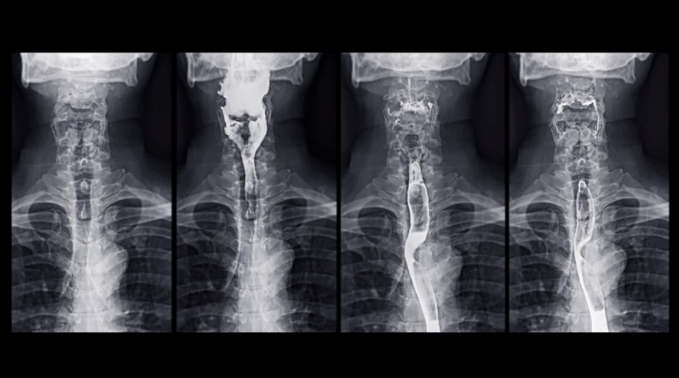
Figure 2: X-ray Exposure of Barium Swallow Study (iStock-1418661193)
  - Dense structures like bones, capillaries, or barium sulfate, absorb more X-rays and appear white.
  - Less dense structures allow more X-rays to pass through and appear darker.

- On live fluoroscopy the attenuation is altered in order to minimize radiation exposure, resulting in greyscale images rather than black and white.
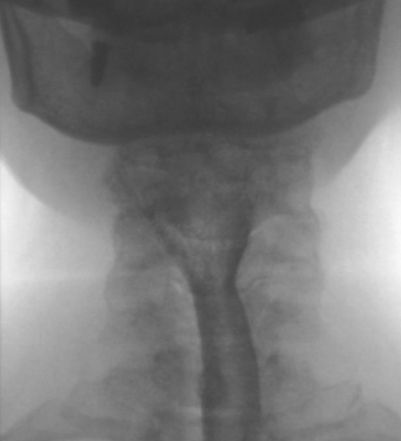
Figure 3: Live Fluoroscopy of Pharynx and Proximal Esophagus
Palmar, Padilla, & MacWhinney (2023)
Video #067
  - Dense structures like bones or barium sulfate appear more grey
  - Less dense structures like tissue or air will appear light grey
Image Display

- The X-ray photons are converted into a real-time video image.
- The image is displayed on a monitor, allowing clinicians to watch internal motion (e.g., swallowing)

Radiation & Safety
Review pages 3 – 17 of the IH Radiation Safety Manual: X-ray for information on radiation dose limits, personal protective equipment, and staff protection controls, and pages 36 & 37 for radiation safety principles.
Typical radiation dose of an adult VFSS is about 0.27 millisievert (mSv) (Bonilha et al., 2019), which is equivalent to about 32 days of background radiation. Annual dose limits for the general public are 1 mSv, for radiation workers is 20 mSv (average over 5 years) with a maximum if 50 mSv/year, and for pregnant workers 4 mSv.
Thyroid, breast, and bone marrow are the most radiosensitive. Cancer risk from a single VFSS is extremely low (e.g., 0.0011% for a 20-year-old male).
In addition to the ALARA (As Low As Reasonably Achievable) Principle for radiation exposure, all personnel involved in the VFSS procedure must comply with Health Canada's Safety Code 35 for shielding, filtration, and performance standards. The following are particularly relevant for SLPs performing VFSS.
- Except for those persons whose presence is essential, all persons must leave the room when the irradiation is carried out (A.2.1.2)
- Personnel must, at all times, keep as far away from the X-ray beam as practicable. Direct radiation exposure of personnel by the primary X-ray beam must never be allowed (A.2.1.3)
- All personnel must use available protective devices (A.2.1.5)
- All operators of X-ray equipment, together with personnel (i.e., nurses) who routinely participate in radiological procedures, and others likely to receive a radiation dose in excess of 1/20th of the dose limit to radiation workers [20 mSv]… must be declared radiation workers and monitor their radiation exposure with use of a personal dosimeter (A.2.1.6)
- Personal dosimeters must be worn and stored according to the recommendations of the dosimetry service provider. When a protective apron is worn, the personal dosimeter must be worn under the apron. If extremities are likely to be exposed to significantly higher doses, additional dosimeters should be worn at those locations of the body (A.2.1.7)
- Where there is a need to support weak patients or to support or comfort children, holding devices should be used. If parents, escorts or other personnel are called to assist, they must be provided with protective aprons and gloves, and be positioned so as to avoid the X-ray beam. No person should regularly perform these duties. (A.2.1.10)
- To protect patients from unnecessary radiation exposure, it is important to ensure that X-ray examinations are justified (A.3.0)
- To avoid the necessity of retakes, it is particularly important before taking a long series of images that a single preliminary image of the series should be taken to verify correctness of settings (A.3.2.2.5)

Contrast media
Barium sulfate is the standard contrast medium for VFSS. Barium absorbs more X-rays than the body, showing up as bright white on X-ray exposures (stills), or dark grey on live fluoroscopy.

Other fluoroscopic procedures
Fluoroscopy with barium is also commonly used for Esophagrams (also known as “Barium Swallows”) and Upper GI Series or Studies. While sometimes the terms “Barium Swallow” and “Upper GI Series” ares used interchangeably, they do refer to different exams. Here is how they compare to VFSS.
Feature | VFSS | Barium Swallow | Upper GI Series
Main Focus | Swallowing function | Structural and functional evaluation of the esophagus | Structural and functional evaluation of the esophagus, stomach, and duodenum
Performed by | SLP | Radiologist | Radiologist
Technique | Continuous fluoroscopy | Static and dynamic images | Series of timed, static images
Includes | Oral, pharyngeal, and esophageal phases | Focus on esophageal motility, may include pharyngeal phase | Mostly esophagus and beyond
Indications | Suspicion of oral, pharyngeal, or esophageal dysphagia | Suspicion of reflux, strictures, or dysmotility | Suspicion of reflux, ulcers, or gastric outlet obstruction

Unrelated to swallowing/upper GI assessments, fluoroscopy can also be used for dynamic assessment of genitourinary, musculoskeletal, cardiovascular, hepatobiliary, pancreatic, and reproductive systems, as well as interventional procedures such as central line or nasogastric tube placement.

VFSS Fundamentals

2.1. Indications
The VFSS is a powerful tool that could be recommended for the following reasons:
- Assess the oral, pharyngeal, or esophageal phase of swallowing to determine the presence/absence of dysphagia, aspiration, and/or appropriate rehabilitation strategies
- Inform a pre-treatment baseline
- Monitor swallowing changes (e.g., acute change, treatment effect, or degenerative)
- Support quality of life decision making
- Influence dysphagia or overall care management
- Failed swallow screening
- Known or possible altered anatomy that may affect swallow physiology

2.2. Contraindications
VFSS is contraindicated if the client is unable to tolerate the exam, participate in the exam, if the exam will cause harm to the client, or if the exam will not change the course of client care.
The VFSS should not be completed if any of the following conditions are present:
- Unstable medical condition
- Client is uncooperative
- Client is unable to maintain posture/be positioned safely
- Completion of the VFSS will not change management (e.g., client wants to eat at risk regardless of the results)
- Presence of tracheo-esophageal fistula
- No access to portable vent or any other respiratory support required
- NPO for reasons unrelated to swallow function
- Client is allergic to barium
- No clear rationale for VFSS

2.3. Benefits and limitations

What VFSS Can Do | What VFSS Can’t Do
- Assess oral, pharyngeal, and esophageal phases of swallowing  - Detect aspiration beyond the subglottic shelf  - Best appreciate swallow kinematics, including tongue base retraction and hyolaryngeal excursion  - View submucosal changes (e.g., osteophytes, cervical hardware) | - Extended examinations  - Test with “real” food and drink (e.g., not mixed with barium)

2.4 VFSS vs. FEES
Both VFSS and FEES are considered gold standard swallow assessments. Consider the following when deciding between these two instrumental exams.
- Equipment availability: if your client urgently requires an instrumental swallow assessment, consider selecting the tool that is most accessible.
- Client body habitus and mobility: VFSS can be more suited to clients who are independently mobile or can be easily transferred, as some fluoroscopy machines have size restrictions. FEES is easily transported and therefore would be indicated for clients with complex positioning needs or limited ability to transfer either due to critical illness or equipment needs (e.g., respiratory support).
- Suspected etiology of dysphagia: FEES allows for direct visualization of laryngeal and pharyngeal mucosa and more detailed appreciation of bolus path, aspiration, penetration, and residue. FEES may be best indicated if the SLP is suspicious of a lesion or mucosal anatomical changes (e.g., post-extubation), if voice changes accompany swallowing concerns, or if aspiration or secretion management is the primary concern. VFSS allows for better appreciation of swallow kinematics along the oro-pharyngeal-esophageal continuum, as well as direct visualization (rather than inferred function) of pharyngeal swallow gestures such as hyolaryngeal excursion and pharyngeal contraction. VFSS would be indicated if there was clinical suspicion of oral dysphagia or esophageal dysmotility as well as pharyngeal dysphagia.

2.5. Roles and responsibilities
Dysphagia is best managed with a multidisciplinary approach. Here are the relevant disciplines involved in VFSS. Those directly involved in the VFSS will depend on the complexity of the client.
Most Responsible Practitioner (MRP): recognize signs and symptoms of dysphagia and indications for VFSS, order VFSS, follow up after VFSS with additional workup, referrals, and medical management. The MRP may also review the VFSS findings with the client using the SLP report.
Nursing: may be invited to assist with complex or critical clients (e.g., monitoring vitals, managing medical equipment).
Occupational Therapist: may be invited to support VFSS in cases where seating or feeding requirements are complex (e.g., quadriplegia).
Radiologist: does not need to be present for the exam but should be available on-site to support the exam in the case of aberrant findings requiring diagnostics or advanced anatomical interpretation, report on any VFSS images or clips sent to PACS.
Radiology Technician: facilitate the VFSS by setting up the equipment and operating the fluoroscopy machine as directed by the SLP, assist with positioning client for VFSS when appropriate.
Respiratory Therapist: may be invited to support VFSS in cases where urgent suction may be required in the event of aspiration, or complex respiratory management required (e.g., tracheostomy, ventilator dependent).
Speech-Language Pathologist: identify appropriate candidates for VFSS, consult MRP and care team to facilitate VFSS referral, obtain informed consent from client for VFSS, direct the radiology technician regarding VFSS image framing , quality, and capture, determine when to discontinue an exam, adhere to radiation safety procedures, analyze and interpret the VFSS, document the VFSS, share findings of VFSS with the client, complete any indicated followup after the VFSS including communication within the continuum of care, providing recommendations, initiating swallow rehabilitation, completing any indicated referrals or recommendations for referrals, ensuring the referring provider aware of VFSS results.

Procedure

Best practice and standardization
Best practice in VFSS is to complete the exam the same way every time, inclusive of materials, protocols, and analysis framework. This principle ensures that results are consistent, can be interpreted consistently, and can be compared across time points and between clinicians. A collection of articles supporting standardization in VFSS can be found on the VARIBAR website.

Each VFSS should minimally include:
- Informed consent from the client before each exam and culturally appropriate practices where applicable.
- A thorough chart review and clinical interview if not already completed during clinical swallow evaluation. Case history should include medical history, relevant medications, and history of presenting illness, including onset, duration, signs and symptoms, weight history, respiratory history, reflux symptom history. The SLP may also choose to complete patient reported outcome measures (PROMs) before the exam to inform baseline or pre/post treatment effect.
- An oral mechanism exam.
- A scout image +/- a dry swallow to identify anatomical landmarks present before barium administration.
- Bolus trials with a standardized barium recipe, administered according to a core protocol, then followed by a customised set of stress tasks or probes.
- Unless limited by client mobility, trials completed in the lateral and antero-posterior projection, including an esophageal sweep.
- Review of findings or plan for review of findings with the client in a timely fashion.

Barium recipe
Using standardized, IDDSI compliant, low density barium recipes for every VFSS will ensure that results are accurate and reproducible.
Weight-to-volume ratio (w/v): the concentration of barium in a barium sulfate suspension; the thickness or density of the substance.
Best practice recommends a low-density barium (20-40% w/v) or at minimum <100% w/v. High density barium is designed for mucosal coating to better detect anatomical abnormalities (e.g., on Esophagrams or Upper GI Series). Using high density barium in VFSS may skew the results by falsely inflating residue scores and limiting extrapolation to regular foods, which are not as heavy or thick. Low-density barium is preferred as it most closely mimics regular food and drink without sacrificing visibility on fluoroscopy.
Review the following Barium Recipe Information from Steele Swallowing Lab to learn more.

Equipment specifications
Frame rate (fps): the number of images recorded or displayed per second.
Pulse rate (pps): the number of x-ray pulses emitted per second by the fluoroscope.
30 fps is the recommended frame rate for VFSS. This frame rate is optimized to capture presence of aspiration and manage client radiation exposure. The ability to use 30 fps may be dependent on type fluoroscopy machine. If 30 fps is not possible, use the highest frame rate available and ensure that the frame rate is included in documentation.
Work with your radiology technician to ensure your frame rate matches your pulse rate, and your image capture is optimized.
Ideal image framing:
Lateral view includes the lips, oral cavity, soft palate, nasopharynx, oropharynx, hypopharynx, larynx, and upper esophagus.
Antero-posterior initially focused on oral cavity, so palate forms the superior border of the image, and the vocal folds and tracheal column form the inferior border, field collimated bilaterally to the angles of the mandible.
The entire esophageal phase is visualized in the upright position if feasible.

Scales and scoring
Utilizing validated, evidence-based scales and scoring tools ensures that results are consistently described in the same language and can be easily compared between time points.

Patient reported outcome measures (PROMs) can be completed by the client throughout the course of assessment and intervention to measure change over time and can be easily integrated into VFSS procedure. Commonly used PROMs include:
- Reflux Symptom Index (RSI): use when there is clinical suspicion of gastroesophageal reflux disease (GERD) or laryngopharyngeal reflux disease (LPRD)
- Eating Assessment Tool (EAT-10): quick, 10 item screen that covers perceived psychosocial and health impacts of swallowing as well as swallow function, predictive of presence of pharyngeal residue (Golac et al., 2023)
- Sydney Swallow Questionnaire: use when a more detailed patient reported swallow profile is required; helpful when clients have difficulty describing their symptoms or symptom patterns
- Dysphagia Handicap Index (DHI): use to evaluate patient reported treatment efficacy related to quality of life measurements
- PILL-5 Screening Questionaire: use when clients have difficulty swallowing pills
- MD Anderson Dysphagia Inventory (MDADI): use with head and neck cancer population
- Swallowing Outcomes After Laryngectomy (SOAL): use with total laryngectomees
- Munich Dysphagia Test (Parkinson's Disease): use with clients with Parkinson’s disease

Within the VFSS, varying types of scales are available to describe single components of the swallow, or overall swallow physiology and severity. These scales can be based in subjective/perceptual information (e.g., observing mild vallecular residue), or objective/quantitative analysis (e.g., measuring vallecular residue and comparing to normative values to judge severity). Completion of pixel-based measurements is an emerging practice in speech-language pathology that requires advanced technology and software to implement.

No matter which scale is used, best practice is to report on a standard set of parameters with a standard interpretation method. Below are some examples of validates scales and their uses.

Scale | Type | Purpose | Learn More
Penetration Aspiration Scale (PAS) | Subjective, Ordinal (Rated from 1-8) | Rate level of airway invasion | Coyle (2017)  PAS Tutorial by Ianessa Humbert (3 min)
Eisenhuber Residue Scale (ERS) | Subjective, Ordinal (Rated from 1-3) | Rate pharyngeal retention relative to the height of the vallecular or pyriform sinus | Eisenhuber et al. (2002)
Bolus Residue Scale (BRS) | Subjective, Ordinal (Rated from 1-6) | Rate residue based on number of locations it occurs in the pharynx | Rommel et al. (2015)
Bolus Clearance Ratio (BCR) | Quantitative |  | Bolus Clearance Ratio (BCR) - YouTube
Dynamic Imaging Grade of Swallowing Toxicity (DIGEST) | Subjective, Ordinal (Rated from 0-4) | Compares ratings of swallow safety using PAS and swallow efficiency by rating residue to produce an overall dysphagia severity grade | *Only valid for Head and Neck Cancer and ALS patients  DIGEST Training Manual  Hutcheson et al. (2016)
Modified Barium Swallow Impairment Profile (MBSImP) | Subjective, Ordinal, 17 swallow components rated from 0-4 | Standardized training, protocol, approach, language, analysis, and reporting | MBSImP Website
Analysis of Swallow Physiology: Events, Kinematics, and Timing for use in Clinical practice (ASPEKT-C) | Objective, Quantitative | Standardized method to extract numerical data from VFSS, compare to normative values, and identify treatment targets | ASPEKT-C – Swallowing Rehabilitation Research Lab
Functional Oral Intake Scale (FOIS) | Ordinal (Rated from 1-7) | Tool to document change in functional oral intake of food and liquid | FOIS Scale  Crary et al. (2005)
Robust Esophageal Screening Tool (REST) | Screen (Pass/fail) | Evaluate esophageal clearance | Watts et al. (2021)

Assessment

Learners are encouraged to visit TalkBank, create free account and log in to view videos and case information associated with the images (Palmar, Padilla, & MacWhinney, 2023).

Normal anatomy and physiology on VFSS
Review the following video for a detailed overview of anatomy and physiology as seen in the lateral view on VFSS.
Anatomy & Physiology of Swallowing -- MBSImP Animations (9min MBSImP)

Aging swallow
Before reviewing “normal” anatomy and swallowing, the caveat of the aging swallow must be addressed. As we age, we experience muscle loss (sarcopenia) throughout our whole body, including the upper aerodigestive tract (Burkhead et al., 2007). This results in presbyphagia, an aged, yet still healthy swallow that can mimic some signs of oropharyngeal dysphagia.
In presbyphagia, we see reduced muscle bulk of the tongue, pharyngeal walls, and vocal folds, a wider pharyngeal space, and a greater distance between the hyoid and the larynx (larger and longer pharynx). This means that not only are the muscles weaker, but they have farther to move to contact other structures and generate pressure. As a result, the entire process of swallowing is less efficient due to slower onset of movement, decreased amplitude of movement, and increased transit times. Thus, presbyphagia could look like (Cook et al., 1994; Garant et al., 2022; de Lima Alvarenga et al., 2018; Fei et al., 2013; Leonard, Kendall, & McKenzie, 2004; Mulharen et al., 2018; Shaw et al., 1995):
- Delayed swallow onset (hyoid burst)
- Swallow initiated at the pyriform sinus
- Incomplete pharyngeal space obliteration
- Presence of residue/multiple swallows per bolus
- Increased oral and pharyngeal transit time
- Penetration of the laryngeal vestibule
- Preserved laryngeal sensitivity
- Decreased duration of UES opening
Presbyphagia should not have a functional impact on nutrition, hydration, or respiratory health. However, adults with presbyphagia are more vulnerable to sarcopenic dysphagia or disase-related dysphagia due to frailty and reduced functional reserve.

Normal anatomy on VFSS
Lateral Projection
Lateral projection is the most common in VFSS as it offers a continuous view of the oral, pharyngeal, and upper esophageal phase of swallowing. More specifically, lateral view allows direct visualization and assessment of the oral phase, lingual motion and transit, velopharyngeal closure, hyolaryngeal excursion, epiglottal deflection, pharyngeal stripping wave, laryngovestibular closure, bolus path to trachea (penetration/aspiration) or esophagus, UES function, and reflux. Residue is observed, though symmetry cannot be accurately determined as the right and left vallecular and pyriform sinuses overlap in this view, which can cause over-estimation of residue severity if not cross-referenced with another plane (Jones-Rastelli et al., 2024). Timing components of the swallow are best appreciated in the lateral projection. Key landmarks of the lateral projection are illustrated in the following two images.

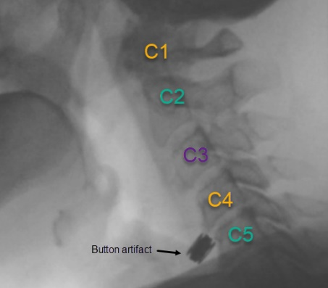
Figure 4: Cervical Vertebrae
Palmar, Padilla, & MacWhinney (2023)
Video # 070
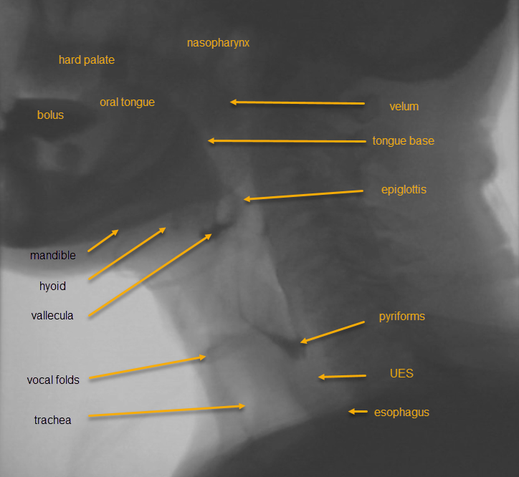
Figure 5: Anatomical Landmarks in the Lateral Projection
Palmar, Padilla, & MacWhinney (2023)
Video # 066
Additional landmarks:
Epiglottic petiole: where the base of the epiglottis meets the thyroid cartilage; the epiglottal root
Dorsal surface of epiglottis: back of the epiglottis, faces the posterior pharyngeal wall in the upright position
Laryngeal vestibule: the airspace above the vocal folds, bounded by the epiglottis, aryepiglottic folds, and arytenoid cartilages
Lateral channels: formed by the aryepiglottic folds medially and the pharyngeal walls laterally, the lateral channels funnel material around the laryngeal vestibule and into the pyriform sinus; visible as a line of barium connecting the vallecular and pyriform sinuses, as in the reference image above
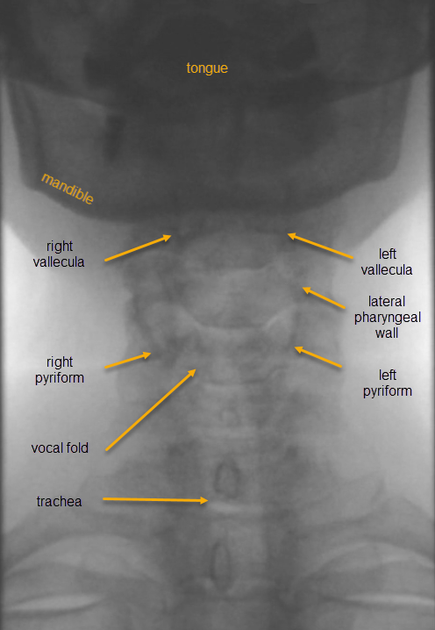

Antero-Posterior (AP) Projection
The AP projection allows the clinician to appreciate the symmetrical components of the pharyngeal swallow in more detail, such as mastication, pharyngeal contraction, vallecular or pyriform residue, and UES function. With an upward tilt of the chin, it can also provide a gross estimation of vocal fold function with the speech task “ee ee”. Completing an esophageal sweep is an essential component and strength of the AP view, enabling visualization of bolus flow to the level of the stomach. Due to the complex codependency of events on the swallow continuum, the esophagus, whenever possible, should be screened in every exam.

Figure 6: Anatomical Landmarks in the AP Projection
P Palmar, Padilla, & MacWhinney (2023)
Video # 067
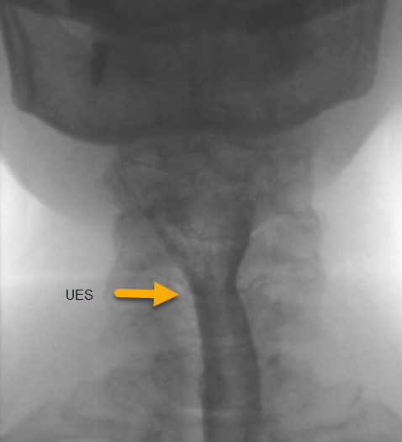
Figure 7: UES in the AP Projection
Palmar, Padilla, & MacWhinney (2023)
Video # 067

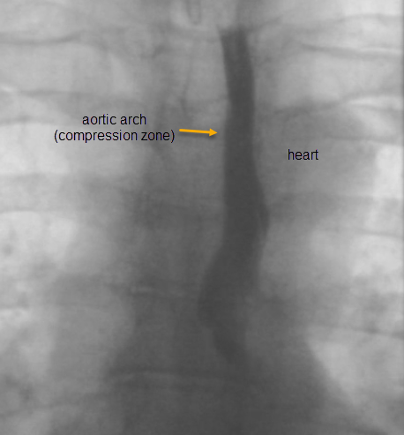
Figure 8: Esophagus in the AP Projection
Palmar, Padilla, & MacWhinney (2023)
Video # 067
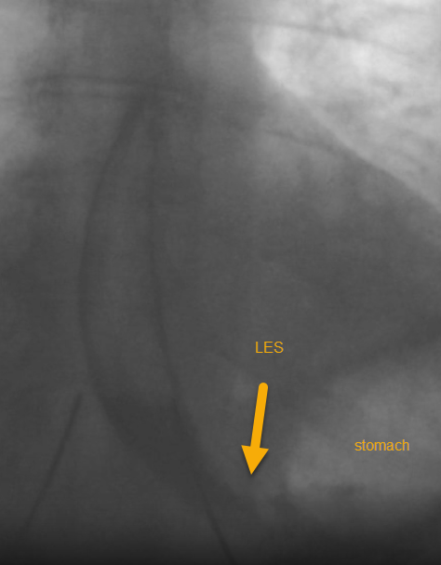
Figure 9: LES in the AP Projection
Palmar, Padilla, & MacWhinney (2023)
Video # 67

Oblique Projection
In the oblique projection, the client is rotated at a 30-45 degree angle. The oblique projection is not standard in a VFSS exam, but can instead be utilized to improve visualization of certain structures or pathologies when lateral or AP is insufficient. Oblique may be useful when:
- Key structures are obscured in the lateral view (e.g., by shoulders, surgical hardware, tracheostomy tube, bariatric patient)
- Bolus path through pharynx is unclear
- AP view is not possible
- Asymmetric impairment is present

Normal events on VFSS
Though swallowing is often taught in discrete phases, in reality swallowing occurs in a complex, interdependent cascade of events along the aerodigestive tract. Swallowing is a closed pressure system, and functional swallowing hinges on the ability to generate pressure by exerting force against the tail of the bolus (intrabolus pressure) and sealing all valves to direct it to the area of lowest pressure (the UES) at the right time.
Swallow events generally occur in the following sequence, noting that from a timing perspective there will be overlap in pharyngeal events, and individual variation in swallow sequencing is normal, even on the same bolus type (Molfenter et al., 2014) :
- Acquisition: jaw opens, lips/jaw assist to collect bolus and seal in oral cavity
- Manipulation / mastication: rotary jaw movement, lateral tongue movement, lip seal, cheek tension, soft palate contains posteriorly
- Collection: tongue collects the bolus and cradles it in the tongue body against the palate, with the lateral tongue margins elevated
- Propulsion: antero-posterior stripping motion of the tongue against the palate to propel the bolus toward the pharynx
- Swallow initiation: initial hyoid burst
- Nasopharyngeal closure: velar elevation / superior pharyngeal contraction to seal the nasopharynx
- Pharyngeal reconfiguration: onset of arytenoid movement towards the epiglottis, laryngeal elevation/pharyngeal shortening, tongue base retraction and hyolaryngeal excursion brings the epiglottis to horizontal position, pharyngeal stripping wave meets the tongue base, laryngovestibular closure culminating in the approximation of the arytenoid cartilage to the epiglottic petiole and pharyngeal contraction bringing the epiglottic tip to full inversion
- Relaxation / traction of the UES: tonic at rest, the brain sends the signal to the UES to relax and the traction forces of hyolaryngeal excursion open the sphincter to accept the bolus
- Pharyngeal stripping wave / lateral pharyngeal contraction completes, applying pressure to the bolus tail at the inverted epiglottis to propel the bolus through the UES
- Primary esophageal peristaltic wave triggered by pharyngeal swallow travels from UES to LES
When considering the range of normal on VFSS, it is important to consider the following:
- Preferential, social, and cultural behaviours of eating and drinking
- Age
- Bolus accommodation effects
- Most variable elements of swallowing, such as: mastication, swallow initiation, and hyoid displacement
- Most consistent elements of swallowing, such as: duration of UES opening
Normal Oral Events
- Piecmealing a bolus over 20mL in volume
- Premature spillage without laryngeal invasion
- Vallecular aggregation (Gandhi et al., 2024)
- Swallow initiation at level of pyriforms (that does not result in aspiration)

Normative Values
Event | Reference Norms | Influences | Source
Duration to LVC | - Thin liquids 95ms  - Ice chips 110ms  - Pudding 107ms | - Viscosity  - Age | Humbert et al. (2018)
Duration of LVC | - Thin liquids 603ms  - Ice chips 496ms  - Pudding 516ms | - Viscosity  - Age | Humbert et al. (2018)
LVC | - Complete 98% of the time  - Incomplete LVC rare but can occur | - Viscosity  - More likely to be incomplete on IDDSI 0, 1, or 2 | Steele et al. (2023)
Duration of UES opening | - 210 – 670ms | - Increased with age  - Longer with IDDSI levels 2 & 3  - Shorter with IDDSI levels 0 and 4  - Increased with volume | Ambrocio et al. (2024); Molfenter & Steele (2012)
Pharyngeal transit time | - 350-1190ms | - Viscosity  - Sex  - Age | Humbert et al. (2018); Molfenter & Steele (2012)
Penetration and Aspiration | - PAS 1 & 2, 97% of the time  - PAS 3, 4, 5 rare but can occur  - PAS >6 not normal | - Viscosity  - PAS 3, 4, & 5 may rarely occur  - Most likely to occur on IDDSI 0 | Steele et al. (2023)
Pharyngeal residue | - Rare  - May occur in small volumes | - Increased with age | Garand et al. (2022)
Esophageal transit | - Clearance less than 60s in the upright position and following a liquid wash

Abnormal Anatomy on VFSS
SLPs diagnose dysphagia. SLPs cannot diagnose any structural abnormalities seen on VFSS. When structural abnormalities are seen, it is recommended to call the radiologist at that time for definitive diagnostics. If the radiologist is unable to review, the SLP should describe, but not diagnose, the abnormality seen.
Further anatomical abnormalities and reference images can be found in this article from Abdominal Radiology: An update on pharyngeal assessment by the modified barium swallow

5.1 Cervical Spine Disorders
Understanding spinal anatomy is essential in the context of VFSS as spinal alignment and integrity can significantly influence swallowing physiology. The cervical spine plays a crucial role in head and neck posture, which affects bolus flow, airway protection, and visualization during imaging. This section provides an overview of common changes to the cervical spine and their implications on swallowing function.
Osteophytes
An osteophyte (or “bone spur”) is a bony growth that forms along the edges of bones, often in or near joints, caused by bone or ligament deterioration or diffuse idiopathic skeletal hyperotosis (DISH). Osteophytes can be asymptomatic, but dysphagia is most common with osteophytes at C3-5 (Choi et al., 2019).
Clinically, a person with an osteophyte might present with similar complaints as those with UES dysfunction or stricture, as the osteophyte narrows the pharynx and can be obstructive to bolus flow as well as alter the mechanics of pharyngeal force generating capacity. The osteophyte may also deflect bolus path into the airway or result in ulceration at point of pressure. Someone with a symptomatic osteophyte might describe multiple swallows, sensation of pharyngeal residue, globus sensation, improved swallowing with thinner/runnier textures, coughing with intake. Larger osteophytes (>10mm) tend to result in aspiration (Strasser et al., 2000), and osteophytes at C4-5, C5-6, and C6-7 are associated with globus sensation (Ko et al., 2012).
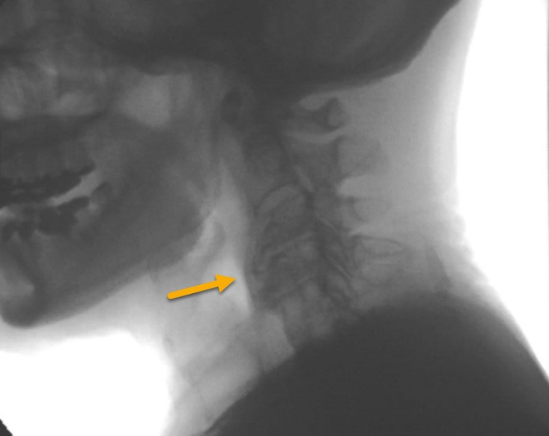
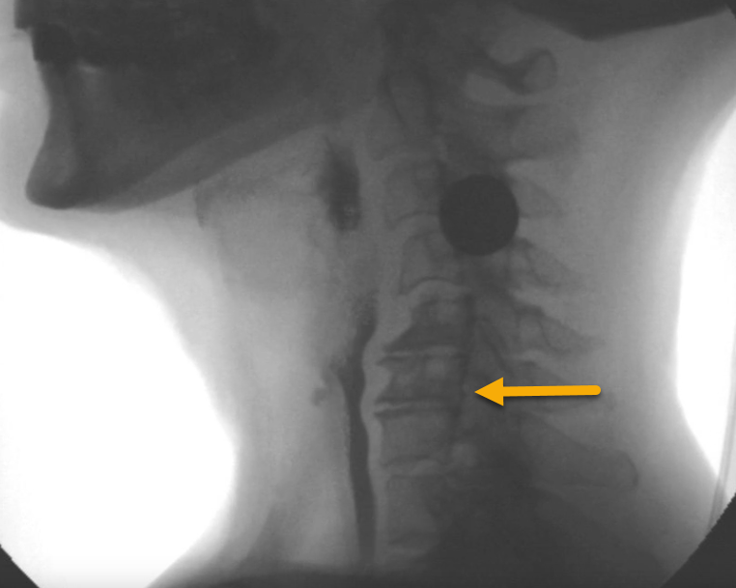
Figure 10: Osteophyte Bar C4-5
Figure 11: Osteophyte Bar C5-7

Video # 073 Video # 079
An undiagnosed osteophyte could be described as “a bony protrusion at the level of C5 effacing the pharyngeal lumen”.
Suspected DISH could be described as “a large bone plate on the anterior cervical spine concerning for DISH.”
Anterior Cervical Spine Surgery
83% of patients post cervical spine surgery will have dysphagia 1 week post-op (Min et al., 2016), 9.6 % of patients will have dysphagia at one month. Dysphagia post-operatively can be caused by edema or nerve injury, however presence of pre-operative dysphagia must also be considered (Frempong-Boadu et al., 2002; Jones-Rastelli et al., 2023).
The most common anterior cervical spine surgery seen by SLPs is Anterior Cervical Discectomy and Fusion (ACDF). It is a technique used to alleviate symptoms associated with spinal disease.

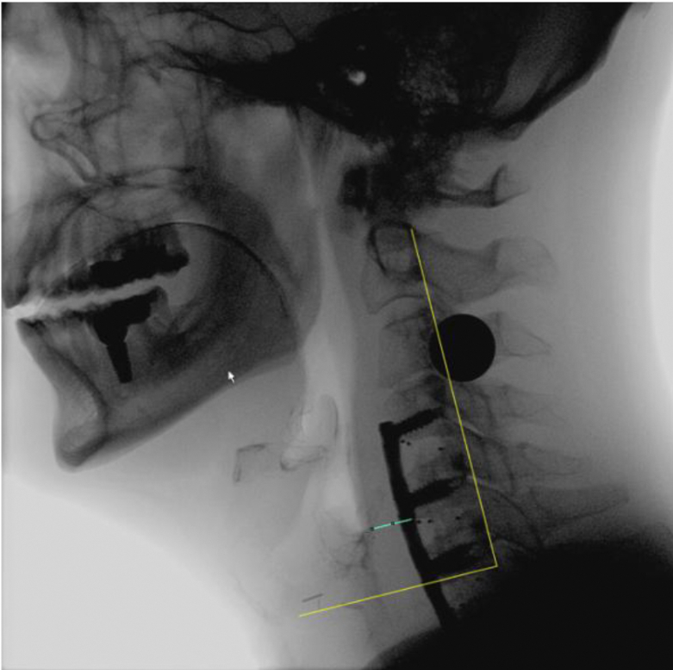
Figure 12: Prevertebral Edema Following ACDF
Jones-Rastelli et al. (2023)
On VFSS, a patient post-ADCF is likely to present with prevertebral edema, impaired pharyngeal constriction, reduced UES distension, and pharyngeal residue (Jones-Rastelli et al., 2023; Muss et al., 2017). The relationship between all factors is complex and interdependent, however it has been suggested that prevertebral edema may compensate for impaired pharyngeal constriction, leading to reduced pharyngeal residue in some cases (Jones-Rastelli et al., 2023).
Nerve injury can present as oral dysphagia (damage to glossopharyngeal and/or hypoglossal nerve at surgical site C3 and above), pharyngeal swallow impairment (damage to superior laryngeal nerve at surgical site C3-4), or laryngeal impairment/vocal fold paralysis (damage to recurrent laryngeal nerve at surgical site C6).
Cervical Bracing
Cervical bracing may be used to treat stable cervical injuries or post-operatively. Cervical collars (e.g., Aspen collar), cervicothoracic braces, and halo fixation are examples of cervical bracing. Cervical bracing restricts neck movement, which limits the use of postural modifications, and by altering physiology may increase pharyngeal residue and laryngeal penetration (Stambolis et al., 2003).
Degeneration
Over the course of a lifetime or after intervention, cervical spinal alignment can be altered. Pictured below is an example of degeneration of the cervical spine post radiation therapy. Kyphosis (excessive forward rounding) of the upper spine can be observed particularly in elderly patients. As with osteophytes and surgical procedures, changes to spinal alignment can impact coordination, pharyngeal contraction, and pressure generation, potentially resulting in pharyngeal residue and airway invasion.
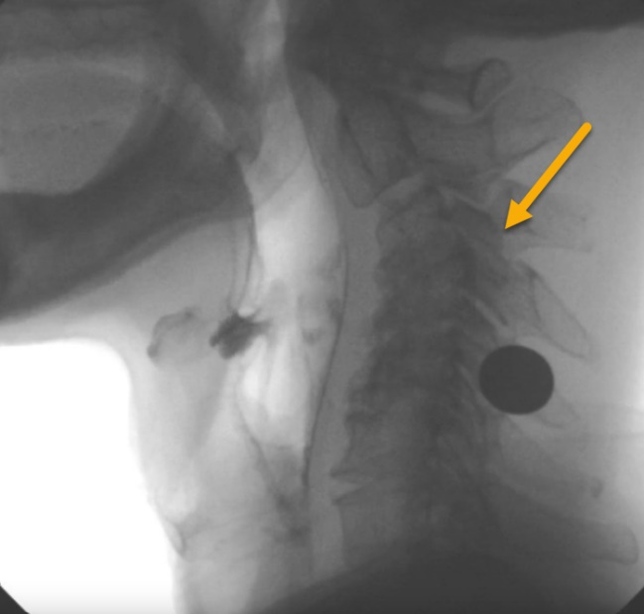
Figure 13: Degenerative Changes of the Cervical Spine
Palmar, Padilla, & MacWhinney (2023)
Video # 087

5.2 Cricopharyngeal Muscle Dysfunction (CPMD)
Sign up for this free webinar (60 min) from Dysphagia Café for a detailed overview of the cricopharyngeus and associated dysfunction, with VFSS examples.
CPMD generally refers to failure of the UES to open. It can either be intrinsic (hypertonic muscle fibers, impaired neural signal for relaxation) or extrinsic (tethered via web/stricture). CPMD can range from asymptomatic to severe. Gastroesophageal and/or laryngopharyngeal reflux is a common cause for intrinsic CPMD, as over time the UES tightens to create a stronger barrier between the esophagus and the pharynx to protect the laryngeal tissue from damage and airway invasion (Koutroumpakis & Richards, 2025). Hallmarks of CPMD are globus sensation, tightness during swallowing, and solid food dysphagia (Krekeler & Howell, 2024). Obstructive CPMD results in hesitant oral phase (maladaptive compensation), pharyngeal residue, and potential airway invasion.
Note that in some cases it can be difficult to differentiate between reduced duration of UES distention secondary to weak hyolaryngeal excursion/ insufficient intrabolus force and primary UES dysfunction. A thorough review of clinical history and strong foundation in anatomy and physiology will help make this distinction.
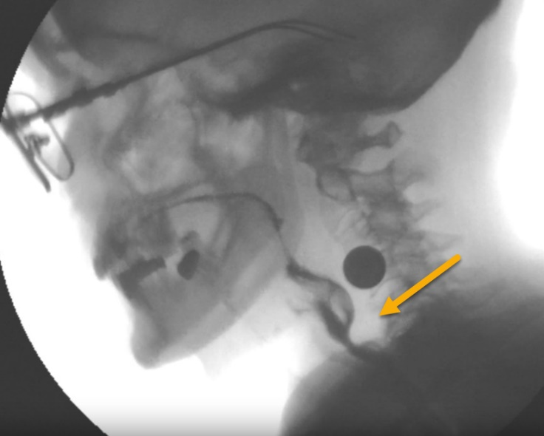
Figure 14: Cricopharyngeal Muscle Dysfunction
Palmar, Padilla, & MacWhinney (2023)
Video # 080

Cricopharyngeal Bar
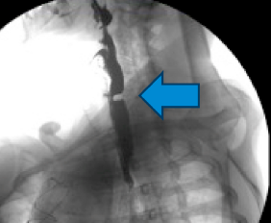
Figure 15: Cricopharyngeal Bar
Albeinz & Estremera-Arevalo (2024) p. 3
An undiagnosed CP bar could be described as “a shelf-like protrusion at the level of the cricopharyngeus concerning for a cricopharyngeal bar” or a “jutting phenomenon”.

Diverticula
Diverticula are outpouchings in the pharynx, larynx, or at the UES caused by herniation of mucosa through areas of weakness in the muscle fibers by way of pulsion or traction/shearing. CPMD or other downstream obstructions are common precipitants of pulsion diverticula, as the obstruction repetitively forces swallow pressure into these areas of weakness.
Zenker’s diverticula (ZD) are the most common, and are associated with clinical symptoms of solid dysphagia, regurgitation in medium and large diverticula, globus in small diverticula, and pharyngeal residue. ZD typically present in the 7th and 8th decades of life and can be treated surgically (Bergeron et al., 2013).
Pharyngoceles: lateral pharyngeal diverticula, usually between the pharyngeal constrictors, etiology can be pulsion or shearing
Zenker’s Diverticulum: “J” shaped in lateral view, posterior-inferior pulsion diverticula through Killian’s triangle, above the UES and below the inferior pharyngeal constrictor (Bergeron et al., 2013)
Killian-Jamieson Diverticulum: anterolateral diverticula below the cricopharyngeus through Killian-Jamieson space
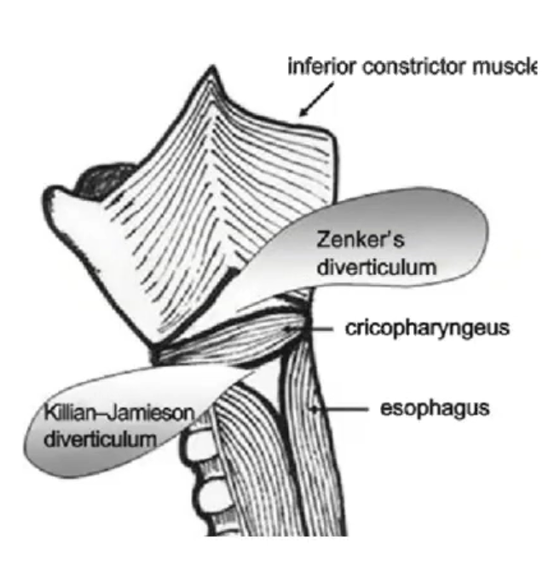
Figure 16: Zenker's vs KJ Diverticulum

5.3 Tumors
Head and neck tumors can profoundly disrupt swallowing by altering the anatomy and physiology of the oral cavity, pharynx, and larynx. Tumor growth may physically obstruct the bolus pathway, restrict movement of critical structures, or compress the nerves responsible for coordinating the swallow. Even before treatment begins, patients may experience reduced tongue mobility, impaired airway protection, or difficulty generating the pressure needed to propel food and liquid efficiently. Pain, mucosal changes, and edema can further limit function.
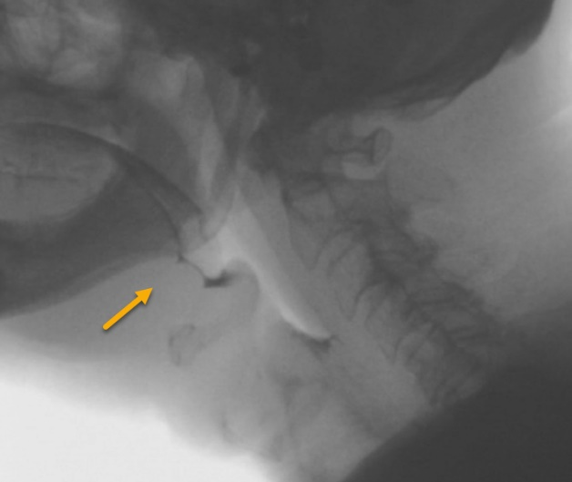
Figure 17: Tumor at Right Tongue Base
Palmar, Padilla, & MacWhinney (2023)
Video # 064
In the image shown, a mass in the vallecular space is visible, along with edema of the epiglottis, larynx, and pharynx. The case history of this individual is not specified, however it is suspected that they are undergoing radiation treatment. On VFSS, a pharyngeal or laryngeal mass such as this would impact space obliteration at the height of the swallow resulting in residue and/or aspiration.

Tracheostomy
Any SLP working with a tracheostomized person should have their Certificate H, and should refer to the Tracheostomy Self-Learning Resource for SLPs. Below are examples of how a tracheostomy tube appears on VFSS.
People with tracheostomies are at higher risk of silent aspiration due to reduced airflow across laryngeal and pharyngeal tissues (CITE?). Completing an instrumental assessment such as VFSS on tracheostomized patients is considered best practice prior to initiation of oral intake.
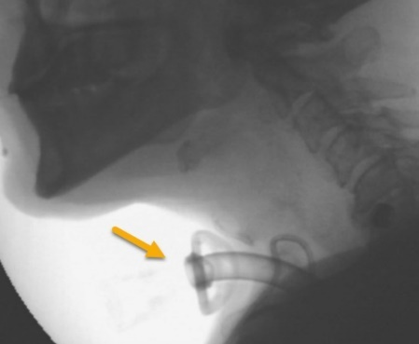
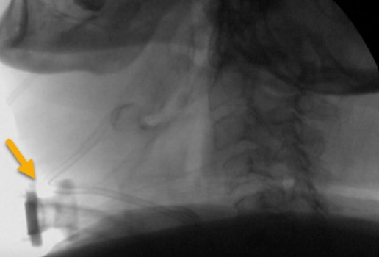

Figure 18: Tracheostomy on VFSS
Figure 19: Tracheostomy on VFSS
Video #081 Video # 068
Palmar, Padilla, & MacWhinney (2023)

5.4 Edema
Edema of the upper aerodigestive tract is a nonspecific finding and can occur following extubation or other head/neck trauma, radiation therapy, surgery, or post-extubation, or as a result infection, inflammation, or abscess. Prevertebral soft tissue thickness should measure <7mm, or half of the vertebral body width at C2, and <22mm or the width of the adjacent vertebral body at C7 (Zarzour et al., 2024).

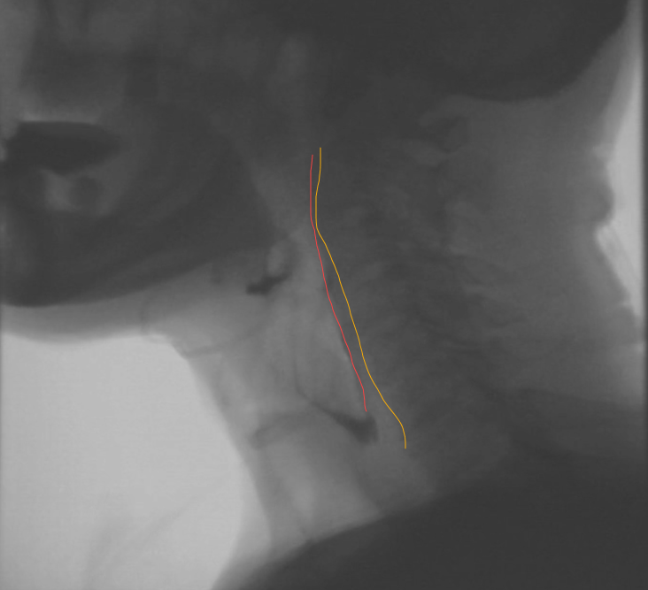
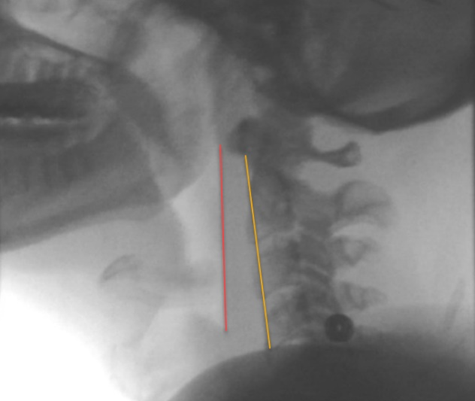
Figure 20: Normal Prevertebral Thickness
Figure 21: Prevertebral Edema
Video # 066 Video #077
Palmar, Padilla, & MacWhinney (2023)

Abnormal physiology on VFSS

6.1 Neurological Impairment
The oropharyngeal swallow can be significantly altered by neurological conditions impacting sensation, motor control, and cognition (Leonard et al., 2022). Refer to the chart below for common neurological diagnoses and their swallow profiles.

Condition | VFSS Findings | Clinical Implications | References
ALS | - Lingual weakness  - Average 2 swallows per bolus  - Presence of pharyngeal residue  - Worst efficiency with moderately thick liquids  - Highest frequency of penetration / aspiration with thin liquids  - Partial / incomplete LVC  - Incomplete LVC, increased time to LVC, and incomplete pharyngeal constriction are most common culprits of unsafe/ inefficient swallowing | - Reduced efficiency often an initial sign of bulbar onset ALS  - Reduced tongue strength, speed, and range are predictive of dysphagia  - Increased swallows per bolus impact meal endurance  - Thick liquids may be an appropriate intervention for those aspirating thin  - Enteral nutrition required to sustain life towards the end of disease course | Donohue et al. (2023); Gandhi et al. (2022); Gandhi et al. (2024); Waito et al. (2020)
Dementia | - Prolonged oral prep  - Reduced HLE  - Delay in LVC  - Higher PAS scores  - Early stage: delayed swallow onset and reduced lingual movement  - Moderate stage: difficulty with bolus preparation, reduced pharyngeal clearance, reduced UES opening, and aspiration | - Aspiration pneumonia is a common cause of mortality in individuals with dementia  - Dysphagia not influenced by presence of antipsychotic drugs in this population  - Enteral nutrition does not meaningfully prolong life for individuals with dementia and dysphagia | Humbert et al. (2010)  Miarons et al. (2018)
Oculo-pharyngeal Muscular Dystrophy (OPMD) | - Reduced pharyngeal constricton  - Reduced range and speed of hyoid movement | - Physiologic impairments may not result in functional impairments (e.g., unsafe or inefficient swallowing) | Waito et al. (2018)
Parkinson’s Disease (PD) | - Disorganized lingual movement / tongue pumping  - Inefficient swallow, residue, is common  - Airway invasion on thin liquids is common  - Airway invasion with solids is uncommon | - Lingual strength preserved at early stages  - Degree of overall rigidity correlates with degree of aspiration | Borders et al. (2023); Gandhi et al. (2022); Nakamori et al. (2024)
Progressive Supranuclear Palsy (PSP) | - As with PD, plus:  - More likely to have deeper airway invasion, more frequent vocal fold/subglottic residue and hypopharyngeal residue compared to PD | - Can be initially difficult to differentiate PD from PSP | Borders et al. (2023)
Stroke | - Motor and/or sensory impairments in the oral cavity or pharynx  - Lingual weakness  - Lip / cheek weakness  - Unilateral impairment | - Presentation variable depending on lesion location  - Poor lingual endurance correlated with presence of oral dysphagia  - Tongue weakness does not correlate with pharyngeal dysphagia  - Sensory impairments may be primary cause of altered physiology (e.g., poor bolus control, altered timing, reduced amplitude of movement) | Krekeler et al. (2025); Smaoui et al. (2022)
TBI | - Impulsive / altered eating behaviour  - Physiologic dysphagia may relate to frailty, Glasgow Coma Scale (GCS) score, intubation, or neurological damage | - GCS <15 associated with increased odds of dysphagia and mortality in geriatric trauma patients  - Aspiration associated with fall mechanism of injury | Auker et al. (2025)

6.2 Head and Neck Cancer
Head and neck cancer (HNC) can result in dysphagia at every stage of the disease. Dyphagia severity and functional impact depends on the tumor location, extent, and treatment, as well as the patient’s functional reserve and coping mechanisms.
Tumors are classified using the TNM staging system. An X means the target cannot be measured. A 0 means the target cannot be found. Numbers 1-4 represent progressively severe disease. Tumor size is associated with increased risk of dysphagia and aspiration (Pflug et al., 2025).
- T refers to the size and extent of the primary tumor (TX, T0, T1, T2, T3, T4)
- N refers to the number of nearby lymph nodes that have cancer (NX, N0, N1, N2, N3)
- M refers to whether the cancer has metastasized (MX, M0, M1)
Cancers can be treated surgically (resection), with radiation, or chemotherapy. Commonly a combination of therapies is used. Surgical treatment results in anatomical distortions that can impact swallowing (such as total laryngectomy or hemiglossectomy), whereas radiation and chemotherapy result in system toxicities that have both acute and late stage impacts on muscles, nerves, and mucosa involved in swallowing. Stage severity and treatment with chemo-radiation are associated with worse functional outcomes (Bhenthanabotla et al., 2025). Understanding the clinical course of HNC therapy informs timing and expectations of VFSS as well as treatment planning.
Radiation is measured in Grays (Gy), and is delivered in fractions over multiple sessions to achieve a total dose. Higher total dose is associated with increased chances of side effects including those related to dysphagia. For example, there is a 19% increase in the probability of dysphagia for every 10Gy beyond a dose of 55 Gy to the pharyngeal constrictors (Levendag et al., 2007).
Acute affects of radiation usually peak during the last week of radiation treatment and for 2 weeks afterward, and typically subside by 6 weeks post treatment. Acute side effects include pain, dermatitis, mucositis, soft tissue edema, and xerostomia. Late side-effects of radiation may begin >3 months to several years post radiation, and include radiation fibrosis syndrome (RFS), lymphedema, and lower motor neuron damage. Radiation therapy can also impact salivary glands and function, resulting in thick, ropey oral secretions or hyposalivation (xerostomia), which impacts the management and formation of an oral bolus (Malik et al., 2024).
RFS occurs when radiation therapy permanently and progressively disrupts normal cellular function, resulting in chronic edema and increased fibroblast production, leading to progressively stiffer, non-compliant tissues (Pflug et al., 2025). Poor epiglottic deflection (pictured below), reduced hyolaryngeal excursion, reduced pharyngeal constriction, and UES strictures are common manifestations of RFS in the pharynx. RFS in the oral cavity can result in trismus. Inclusion of the superior and middle pharyngeal constrictor or the geniohyoid muscle in the radiation field are associated with poorer swallowing outcomes (Starmer et al., 2015).
Penetration, aspiration, and pharyngeal residue are common videofluoroscopic findings in the HNC population, and in the event of RFS, these difficulties will progress over time and can be some of the most difficult to treat (Bhethanabotla et al., 2015). Note that pharyngeal residue is more common than penetration and aspiration (Pflug et al., 2025) and more common than oral residue (Pisegna et al., 2020). Pharyngeal residue in particular is associated with worse functional outcomes and quality of life ratings (Evangelista et al., 2020). It is also important to note that due to the multifactorial involvement of anatomical and physiological forces in UES distension, VFSS alone has shown to have insufficient specificity and sensitivity to identify UES strictures (Szczesniak et al., 2016).
Specific physiologic and functional impairments seen on VFSS post pharyngeal radiation may include:
- Impairments in LVC (reduced time to LVC, incomplete LVC, reduced duration of LVC) leading to penetration and/or aspiration (Barbon et al., 2020, Starmer et al., 2015)
- Penetration during the swallow leading to aspiration after the swallow (Pisegna et al., 2020)
- Longer pharyngeal transit times (Starmer et al., 2015)
- Weak pharyngeal constriction (Barbon et al., 2020; Bhethanabotla et al., 2025)
- Increased posterior pharyngeal wall thickness (Evangelista et al., 2020)
- Reduced UES distension (Bhethanabotla et al., 2025; Szczesniak et al., 2016)
- Pharyngeal residue (Pflug et al., 2025)
- Silent aspiration (Pflug et al., 2025)

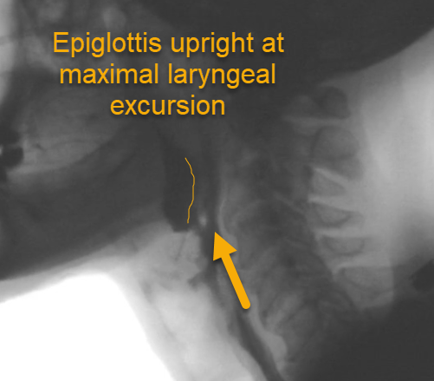
Figure 22: Fibrotic Epiglottis
Video #078
Palmar, Padilla, & MacWhinney (2023)
Specific physiologic and functional impairments seen on VFSS in the case of oral cancers may include:
- Difficulties with any or all aspects of oral prep including mastication, collection, and propulsion of the bolus
- Inadequate / impacted dentition
- Trismus
- Pharyngeal dysphagia if the geniohyoid and/or mylohoid impacted by surgery or radiation (Malik et al., 2024)

6.3 Respiratory Impairment
Individuals with respiratory diagnoses may experience alterations to their swallow as a result of disrupted coordination between breathing and swallowing, muscle weakness/reduced functional reserve relating to acute/critical or chronic disease, or respiratory interventions such as intubation and heated humidified high flow nasal cannula (HHHFNC).
On VFSS, individuals with stable COPD may demonstrate shorter LVC durations, longer swallow reaction times, and reduced pharyngeal constriction when compared to healthy normative values (Mancopes et al., 2020). Patients with acute respiratory distress syndrome (ARDS) may demonstrate increased pharyngeal transit time in a post-extubation setting (Brodsky et al., 2018).

Esophageal clearance

Foundational information on esophageal dysphagia can be found in this two part interview with Julie Huffman, on the Swallow Your Pride Podcast (60 min each).

033 – Julie Huffman M.A., CCC-SLP – Part 1: Esophageal Dysphagia: How Much Do You Really Know? - Swallow Your Pride Podcast
034 – Julie Huffman M.A., CCC-SLP – Part 2: Esophageal Dysphagia: How Much Do You Really Know? - Swallow Your Pride Podcast
Research has long supported the complex and interdependent relationship between the esophagus and pharynx, to the point that some would call the demarcation of the two phases at the UES arbitrary. Because swallowing is a sequential, pressure-driven system, changes in one one anatomical area (e.g., multiple swallows per bolus) can alter function in another (e.g., inhibited peristaltic movement in the esophagus). These impacts can be “downstream” (e.g., multiple swallows per bolus inhibits esophageal peristalsis) or “upstream” (e.g., poor motility resulting in hesitant swallow initiation or globus sensation).
Esophageal dysphagia is a common finding in individuals reporting difficulty swallowing and can be the primary cause of oropharyngeal symptoms, such as globus sensation, residue, or even aspiration (Reedy et al., 2021). Pathology originating in the esophagus such as reflux, strictures, or dysmotility can have upstream impacts on the oropharyngeal swallow, resulting in referred sensation of residue to the pharynx (also called globus sensation), pharyngeal retention due to increased esophageal pressure, and ruminating or hesitant oral phase and swallow initiation due to anticipated obstruction.
Whenever possible, a non-diagnostic visualization of the esophagus should be completed on VFSS in the AP view to identify any potential impacts on the swallow continuum. Use of multiple textures including solids and pills is important to reveal potential abnormalities in motility or anatomy (Madhavan et al., 2015; Watts et al., 2019).
Normal esophageal contour should be collapsed at rest, smooth and parallel (not tapered or hourglass shaped) as the bolus passes. Normal esophageal motility should look like smooth passage of the bolus from UES to LES. Natural pauses and mild retrograde flow may occur at natural anatomic pressure points of the aortic arch and LES. Motility is considered abnormal if the bolus has not completely cleared from the esophagus after 60 seconds.
SLPs cannot diagnose anatomical aberrances or motility disorders. SLPs can report descriptions of the anatomy seen, and delayed esophageal clearance concerning for a motility disorder. At clinical discretion, consider calling the radiologist to assess and report on findings, especially if this would avoid any patient need to come in for another exam.

Management

Interventions during VFSS

Based on physiologic findings on VFSS, the SLP should trial strategies and maneuevers that may improve swallow function. Strategies and maneuvers are not “one size fits all” and just like thickened liquids, the therapeutic benefit of a should be evaluated on imaging before being recommended to a client.

Postural Techniques

Posture | Indication | Physiologic Impact | Considerations | Reference
Supine | - Difficulties with AP transit  - Vallecular residue  - Aspiration due to delayed swallow trigger or reduced LVC | - Leverages gravity to encourage bolus transit to pharynx  - Encourages bolus flow down posterior pharyngeal wall, away from airway |  | Park et al. (2013)
Head Turn | - Unilateral pharyngeal weakness | - Directs bolus flow to strong side of the pharynx  - Increases pharyngeal clearance  - Slight increase in UES distension | - Compensates but does not rehabilitate; muscles of the weak side must be activated in order to improve function | Ashford et al. (2009)
Head Tilt | - Unilateral oral impairment | - Directs oral bolus towards strong side for preparation and management | - Cervical spine / postural integrity
Chin Tuck | - Poorly coordinated swallow | - Does not increase vallecular space  - No significant differences found in swallow onset based on head position  - At best, inconsistent reduction in aspiration | - Potential benefits at the individual level, variable findings in research  - May be difficult to perform for some with advanced disease/cervical spine disease  - Encourages bolus flow towards airway | Ashford et al. (2009); Forbes & Humbert (2021)
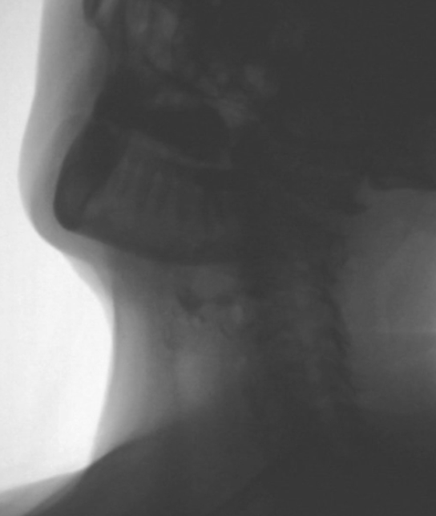
Figure 23: Head Turn on VFSS
Palmar, Padilla, & MacWhinney (2023)
Video # 067
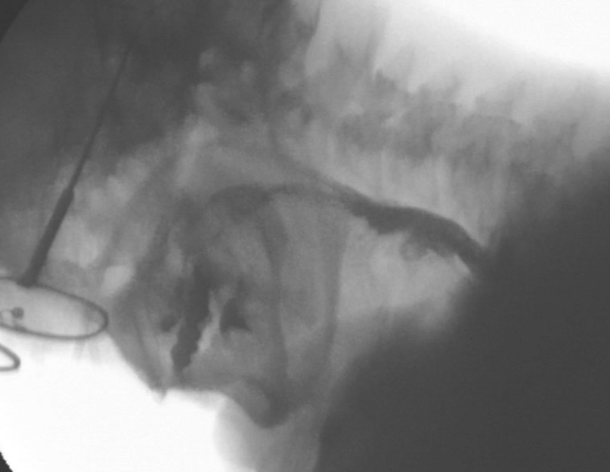
Figure 24: Chin Tuck on VFSS
Palmar, Padilla, & MacWhinney (2023)
Video #089

Maneuvers

Maneuver | Indication | Physiologic Impact | Considerations | Reference
Supra glottic swallow | - Decreased LVC  - Airway invasion  - Decreased anterior hyoid movement | - Voluntary laryngeal closure | - Difficult to learn  - Contraindicated for people with dysphagia post-stroke, with history of cardiac arrythmia, coronary artery disease, congestive heart failure, or uncontrolled hypertension | Ashford et al. (2009); Chaudhuri et al., (2002)
Super-supra glottic swallow | - Decreased LVC  - Airway invasion  - Decreased anterior hyoid movement | - Voluntary laryngeal closure with additional pressure |  | Ashford et al. (2009); Chaudhuri et al., (2002)
Throat Clear and Swallow | - Airway invasion | - Voluntary ejection and clearance of penetrated or aspirated material | - Commonly indicated for HNC | Ebersole et al. (2025);

Environmental adaptations
Alterations of diet texture, viscosity, and volume can be utilized to compensate for dysfunctional components of oropharyngeal swallow. Modified diet textures can be helpful stepping stones in returning to baseline swallow function. The SLP should be aware of the risks, benefits, and alternatives to modified diet textures and be prepared to discuss them with their client.

Interventions following VFSS
The VFSS can and should be used to design dysphagia rehabilitation plans. The ultimate goal of every dysphagia rehabilitation plan should be to restore swallow function to baseline, or in the case of progressive diseases, maintain baseline swallowing for as long as possible. In cases where baseline function cannot be achieved (e.g., due to severe radiation fibrosis syndrome), the SLP should then aim to achieve as close to baseline as possible using compensatory strategies or maneuvers during swallowing.

If, despite rehabilitation and application of compensatory strategies and maneuvers, the swallow does not improve to the point of baseline diet consumption, the SLP can then adapt their goals to support consumption of the least restrictive diet textures possible for their client.

Below are listed common postural techniques, maneuvers, and exercises that can be used as part of a comprehensive dysphagia rehabilitation program.


Exercises
Below is a summary of common exercises used in dysphagia rehabilitation. Keep in mind that some of these exercises may also qualify as a maneuver (e.g., effortful swallow, Mendelsohn).
Exercise | Indication | Physiologic Impact | Considerations | Reference
Chin Tuck Against Resistance | - Reduced hyolaryngeal excursion  - Physiologcially reduced UES distension | - Increased activation of the suprahyoid muscles  - Potential to reduce airway invasion | - Strong evidence base  - More selectively targets the suprahyoid muscles than the Shaker  - Recommended over the Shaker when possible | Lee et al. (2025); Park & Hwang (2021)
Shaker | - Reduced hyolaryngeal excursion  - Physiologically reduced UES distension | - Increased activation of the suprahyoid muscles  - Potential to reduce airway invasion | - Increased (unwanted) sternocleidomastoid activation  - Limited exercise progression | Lee et al. (2025); Park & Hwang (2021)
RMST | - Respiratory weakness | - Increased expiratory driving pressure for cough  - Potential effects on suprahyoid muscle recruitment  - May reduce aspiration via redirective cough  - Tonic activation of pharyngeal muscles to maintain airway patency | - RMST engages the suprahyoid muscles but evidence is not yet convincing on impact on swallow function  - Preliminary evidence exists for RMST and the maintenance of swallow function in neurodegenerative diseases | Burkhead et al. (2007); Lee et al. (2025); Mancopes et al. (2020)
Oral Resistance Training | - Anterior spillage  - Pocketing  - Oral residue  - Oral motor weakness | - Increased strength and pressure exerted by lip, tongue, jaw | - Non-swallowing task may have reduced transference to swallow function | Smaoui et al. (2020)
Masako | - Pharyngeal residue | - Increased oral and pharyngeal pressure  - Increased suprahyoid muscle strength and thickness  - Increased superior pharyngeal constrictor movement | - Anterior dentition required  - Limited exercise progression | Soyler et al. (2025); Yasaroglu et al. (2024)
Effortful Swallow | - Decreased laryngeal excursion  - Pharyngeal residue | - Increased oral and pharyngeal pressure  - Increased suprahyoid muscle strength and thickness  - Increased muscular activation of the pharyngeal constrictors and base of tongue | - Limited exercise progression with dry swallows  - Can introduce high viscosity bolus to progress resistance  - Preliminary evidence to support swallowing against kinesiology tape to increase resistance | Balou et al. (2019); Burkhead et al., (2007); Kim & Park (2024); Soyler et al. (2025)
Effortful Pitch Glide | - Reduced hyolaryngeal excursion  - Pharygeal residue | - Increased pharyngeal shortening and constriction |  | Balou et al. (2019)
Mouth Open Swallow Maneuver | - Reduced hyolaryngeal excursion | - Jaw opening lowers hyoid/laryngeal complex at swallow onset  - More vertical hyoid movement than Masako  - More vertical laryngeal movement than Mendelsohn and Masako | - Ability to tolerate 10mm wedge between molars (6 wooden tongue depressors taped together)  - Preliminary, but solid evidence to support this new exercise | Yasaroglu et al. (2024)
McNeill Dysphagia Therapy | - Moderate-severe pharyngeal dysphagia | - Intensive swallow-based therapy  - Increased recruitment of Type II muscle fibers | - Strong evidence that this approach reduces dysphagia severity, reduces aspiration, and supports earlier return to oral diet  - Intensive time investment  - Financial investment and certification required | Carnaby et al. (2020)
Mendelsohn | - Reduced hyolaryngeal excursion  - Pyriform sinus residue | - Voluntary prolongation of hyolaryngeal elevation and UES opening | - Difficult to perform

8.2 Exercise considerations
Unfortunately, there is no consensus in the literature or among SLPs regardging optimal dosage or programming for dysphagia rehabilitation (Burkhead Morgan, 2017). Therefore, “the goal of clinical practice is to use the scientific literature to establish reasonable physiological rationales as starting points, with the important and ultimate goal of narrowing and specifying decisions to suit each patient’s needs” (Forbes & Humbert, 2021, p. 1056).
With respect to dysphagia rehabilitation, we must rely on understanding of oropharyngeal musclulature and composition, and borrow what principles we can from exercise science and research on skeletal limb muscle. The following article by Burkead, Sapienza, and Rosenbek (2007) provides a concise review of what SLPs need to know about Type I and Type II muscle fibers, how they respond to strength training, and how this applies to swallowing exercises.
Strength-Training Exercise in Dysphagia Rehabilitation: Principles, Procedures, and Directions for Future Research | Dysphagia (open access)
In summary, when developing a dysphagia rehabilitation program, the SLP must consider the following principles of exercise science (Burkhead et al., 2007):
- Intensity: load, volume, and duration of the exercise stimulus
- Specificity: how closely the exercise task corresponds with the targeted outcome
- Transference: isolated strength training regimens that incorporate progressive resistance have been shown to transfer to improved performance in functional activities
Current review of the dysaphagia rehabilitation literature suggest that the most effectively designed dysphagia rehabilitation programs are:
- High intensity, 100 – 330 swallows per session (Balou et al., 2019; Lee et al., 2025)
- Minimum of 5 weeks long to achieve hypertrophy (Balou et al., 2019; Burkhead et al., 2007)
- Using progressive overload via training devices, perceived effort ratings (to the point of fatigue), or bolus viscosity (Burkhead et al., 2007)
- Comprised of both isolated muscle strength training and task-specific swallow practice (Burkhead et al., 2007)
- Incorporating a once weekly maintenance program after high intensity treatment completed (Burkhead et al., 2007)
For example, a high-intensity (330 swallow per session) 8 week program of 20 efforful swallows, 20 Mendelsohns, 20 Masakos, 20 super-supraglottic swallows, 20 Shakers, and 10 effortful pitch glides showed significant improvement in initiation of pharyngeal swallow, laryngeal elevation, and pharyngeal residue (Balou et al., 2019).
Another study demonstrated statistically better recovery in swallow function and physiology in head and neck cancer patients using twice daily sessions over a period of 4 weeks that included range of motion exercises, isometric strengthening exercises, and swallowing function exercises (Tsou et al., 2025).

Outcome measures
In order to evaluate the effectiveness of a dysphagia rehabilitation program, the SLP needs a way to measure change over time. The reader is referred to section 3.3 of this learning resource for an overview of available client reported and functional scales that can be used for this purpose.

Documentation

College Documentation Standards
Review Clinical Practice Guideline 04: Documentation and Records Management

IH Documentation Standards

Read Section 4.8 of IH Clinical Documentation Standards

Best Practice in Clinical Reporting of VFSS

Technical components that should be included in VFSS report are:

- Barium concentration
- Frame rate
- Patient positioning
- Projections
- Specific area covered by fluoroscope
- Compensatory strategies and rehabilitative techniques trialed
- Type, consistency, and volume of contrast
- Manner of presentation
- Number of presentations
- Any adverse events

Swallowing components that should be included in VFSS report are:

- Symptoms observed
- Details of aspiration
- Hypothesized pathophysiology
- Dysphagia severity rating
- Prognostic statement
- Recommendations
- Referral to other clinicians
- Measureable goals
- Frequency and projected duration of treatment
- Patient education and their response to education

See:
American Speech-Language-Hearing Association (2020)
Martin-Harris et al. (2021)
Scharitzer et al. (2025)
Steele Swallowing Lab (2021)
Speech-Language and Audiology Canada (2022)

References

Albeinz, E., & Estremera-Arevalo, F. (2024). Cricopharyngeal achalasia and upper oesophageal endoscopic myotomy. Best Practice & Research Clinical Gastroenterology, 71: 101937. doi: 10.1016/j.bpg.2024.101937.
Ambrocio, K.R., Ramsey, R., O'Rourke, A., Beall, J., & Garand, K.L. (2024). Normal variations in upper esophageal function during deglutition: a secondary analysis of videofluoroscopic data. Laryngoscope, 134(5): 2306-15. doi: 10.1002/lary.31173.
American Speech-Language-Hearing Association (2020). Summary of the clinical practice guideline. New Zealand Speech-language Therapy Clinical Practice Guideline on Videofluoroscopic Swallowing Study (VFSS)
Ashford, J., McCabe, D., Wheeler-Hegland, K., Frymark, T., Mullen, R., Musson, N., Schooling, T., & Smith Hammond, C. (2009). Evidence-based systematic review: oropharyngeal dysphagia behavioral treatments. Part III - impact of dysphagia treatments on populations with neurological disorders. Journal of Rehabilitation Research and Development, 46(2): 195-204. doi: 10.1682/JRRD.2008.08.0091
Auker, B.R., Reichert, J.M., Stone, X.A., Filippone, I.L., LaRosa, S.K., Perea, L.L., & Bradburn, E.H. (2025). Incidence of aspiration and dysphagia in geriatric trauma patients. The American Surgeon, 91(8): 1244-50. doi: 10.1177/0003138251350995
Balou, M., Herzberg, E.G., Kamelhar, D., & Molfenter, S.M. (2019). An intensive swallowing exercise protocol for improving swallowing physiology in older adults with radiographically confirmed dysphagia. Clinical Interventions in Aging, 14: 283-8. doi: 10.2147/CIA.S194723.
Barbon, C.E., Chepeha, D.B., Hope, A.J., Peladeau-Pigeon, M., Waito, A.A., & Steele, C.M. (2020). Mechanisms of impaired swallowing on thin liquids following radiation treatment for oropharyngeal cancer. Journal of Speech, Language, and, Hearing Research, 63: 2870-79. doi: 10.1044/2020_JSLHR-19-00220.
Bergeron, J.L., Long, J.L., & Chhetri, D.K. (2013). Dysphagia characteristics in zenker's diverticulum. Otolaryngology-Head and Neck Surgery, 148(2): 223-8. doi: 10.1177/0194599812465726.
Bhethanabotla, R.M., Gulati, A., Khalsa, I.K., Evans, C., Perrin, C.E., Lappin, J.L., Kidane, J., ... & Ma, Y. (2025). Swallowing function outcomes in head and neck cancer survivors followed by a long-term dysphagia surveillance protocol. Head and Neck, 0: 1-11. doi: 10.1002/hed.28166.
Borders, J.C., Sevitz, J.S., Curtis, J.A., Vanegas-Arroyave, N., & Troche, M. (2023). Quantifying impairments in swallowing safety and efficiency in progressive supranuclear palsy and pakinson's disease. Dysphagia, 38: 1342-52. doi: 10.1007/s00455-023-10560-7.
Brodsky, M.B., De, I., Chilukuri, K., Huang, M., Palmer, J.B., & Needham, D.M. (2018). Coordination of pharyngeal and laryngeal swallowing events during single liquid swallows after oral endotracheal intubation for patients with acute respiratory distress syndrome. Dysphagia, 33(6): 768-77. doi: 10.1007/s00455-018-9901-z.
Burkhead, L.M., Sapienza, C.M., & Rosenbek, J.C. (2007). Strength-training exercise in dysphagia rehabilitation: principles, procedures, and directions for future research. Dysphagia, 22: 251-65. doi: 10.1007/s00455-006-9074-z.
Carnaby, G.D., LaGorio, L., Silliman, S., & Crary, M. (2020). Exercise-based swallowing intervention (McNeill dysphagia therapy) with adjunctive NMES to treat dysphagia post-stroke: a double blind placebo-controlled trial. Journal of Oral Rehabilitation, 47(4): 501-10. doi: 10.111/joor.12928.
Chaudhuri, G., Hildner, C.D., Brady, S., Hutchins, B., Aliga, N., & Abadilla, E. (2002). Cardiovascular effects of the supraglottic and super-supraglottic swallowing maneuvers in stroke patients with dysphagia. Dysphagia, 17: 19-23. doi: 10.1007/s00455-001-0097-1.
Choi, H.E., Jo, G.Y., Kim, W.J., Do, H.K., Kwon, J.K., & Park, S.H. (2019). Characteristics and clinical course of dysphagia caused by anterior cervical osteophyte. Annals of Rehabilitation Medicine, 43(1): 27-37. Doi: 10.5535/arm.2019.43.1.27
Cook, I.J., Weltman, M.D., Wallace, K., Shaw, D.W., McKay, E., Smart, R.C., & Butler, S.P. (1994). Influence of aging on oral-pharyngeal bolus transit and clearance during swallowing: scintigraphic study. American Journal of Physiology, 266(6 Pt 1): G972-7. doi: 10.1152/ajpgi.1994.266.6.G972.
Coyle, J. (2017). Scaling the swallow: the penetration-aspiration scale quantifies how – and where – a patient’s swallow goes awry. The ASHA Leader, 22(5): 36-8. doi: 10.1044/leader.OTP.22052017.36
Crary, M.A., Carnaby Mann, G.D., & Groher, M.E. (2005). Initial psychometric assessment of a functional oral intake scale for dysphagia in stroke patients. Archives of Physical Medicine and Rehabilitation, 86(8): 1516-20. doi: 10.1016/j.apmr.2004.11.049.
de Lima Alvarenga, E., Piovesan Dall'Oglio, G., Zuiki Murano, E., & Abrahao, M. (2018). Continuum theory: presbyphagia to dysphagia? Functional assessment of swallowing in the elderly. European Archives of Otolaryngology, 275: 443-49. doi: 10.1007/s00405-017-4801-7.
Donohue, C., Robison, R., Steele, C.M., Wymer, J.P., & Plowman, E.K. (2023). Profiling number of swallows per bolus and residue in individuals with amyotrophic lateral sclerosis. Journal of Speech, Language, and Hearing Research, 66:3763-72.
Ebersole, B.M., Chapman, J., Warneke, C.L., Buoy, S., Tang, X., McMillan, H., Aldridge, E., ...& Hutcheson, K. (2025). Compensatory swallowing strategies recommended in oncology practice: practice patterns and relationship to dynamic imaging grade of swallowing toxicity (DIGEST) grades. Dysphagia, 40: 998-1007. doi: 10.1007/s00455-024-10799-8.
Eisenhuber, E., Schima, W., Schober, E., Pokieser, P., Stadler, A., Scharitzer, M., & Oschatz, E. (2002). Videofluoroscopic assessment of patients with dysphagia: pharyngeal retention is a predictive factor for aspiration. American Journal of Radiology, 178: 393-8.
Evangelista, L.M., Bayoumi, A., Dyer, B.A., Shukla, R.P., Rao, S.D., & Belafsky, P.C. (2020). The relationship between posterior pharyngeal wall thickness and swallowing function after radiation therapy. Acta Oto-Laryngologica, 140(8): 685-8. doi: 10.1080/00016489.2020.1752933.
Fei, T., Cliffe Polacco, R., Hori, S.E., Molfenter, S., Peladeau-Pigeon, M., Tsang, C., & Steele, C.M. (2013). Age-related differences in tongue-palate pressures for strength and swallowing tasks. Dysphagia, 28(4):575-81. doi:10.1007/s00455-013-9469-6.
Forbes, J., & Humbert, I. (2021). Impact of the chin-down posture on temporal measures of patients with dysphagia: a pilot study. American Journal of Speech-Language Pathology, 30: 1049-60. doi: 10.1044/2021_AJSLP-19-00223.
Frempong-Boadu, A., Houten, J.K., Osborn, B., Opulencia, J., Kells, L., Guida, D.D., & Le Roux, P.D. (2002). Swallowing and speech dysfunction in patients undergoing anterior cervical discectomy and fusion: a prospective, objective preoperative and postoperative assessment. Journal of Spinal Disorders and Techniques, 15(5): 362-8. doi: 10.1097/00024720-200210000-00004.
Gandhi, P., Barrett, E., Mancopes, R., Peladeau-Pigeon, M., Panes, V., Simmons, M.M., & Steele, C.M. (2024). A preliminary study of vallecular bolus aggregation in healthy swallowing of solid food boluses. Journal of Speech, Language, and Hearing Research, 67: 2077-85. doi: 10.1044/2024_JSLHR-24-00066.
Gandhi, P., Plowman, E., & Steele, C.M. (2022). Comparison of lingual pressure generation in parkinson disease, amyotrophic lateral sclerosis, and healthy aging. American Journal of Speech-Language Pathology, 31: 1845-53. doi: 10.1044/2022_AJSLP-21-00385.
Gandhi, P., Waito, A.A., Peladeau-Pigeion, M., Plowman, E.K., & Steele, C.M. (2024). How do quantitative videofluoroscopy measures differ between people with amyotrophic lateral sclerosis and age-matched healthy adults? Journal of Speech, Language, and Hearing Research, 67: 2512-32. doi: 10.1044/2024_JSLHR-24-00106.
Golac, H., Atalik, G., Gulacti, A., Sansal, E., Ceylan, B.T., Aydinli, F.E., & Yilmaz, M. (2023). The discriminant ability of the eating assessment tool-10 questionnaire to detect residue and aspiration in patients with mixed etiology of dysphagia. Laryngology, 280: 3757-63. doi: 10.1007/s00405-023-07987-x.
Garand, K.F., Grissett, A., Mason Corbett, M., Molfenter, S., Herzberg, E.G., Joe Kim, H., & Choi, D. (2022). Quantifying pharyngeal residue across the adult life span: normative values by age, gender, and swallow task. Journal of Speech, Language, and Hearing Research, 66: 820-31.
Humbert, I., McLaren, D.G., Kosmatka, K., Fitzgerald, M., Johnson, S., Porcaro, E., Kays, S., ... & Robbins, J. (2010). Early deficits in cortical control of swallowing in alzheimer's disease. Journal of Alzheimer's Disease, 19(4): 1185-97. doi: 10.3233/JAD-2010-1316.
Humbert, I., et al. (2018). Swallowing kinematic differences across frozen, mixed, and ultrathin liquids boluses in healthy adults: age, sex, and normal variability. Journal of Speech, Language, and Hearing Research, 61: 1544-59.

Hutcheson, K.A., Barrow, M.P., Barringer, D.A., Knott, J.K., Lin, H.Y., Weber, R.S., Fuller, C.D., … & Lewin, J.S. (2016). Dynamic imaging grade of swallowing toxicity (DIGEST): scale development and validation. Cancer, 123(1):62-70. doi: 10.1002/cncr.30283.
Ingleby, H.R., Bonilha, H.S., & Steele, C.M. (2023). A tutorial on the diagnostic benefit and radiation risk in videofluoroscopic swallowing studies. Dysphagia, 38: 517-42. Doi: 10.1007/s00455-021-10335-y.
Jones-Rastelli, R.B., Amin, M.R., Balou, M., Herzberg, E.G., & Molfenter, S. (2023). Alterations in swallowing six-weeks after primary anteriod cervical discectomy and fusion (ACDF). Dysphagia, 39(4): 684-96. doi: 10.1007/s00455-023-10649-z.
Jones-Rastelli, R.B., Crossman, C., Price, D., Stal, F., & Molfenter, S. (2024) The influence of perspective on perception: assessing residue across planes of videofluoroscopy. The Laryngoscope, 135: 1352-58. doi: 10.1002/lary.31873.
Kim, H., & Park, J. (2024). Effects of effortful swallowing against kinesiology taping resistance on the swallowing function in patients with poststroke dysphagia: a randomized controlled trial. Medicine, 103(21): e38344. doi: 10.1097/MD.0000000000038344.
Ko, M., Chen, H., Peng, J., Lin, T., & Lin, W. (2012). Do degenerative diseases associate with foreign body sensation of the pharynx? Dysphagia, 27(1): 88-93. doi: 10.1007/s00455-011-9342-4.
Koutroumpakis, F., & Richards, D. (2025). What's with the lump in the throat? Globus, dysphagia, and the role of the upper esophageal sphincter in laryngopharyngeal reflux disease. Otolaryngologic Clinics of North America, 58: 465-74. doi: 10.1016/j.otc.2025.01.005.
Krekeler, B. N., Hopkins, A., Cooke, M., Tabangin, M., Altaye, M., Wahab, S., & Martin-Harris, B. (2025). Poststroke lingual function and physiology. Journal of Speech, Language, and Hearing Research, 68: 2318-38. doi: 10.1044/2025_JSLHR-24-00605.
Krekeler, B.N., & Howell, R.J. (2024). Cricopharyngeus muscle dysfunction: a poorly defined disorder from diagnosis to treatment. European Archives of Otorhinolaryngology, 281(9): 4519-27. Doi: 10.1007/s00405-024-08644-7.
Lee, C., Banda, K.J., Chu, Y., Liu, D., Lee, C., Sung, C., Arifin, H., & Chou, K. (2025). Efficacy of swallowing rehabilitative therapies for adults with dysphagia: a network meta-analysis of randomized controlled trials. GeroScience, 47: 2047-2065. doi: 10.1007/s11357-024-01389-5.
Leonard, R., Kendall, K.A., & McKenzie, S. (2004). Structural displacements affecting pharyngeal construction in nondysphagic and nonelderly adults. Dysphagia, 19(2): 133-41. doi: 10.1007/s00455-003-0508-6.
Leonard, R., Miles, A., & Allen, J. (2022). Bolus clearance ratio elevated in patients with neurogenic dysphagia compared with healthy adults: a measure of pharyngeal efficiency. American Journal of Speech-Language Pathology, 32: 107-14.
Levendag, P.C., Teguh, D.N., Voet, P., van der Est, H., Noever, I., de Kruijf, W.J.M., Kolkman-Deurloo, I., …& Heijmen, B.J. (2007). Dysphagia disorders in patients with cancer of the oropharynx are significantly affected by the radiation therapy dose to the superior and middle constrictor muscle: a dose-effect relationship. Radiotherapy & Oncology, 85(1)-64-73. doi: 10.1016/j.radonc.2007.07.009.
Madhavan, A., Carnaby, G.D., & Crary, M.A. (2015). 'Food sticking in my throat': videofluoroscopic examination of a common symptom. Dysphagia, 30: 434-8. doi: 10.1007/s00455-015-9605-6.
Malik, A., Sharin, F., Balaji, A., Mathur, Y., Nair, S., Chaturvedi, P., & Nair, D. (2024). Swallowing in advanced oral cancers: a prospective observational study. Journal of Cancer Research and Therapeutics, 20: 340-8.
Mancopes, R., Peladeau-Pigeon, M., Barrett, E., Guran, A., Smaoui, S., Schmidt Pasqualoto, A., & Steele, C. (2020). Quantitative videofluoroscopic analysis of swallowing physiology and function in individuals with chronic obstructive pulmonary disease. Journal of Speech, Language, and Hearing Research, 63: 3643-58.
Mancopes, R., Smaoui, S., & Steele, C.M. (2020). Effects of expiratory muscle strength training on videofluoroscopic measures of swallowing: a systematic review. American Journal of Speech-Language Pathology, 29: 335-56. doi: 10.1044/2019_AJSLO-19-00107.
Martin-Harris, B., Bonilha, H.S., Brodsky, M.B., Francis, D.O., Fynes, M.M., Martino, R., O-Rourke, A.K., … & Zarzour, J. (2021). The modified barium swallow study for oropharyngeal dysphagia: recommendations from an interdisciplinary expert panel. Perspectives of the AHSA Special Interest Groups, 6(3): 610-9. doi: 10.1044/2021_PERSP-20-00303.
Miarons, M., Clave, P., Wijngaard, R., Ortega, O., Arreola, V., Nascimento, W., & Rofes, L. (2018). Pathophysiology of oropharyngeal dysphagia assessed by videofluoroscopy in patients with dementia taking antipsychotics. JAMDA, 812.e1-10. doi: 10.1016/j.jamda.2018.04.016
Min, Y., Kim, W., Kang, S.S., Choi, J.M., Yeom, J.S., & Paik, N. (2016). Incidence of dysphagia and serial videofluoroscopic swallow study findings after anterior cervical discectomy and fusion: a prospective study. Clinical Spine Surgery, 29(4):E177-81.
Molfenter, S.M., Leigh, C., & Steele, C.M. (2014). Event sequence variability in healthy swallowing: building on previous findings. Dysphagia, 29(2): 234-42. doi: 10.1007/s00455-013-9501-x.
Molfenter, S.M., & Steele, C.M. (2012). Temporal variability in the deglutition literature. Dysphagia, 27(2): 162-77.

Mulheren, R.W., Azola, A.M., Kwaitkowski, S., Karagiorgos, E., Humbert, I., Palmer, J.B., & Gonzalez-Fernandez, M. (2018). Swallowing changes in community-dwelling older adults. Dysphagia, 33: 848-56. doi: 10.1007/s00455-018-9911-x.

Muss, L., Wilmskoetter, J., Richter, K., Fix, C., Stanschus, S., Pitzen, T., Drumm, J., & Molfenter, S. (2017). Changes in swallowing after anterior cervical discectomy and fusion with instrumentation: a presurgical versus postsurgical videofluoroscopic comparison. Journal of Speech, Language, and Hearing Research, 60(4):785-93.

Nakamori, M., Toko, M., Yamada, H., Hayashi, Y., Ushio, K., Yoshikawa, K., Haruta, A., ... & Maruyama, H. (2024). Association between motor symptoms of parkinson's disease and swallowing disorders. Neurologiccal Sciences, 45: 2021-26. doi: 10.1007/s10072-023-07238-1.

Palmar, P.M., Padilla, A.H., MacWhinney, B. (2023). The development and implementation of a data repository for swallow studies. Dysphagia. Advance online publication. doi:10.1007/s00455-023-10632-8.
Park, B., Seo, J., Ko, M., & Park, S. (2013). Effect of 45 degree reclininc sitting posture on swallowing in patients with dysphagia. Yonsei Medical Journal, 54(5): 1137-42. doi: 10.3349/ymj.2013.54.5.1137.
Park, J., & Hwang, N. (2021). Chin tuck against resistance exercise for dysphagia rehabilitation: a systematic review. Journal of Oral Rehabilitation, 48: 968-77. doi: 10.1111/joor.13181.
Pflug, C., Muller, F., Koseki, J, Petersen, C., Nienstedt, J.C., & Tribius, S. (2025). Objective dysphagia is very common after radiotherapy in oropharyngeal cancer patients. Oral Surgery, Oral Medicine, Oral Pathology and Oral Radiology, 140(1): 54-63. doi: 10.1016/j.oooo.2025.02.008.
Pisegna, J.M., Langmore, S.E., Meyer, T.K., & Pauloski, B. (2020). Swallowing patterns in the HNC population: timing of penetration-aspiration events and residue. American Academy of Otolaryngology - Head and Neck Surgery Foundation, 163(6): 1232-9. doi: 10.1177/019599820933883.
Reedy, E.L., Herbert, T.L., & Bonilha, H.S. (2021). Visualizing the esophagus during modified barium swallow studies: a systematic review. American Journal of Speech-Language Pathology, 30: 761-71. doi: 10.1044/2020_AJSLP-20-00255.
Rommel, N., Borgers, C., Van Beckevoort, D., Goeleven, A., Dejaeger, E., & Omari, T.I. (2015). Bolus residue scale: an easy-to-use and reliable videofluoroscopic analysis tool to score bolus residue in patients with dysphagia. International Journal of Otolaryngology, 2015(1). doi: 10.155/2015/780197
Scharitzer, M., Schima, W., Walshe, M., Verin, E., Doratiotto, S., Ekberg, O., Farneti, D., … & Speyer, R. (2025). ESSD-ESGAR best practice position statements on the technical performance of videofluoroscopic swallowing studies in adult patients with swallowing disorders. European Radiology, 35: 3169-80. doi: 10.1007/s00330-024-11241-1
Shaw, D.W., Cook, I.J., Gabb, M., Holloway, R.H., Simula, M.E., Panagopolous, V., & Dent, J. (1995). Influence of normal aging on oral-pharyngeal and upper esophageal sphincter function during swallowing. American Journal of Physiology, 268(3 Pt 1): G389-96. doi: 10.1152/ajpgi.1995.263.3.G389.
Silbergleit, A.K., Schultz, L., Jacobson, B.H., Beardsley, T., & Johnson, A.F. (2012). The dysphagia handicap index: development and validation. Dysphagia, 27: 46-52. doi: 10.1007/s00455-011-9336-2.
Smaoui, S., Langridge, A., & Steele, C.M. (2020). The effect of lingual resistance training interventions on adult swallow function: a systematic review. Dysphagia, 35: 745-61. doi: 10.1007/s00455-019-10066-1.
Smaoui, S., Peladeau-Pigeon, M., Mancopes, R., Sutton, D., Richardson, D., & Steele, C.M. (2022). Profiles of swallowing impairment in a cohort of patients with reduced tongue strength within 3 months of cerebral ischemic stroke. Journal of Speech, Language, and Hearing Research, 65: 2399-411. doi: 10.1044/2022_JSLHR-21-00568.
Soyler, A.K., Kiylioglu, N., Arslan, S.S., Demir, N., Gok, M., Ertekin, E., & Duger, T. (2025). Do we know the long-term effects of the most popular traditional swallow maneuvers on the submental muscles? Journal of Oral Rehabilitation, 52: 412-9. doi: 10.1111/joor.13862.
Speech-Language and Audiology Canada (2022). SAC position paper on speech-language pathology evaluation and intervention for swallowing and feeding disorders across the lifespan. SAC Position Paper on Speech-Language Pathology Evaluation and Intervention for Swallowing and Feeding Disorders across the Lifespan
Stambolis, V., Brady, S., Klos, D., Wesling, M., Fatianov, T., & Hildner, C. (2003). The effects of cervical bracing upon swallowing in young, normal, healthy volunteers. Dysphagia, Winter;18(1): 39-45. doi: 10.1007/s00455-002-0083-2.
Starmer, H.M., Quon, H., Kumar, R., Alcorn, A., Murano, E., Jones, B., & Humbert, I. (2015). The effect of radiation dose on swallowing: evaluation of aspiration and kinematics. Dysphagia, 30: 430-7. doi: 10.1007/s00455-015-9618-1.
Steele, C.M., Bayley, M.T., Bohn, M.K., Higgins, V., Peladeau-Pigeon, M., & Kulasingam, V. (2023). Reference values for videofluoroscopic measures of swallowing: an update. Journal of Speech, Language, and Hearing Research, 66: 3804-3824. doi: 10.1044/2023_JSLHR-23-00246.
Steele Swallowing Lab (2021). VFSS best practice recommendations. VFSS-Best-Practice-Recommendations-V2.0.pdf
Strasser, G., Schima, W., Schober, E., Pokieser, P., Kaider, A., & Denk, D.M. (2000). Cervical osteophytes impinging on the pharynx: importance of size and concurrent disorders for development of aspiration. American Journal of Roentgenology, 174(4): 499-53. Doi: 10.2214/ajr.174.2.1740449.
Szczesniak, M.M., Maclean, J., O'Hare, J., Humbert, I., Wu, P.I., Quon, H., Graham, P.H., & Cook, I.J. (2016). Videofluoroscopic swallow examination does not accurately detect cricopharyngeal radiation strictures. American Academy of Otolaryngology - Head and Neck Surgery Foundation, 155(3): 462-5. doi: 10.1122/0194599816645270.
Tsou, Y., Meng, N., Chang, W., & Hua, C. (2025). Does swallow rehabilitation improve recovery of swallow function after treatment for advanced head and neck cancer. Scientific Reports, 15: 8300. doi: 10.1038/s41598-025-87877-w.
Waito, A.A., Plowman, E., Barbon, C.E., Peladeau-Pigeon, M., Tabor-Gray, L., Magennis, K., Robison, R., & Steele, C. (2020). A cross-sectional, quantitative, videofluoroscopic analysis of swallowing physiology and function in individuals with amyotrophic lateral sclerosis. Journal of Speech, Language, and Hearing Research, 63: 948-62. doi: 10.1044/2020_JSLHR-19-00051.
Waito, A.A., Steele, C.M., Peladeau-Pigeon, M., Genge, A., & Argov, Z. (2018). A preliminary videofluoroscopic investigation of swallowing physiology and function in individuals with oculopharyngeal muscular dystrophy (OPMD). Dysphagia, 33: 789-802. doi: 10.1007/s00455-018-9904-9.
Watts, S., Gaziano, J., & Richter, J. (2019). Improving the diagnostic capability of the modified barium swallow study through standardization of an esophageal sweep protocol. Dysphagia, 34: 34-42. doi: 10.1007/s00455-018-09966-5.
Watts, S., Gaziano, J., Kumar, A., & Richter, J. (2021). Diagnostic accuracy of an esophageal screening protocol interpreted by the speech-language pathologist. Dysphagia, 36(6):1063-71. Doi: 10.1007/s00455-020-10239-3.
Yasaroglu, O.F., Arslan, S.S., Cengiz, E., Alici, R., Demir, N., Oguz, B., & Duger, T. (2024). Swallowing kinematics and submental muscles activation during a newly designed maneuver called mouth open swallowing maneuver: a comparative study. PLoS ONE, 19(3): e0299845. doi: 10.1371.journal.pone.0299845.
Zarzour, J., Revels, J., Korivi, B.R., & Martin-Harris, B. (2024). An update on pharyngeal assessment by the modified barium swallow. Abdominal Radiology, 50: 2414-25.

