**Co-speech gesture coding manual**

This manual is a “how to” for coding gestures in the NEURAL Research Lab.

Accompanying video: [Coding Tutorial Final.mp4](https://indiana.sharepoint.com/:v:/r/sites/msteams_0965a7/Shared%20Documents/General/%5BBox%20Health%5D%20Research%20Labs/%5BBox%20Health%5D%20Neural%20Research%20Lab/APHASIABANK%20GESTURE%20%26%20DISCOURSE%20STUDY/AdminDocs/Training%20Manuals%20and%20Data%20Analysis%20Records/Gesture/Coding%20Tutorial%20Final.mp4?csf=1&web=1&e=d3GH30&nav=eyJyZWZlcnJhbEluZm8iOnsicmVmZXJyYWxBcHAiOiJTdHJlYW1XZWJBcHAiLCJyZWZlcnJhbFZpZXciOiJTaGFyZURpYWxvZy1MaW5rIiwicmVmZXJyYWxBcHBQbGF0Zm9ybSI6IldlYiIsInJlZmVycmFsTW9kZSI6InZpZXcifX0%3D) (link will work only if you have existing access to our SharePoint)

1. **GENERAL RULES:**

* ***Coding conventions*.** Coding conventions spelled out in this coding manual are just that, conventions. They are not arbitrary, but they are also never perfect. First and foremost, coding conventions are adopted with a view to clarity, relative ease of decision making in coding, and achieving reliability for what is coded (even if occasionally a particular behavior is missed). In other words, coding conventions are designed to maximize the likelihood that what you have called an X really is an X, even though this may mean that an occasional X is not coded.
* ***Behaviors to be coded.*** The following criteria (described in detail below) are therefore critical. Code only behaviors that are (1) clearly codable, (2) fit into our current gesture coding parameters, and (3) are unambiguous.
* ***Elicited behavior.*** In order to assess *spontaneous gesture usage* in a way that is minimally, do not code directly elicited behavior.
  1. *Example: Experimenter says "can you show me X?” and person does X*
* ***Clear codability.*** If there is evidence of a gesture that fits all of the above criteria, then ask yourself whether the gesture is *clearly codable*. Clearly codable means that the behavior has to be there *as behavior*, i.e., the relevant *form* of behavior as described in the manual below must be present. If a gesture is not clearly codable, don't code it. It is better to omit coding a gesture than to categorize it haphazardly with insufficient information.
* ***Successive behaviors*.** Sometimes a PWA will display multiple gestures in succession without pause. In these instances, code each distinct gesture as separate.
* ***Reliability*.** The first goal of any coding manual is to achieve reliability. When a behavioral event seems ambiguous, ask yourself, "Would someone else code this behavior?" If the answer is that you don't know or are not sure, don't code it. Don't guess.
* ***Coding.*** The primary task is to identify gestures. Once identified, these behaviors should be coded for: type (e.g. deictic, pantomime); and usage (e.g. for emphasis; as a replacement for speech); and onset and offset time; and location within the gesture space. We also like to collect qualitative data about the gesture, i.e. what was the handshape? Where was the gesture located on the body (e.g. by the head, at the level of the shoulders, table-level, etc)?

1. **TASKS**

These are descriptions of tasks within the project protocol (CITE)**.** Sometimes, the experimenter will prompt. This is okay to code gestures of the participant in response to the experimenter. Unrelated conversation before/after task. Sometimes people aimlessly chat to the experimenter before/after task; do not code this.

***\*\*In the pages below, what is coded into ELAN is in Tables with the color green, what is not coded, is in red.***

1. **CODING GESTURES**

Gestures are a form of intentional communication; they are directed toward another person in order to communicate. They are spontaneous and voluntary and can sometimes hold specific meanings. Remember: if a gesture is ambiguous, do not code it. Gesture Units & Gesture Phrase Adapted from McNeil Chp3 (1992). Table 1 shows how we determine when a gesture begins and when it ends – this isn’t that clear, so it takes practice. We will start coding the gesture at Preparation and preferably will end at Retraction. Different parts (Prep, Hold, Stroke, Hold, Retraction) will be labelled in ELAN. You want to capture the *entire* gesture unit, from preparation to retraction. Sometimes, only the stroke exists, but in the cases where the other parts of the gesture unit exist, capture it in ELAN.

1. **Gesture phases**

|  |  |  |
| --- | --- | --- |
| **Gesture Unit** | **Description** | **Example**: |
| Preparation | Limb moves away from its rest position to a position in gesture space where the stroke begins. This phase typically anticipates the linguistic segments that are expressive of the gesture’s meaning. | Hand rising up and taking umbrella form |
| Pre-stroke hold | Position and hand posture reached at the end of the preparation; this may be held more or less briefly until the stroke begins. Pre-stroke holds occur when, for some reason, the stroke onset is delayed. Holds, in general, are temporary cessations of movement without leaving the gesture hierarchy (i.e., person doesn’t return to rest). | None |
| Stroke | Peak of effort in the gesture. This phase holds the meaning of the gesture. Stroke is synchronized with the linguistic segments. It typically is performed in the central gesture space (between waist, shoulder and arms). | Hand moving down sharply |
| Post-stroke hold | Final position and posture of the hand reached at the end of the stroke; may be held more or less briefly until retraction begins. These occur when the coexpressive spoken utterance is delayed. | Hand held in position reached at end of stroke |
| Retraction | Return of the hand to a rest position (not necessarily the same rest position occupied prior to starting the gesture) | Fingers relax into loose bunch |

1. **Gesture-speech informational relationship (“function”)**

An utterance is a single thought, typically comprising a phrase or sentence, but in the case of aphasia, may be grammatically incomplete. Take a look at his transcript. Gestures may add to or replace speech; thus, we code supplemental gestures/

PAR: well bread

PAR: and get out the bread

PAR: two slices

PAR: well ‡ &=raises:palm &br &-uh bread . [+ gram]

PAR: and &=points:right get out də@u [: the] bread .

PAR: &=fingers:two two slices . [+ gram]

|  |  |  |  |
| --- | --- | --- | --- |
| **Table 4: Function of Gestures--Coded** | | | |
| **Informational Relationship** | **Code in ELAN** | **Description** | **Example** |
| Redundant | RED | Gesture provides the same information as the co-occurring speech. Speech has to occur within 1 second from the *end* of the gesture, in order for the gesture to be considered redundant with speech. | Participant says “yes” with simultaneous up-down head nods |
| Supplement | SUPP | Information conveyed in gesture is distinct from that in co-produced speech.  If there are any questions as to whether the gesture supplements speech (i.e., they eventually say the word “eat” while gesturing for “eat” prior to saying it), we consider gestures to be supplemental if the *end* of the gesture occurred > 1 second prior to the speech. | Participant produces hand movements as if to a throw a ball and says, “two points”  Participant produces the hand movements as if to drink from a glass and says, “wow”, “oh”, “yea” |

1. **Gesture types**

Next, we only want to look at the essentialness and function of symbolic gestures. Adapted from Sekine and Rose, 2013. Refer to McNeil (chp3) for more details about many of these.

|  |  |  |
| --- | --- | --- |
| **Table 2A: Gesture Classifications: Symbolic Types--Coded** | | |
| **Types of Gestures** | **Code to use in ELAN** | **Definition** |
| **SYMBOLIC TYPE** | | |
| **Referential** | REF | Is used to assign the entity of referents, such as objects, places, or characters in the story, into the space in front of a speaker where any concrete object is absent. Typically, that space (where the referent supposedly lives) is referred to later in the story. The hand shape of the gesture usually takes the form of a pointing gesture, of holding some entity, or of palm facing down on table/in front of them. |
| **Deictic** | DIC | Pointing gesture that is not a concrete referent in the physical environment |
| **Metaphoric** | MET | Depicting an abstract concepts. Concepts are not related to concrete objects or physical referents. Examples are included in the examples section below. |
| **Number** | NUM | Uses the speaker’s fingers to display numbers |
| **Iconic** | IC | Are meaning-carrying and are semantically related to the task. Gestures are iconic if the speaker is “acting out” or “pretending to |

|  |  |  |
| --- | --- | --- |
| **Table 2B: Gesture Classifications: Non symbolic types—Not Coded** | | |
| **Emblem** | EM | Form and meaning are established by the conventions of specific communities and can usually be understood without speech. We count only the following as emblematic: shrugging; thinking (finger on cheek / holding chin); “okay” sign with fingers; thumbs up. |
| **Beat** | BE | Movements that do not present a discernible meaning and are recognized by their prototypical repetitive movement characteristics timed with speech production |

1. **Iconicity Types**

Iconicity types are a subclassification of iconic gestures only. They specify the handshape and provide more information about the gesture being produced. The categories of iconicity are: Handling, Enacting, Object, Shape (based on van Nispen et al., 2016) and Path (based on Cocks et al., 2013).

|  |  |  |  |
| --- | --- | --- | --- |
| **Table 3: Iconicity Representation--Coded** | | | |
| **Iconicity Representation** | **Code to use in ELAN** | **Definition** | **Example** |
| **Handling** | HA | Pretending to use an object | Pretending to write with a pencil |
| **Enacting** | EN | One pretends to be in a different situation, without using an object. | Ex1: Pretending to be cold by rubbing one’s hands to opposite shoulder.  Ex2: Pretending to put 2 pieces of bread together |
| **Object** | OB | Using one’s hands to represent (part of) an object. | Ex1: Holding a hand in front of one’s face for representing a mask.  Ex2: Hand is in a CL-5 claw shape representing a jar |
| **Shape** | SH | Outlining or molding the shape of an object | Drawing the outline of a house with one’s index finger |
| **Path** | PA | The hands show the direction or path of a referent. If a gesture also depicts manner of the movement (e.g., “how” of the gesture), it is coded as Object. | Moving a pointed index finger diagonally in front of the body |

1. **Handshapes**

We note handshapes as they provide more specific information about how the gesture was produced. To do this, we use classifiers from American Signed Language. Classifiers are rule grounded pantomimes. Learn Classifiers from the website linked here: <https://www.lifeprint.com/asl101//pages-signs/classifiers/classifiers-main.htm>

Examples of coding scheme Examples of concepts and how to code the gesture:

* Example 1:

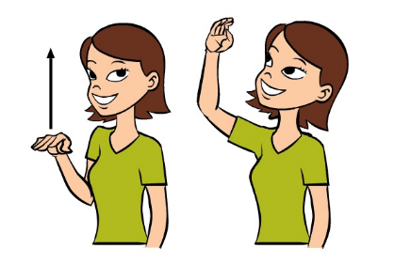

Gesture for examples 1 and 2

* + Gesture: Hand raises up over head
  + Speech: "He's producing work at a high level”
  + Coding Scheme: RED:MET (Redundant + metaphoric)
* Example 2:
  + Gesture: Hand raises up over head
  + Speech: "The first floor is higher than the second floor"
  + Coding Scheme: RED:IC:PA (Redundant + Iconic + Path).
* Example 3:
  + 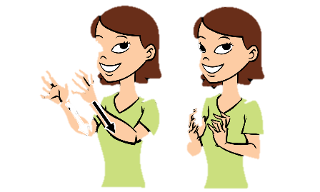Gesture: Pretending to grab something
  + Speech "I love to grab the sales when I buy flower seeds"
  + Coding Scheme: RED:MET (Redundant + metaphoric)
* Example 4:
  + Gesture: Pretending to grab something
  + Speech: "I grab the seeds and place them into the dirt"
  + 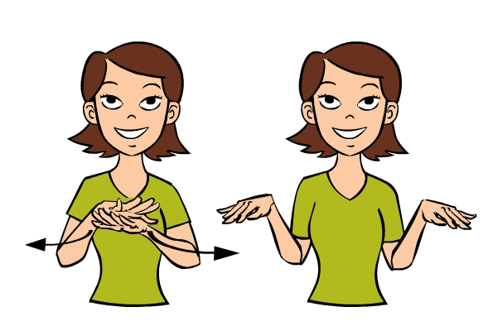Coding Scheme: RED:IC:EN (Redundant + Iconic + enacting)

Gesture for examples 3 and 4

* Example 5
  + Gesture: Pretend to comb
  + Speech: “I need to comb through papers”
  + Coding Scheme: RED:MET (Redundant + Metaphoric)
* Example 6

Gesture: Pretend to comb hair without using tool

Gesture for example 5

* + *Coding Scheme: RED or SUPP:IC:EN
* Example 7:
  + Gesture: Pretend to comb as if using tool:
  + *Coding Scheme: RED or SUPP:IC:HA
* Example 8:

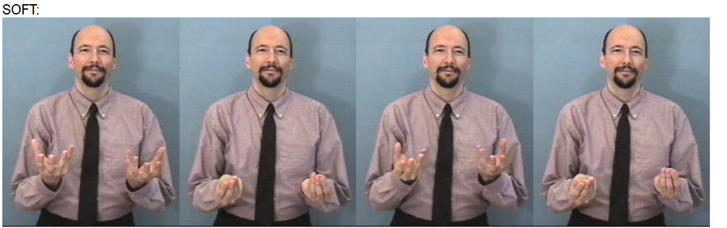

Gesture for example 8

* + Gesture: rubs fingers together denoting texture
  + Speech: “The bread was soft”
  + Coding Scheme: RED:IC:OB

Coding Scheme for Hand Shapes:

CL:1

CL:3

CL:3:BENT

CL:4

CL:5

CL:5:CLAW

CL:A

CL:B

CL:B:FLAT

CL:B:CURVED

CL:B:BENT

CL:C

CL:C:CLAW

CL:C:INDEX&THUMB

CL:F

CL:G

CL:U

CL:H

CL:HORNS

CL:L

CL:CURVED

CL:O

CL:O:FLAT

CL:R

CL:S

CL:V

CL:V:BENT

CL:X

CL:X:COCKED

CL:Y

1. **Procedure for annotating in ELAN**

Resources for getting started:

* Download ELAN: https://archive.mpi.nl/tla/elan/download
* Download CLAN: https://dali.talkbank.org/clan/
* In ELAN: <https://www.mpi.nl/corpus/html/elan/pt01.html>
* **Link to video tutorial below-- Please watch before reading the steps** (link will work only if you have existing access to our SharePoint)
* *** **Sync** your SharePoint to your Desktop before you do the following steps:

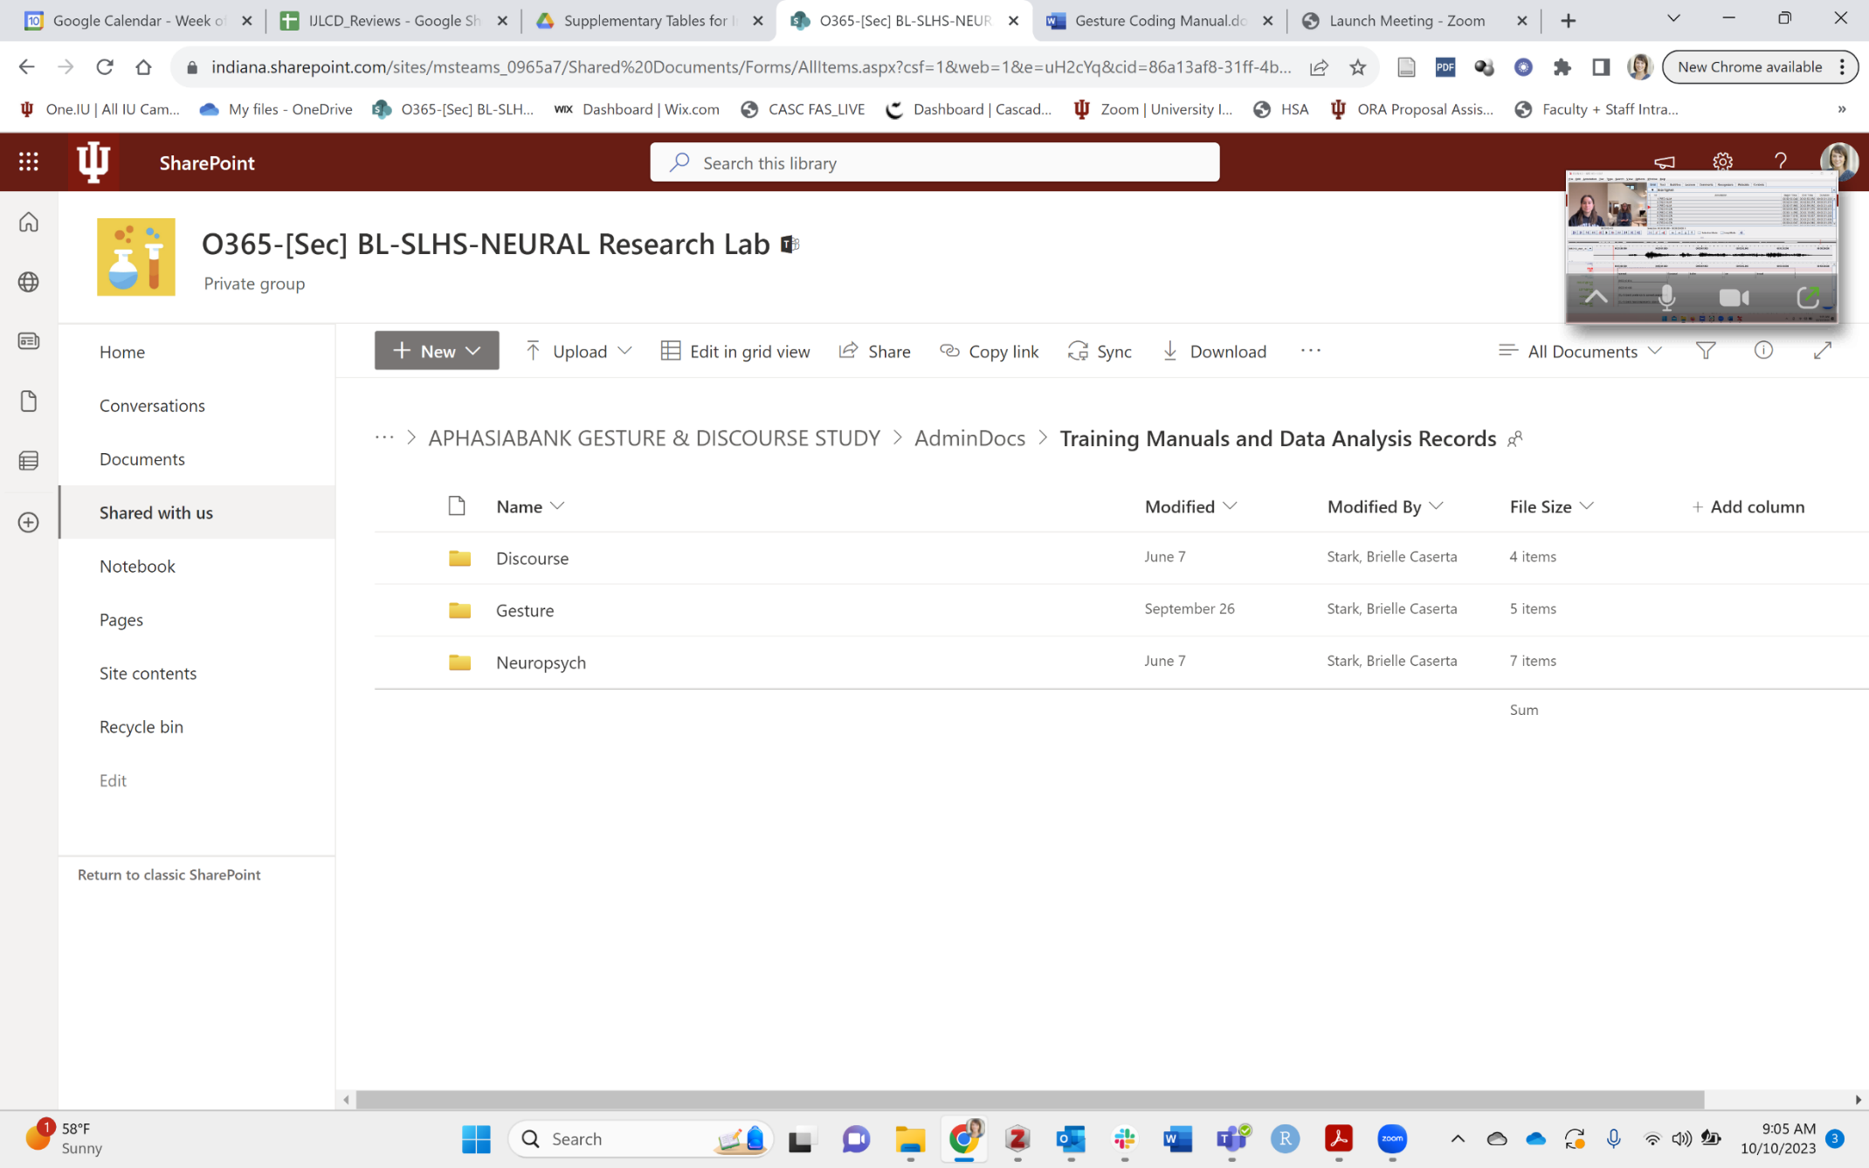

It will make your files appear on your Finder! Like this:

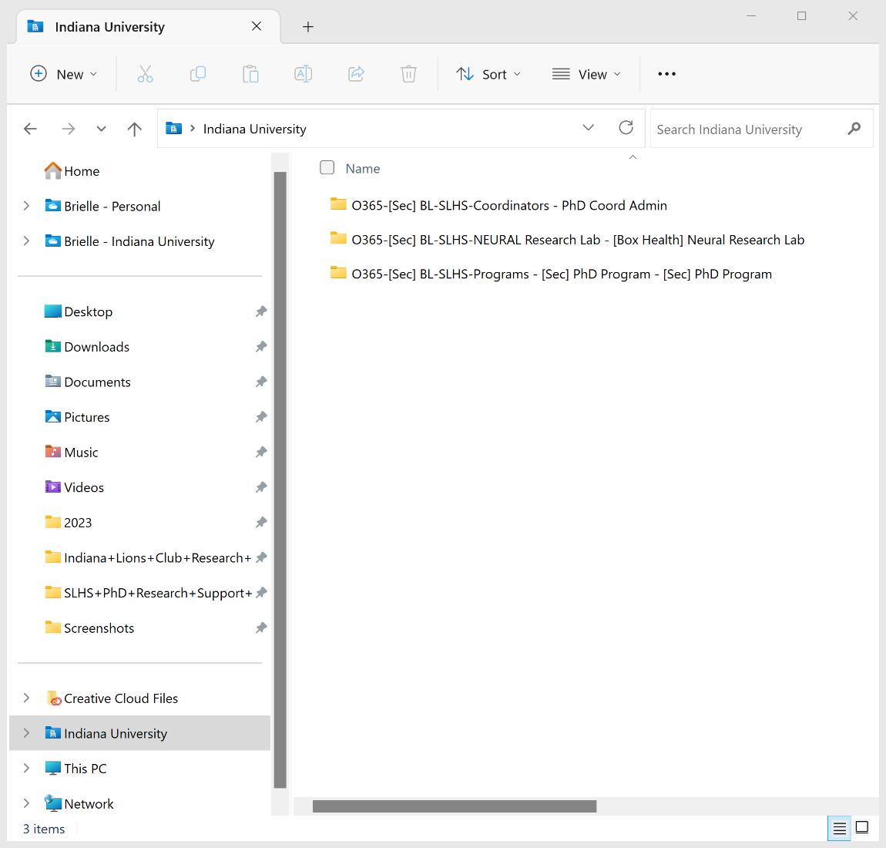

The red box is our lab! Then you can click through the folders to find what you need.

STEPS FOR CODING IN ELAN FOR APHASIABANK TEST-RETEST STUDY

**Step 1: Converting CHAT Files to ELAN: THIS HAS TO BE DONE FIRST!**

1. Files you need for converting successfully:
   * MP4 video of the person speaking (.mp4)
   * CHAT file, which has been time locked to the person speaking (.cha)

1. Converting the chat files:
   * In the window bar, click
     + Window - > Commands
     + Enter: chat2elan +emp4 *.cha
     + Hit “Run”

**Step 2: Open file in ELAN**

1. Open ELAN
2. Select File à Open
3. Select .eaf file
   * If the program prompts you to open the .mp4 file, find original video in .mp4 format that matches the .eaf file.

**Step 3: ELAN tiers of interest**

* + - * Import tiers of interest utilizing coding template in the Gesture Training Manual Folder

|  |  |  |
| --- | --- | --- |
| **Name** | **Usage/Purpose** | **Example(s)** |
| Tiers that are **NOT** converted to CLAN | | |
| task | To note the specific task being coded. Do not code “PROCEDURAL”. See example. | SANDWICH  LAUNDRY  GARDENING |
| marker | To mark placement of gesture. | GESTURE |
| type | To note the type of gesture. IC is not encoded, rather, we code iconicity types (all iconicities are iconic). | REF  DIC  MET  NUM  EN, HA. OB. SH. PA. MIX  Mix = using 2 different iconicity types (e.g., Right hand – handling, Left hand—object) |
| function | To note if gesture is redundant or supplemental to speech | RED  SUP |
| Gestures that **ARE** converted to CLAN   * + - * Enables concise description of gestures once converted to CLAN. | | |
| RIG@PAR | Gestures produced by the Right Hand of the Participant | RED:IC:HA |
| LEF@PAR | Gestures produced by the Left Hand of the Participant | RED:IC:HA |
| HSL@PAR | Hand shape produced by the Left Hand of the Participant | CL:C:CLAW |
| HSR@PAR | Hand shape produced by the Right Hand of the Participant | CL:1 |

Example Image

**Step 5: Annotate gestures in ELAN**

1. Find the point at which gesture begins.
2. Highlight entire gesture from start to finish.
3. Right click on the tier row you wish to annotate and make annotation.
4. Repeat steps for each tier.
5. ELAN may automatically select the section of the annotation for you. If you come across a gesture that should be elongated, but cannot be elongated due to ELAN restrictions, use the automated section, and only count the gesture ONCE. Do NOT repeat the annotation or it will skew the data (it will be counted at 2 iconic or 2 iconicties, when the participant was only trying to gesture 1 concept. If this is unclear, please message contributor KU.

**Step 6: Save your work!**

Save often because ELAN doesn’t have an autosave. Below are examples on how to save your work:

1. Saving scheme:
   * Group Id#_day#_Initials
     + Groups = NBD (non-brain damaged) or RC (aphasia group)
     + ID = participant identifier number
     + Initials = your first and last name initials. This is important as we have multiple coders!
2. Example: NBD123-2.KU
3. Save the ELAN file to SharePoint in the participant’s folder in the appropriate session:



1. **Contributors**

Principal Investigators

* Dr. Jana Iverson, University of Pittsburgh – used her manual as a backbone of this (manual received, summer of ’20)
* Dr. Brielle Stark, Indiana University

Students

* Christine Wu, Smith College (UG student; part of summer virtual internship, ’20)
* Mara (Nikki) Crouse, Smith College (UG student; part of summer virtual internship, ’20)
* Courtney Berzolla, University of Vermont (UG student; part of summer virtual internship, ’20)
* Elizabeth Hodgson, Barnard College (UG student; part of summer virtual internship, ’20)
* Stephanie Yong, Bryn Mawr College (postbac student; part of summer virtual internship, ’20)
* Grace Oeding, IU (part of her UG Senior Honors project, ’22)
* Samantha (Sam) Floras, IU (UG part of SREM Groups program, summer intern ’21)
* Katelyn Urena, IU (PhD Student from 2021) kurena@iu.edu