

CINDERELLA STORY GRAMMAR TRAINING MANUAL

Pond, Higginson, Jaskolka, & Greenslade (2023)

# What is Story Grammar and Why Do We Care?

When telling a familiar story, like the story of Cinderella, people typically present relevant information in a logical sequence (Stein & Glenn, 1987). Presenting information out of order makes a story confusing and hard to follow. For example, if a storyteller shared that Cinderella raced out of the palace and lost her shoe before stating that her Fairy Godmother told her she would have to leave the ball by midnight, this would be confusing. People also tend to share consistent information across retellings (Stein & Glenn, 1987). Thus, listeners might have difficulty recognizing the story of Cinderella if a storyteller failed to mention that her stepsisters were mean, that there was a ball, or that the glass slipper fit her perfectly at the end.

Story grammar analyses, macrostructural (or higher-level organizational) narrative analyses, assess these aspects of storytelling (i.e., sharing consistent and relevant content in a logical sequence). Specifically, story grammar analyses examine how storytellers organize a story’s themes through causal and temporal relationships of events; thus, it allows examiners to assess the internalized framework and audience accommodation of fictional narratives (Hughes et al., 1997). Research has demonstrated the utility of story grammar analyses in distinguishing language-impaired, learning-impaired, and below average readers from control children and adults (Hughes et al., 1997; Roth & Spekman, 1986) as well as differences between individuals with and without cognitive-communication disorders (Mozeiko et al., 2011; Power et al., 2020).

# Steps in Training

1. Setting Up and Getting Oriented to the Coding Sheet
2. Splitting utterances into meaningful units
3. Assigning story grammar codes
4. Determining episode numbers and types

# Setting Up and Getting Oriented to the Coding Sheet

1. Make a copy of the SG coding template, found here: <https://docs.google.com/spreadsheets/d/1EKg5NHYa4-C6sMWJ_nsf0qvlAhEdzY05Phgwi8eVeKM/edit?usp=sharing>
2. Each participant transcript being coded should have its own tab, copied from the coding template (ensure that the “create a copy” box is checked, or the program will simply move the sheet rather than copying it). Rename the new sheet with the participant ID number/client identifier (e.g., participant 14).

RESEARCH NOTE: If the participant transcript does not exist for whatever reason, keep the numbered sheet in excel and change the tab color to black.

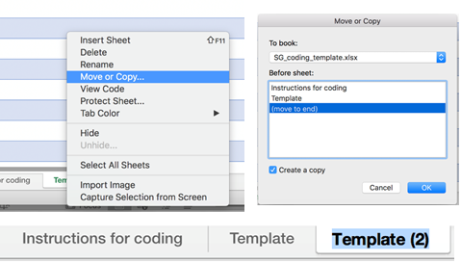

1. Copy and paste the transcript into the new sheet under the “Participant Utterance” or “Utterance” column.

RESEARCH NOTE: If the participant transcript does not exist for whatever reason, keep the numbered sheet in excel and change the tab color to black.

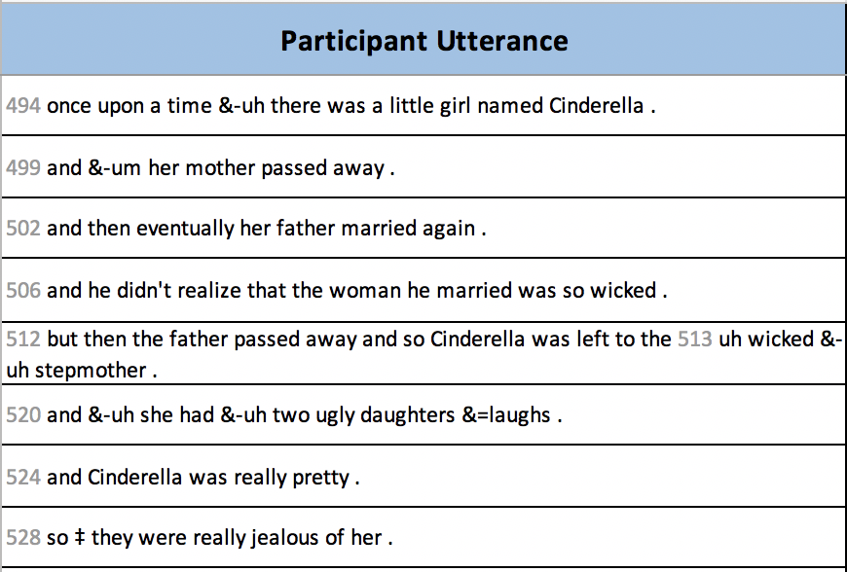

1. Split utterances by propositions, with one proposition per spreadsheet line.  It is recommended to include questions or comments about utterance splitting under the “Rationale/Notes” header on the matching line.

NOTE: For embedded clauses, cut the clause from the utterance, replace it with “...”, and paste it on the next spreadsheet line.

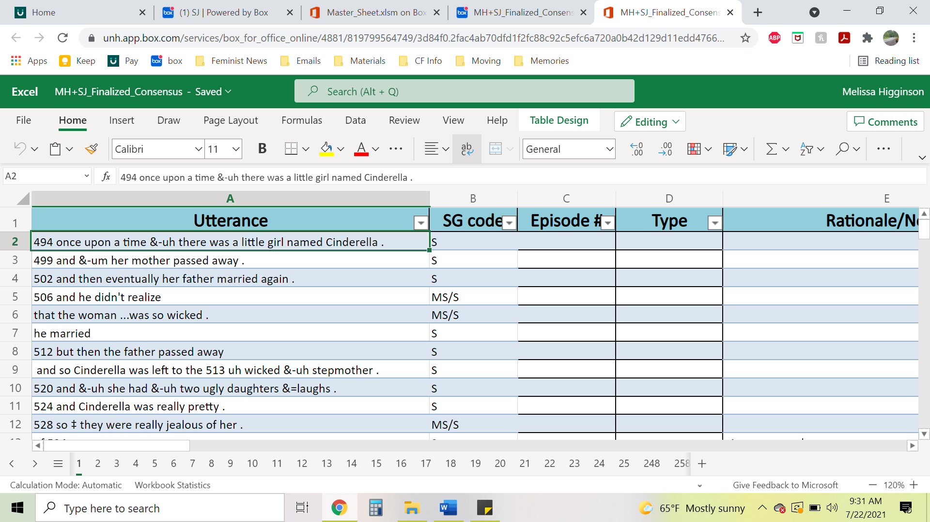

1. Apply the coding instructions to assign a story grammar code(s) to each proposition, under the “SG code” header. It is highly recommended to include rationale and/or questions for application of each code in the “Rationale” header on the matching line.

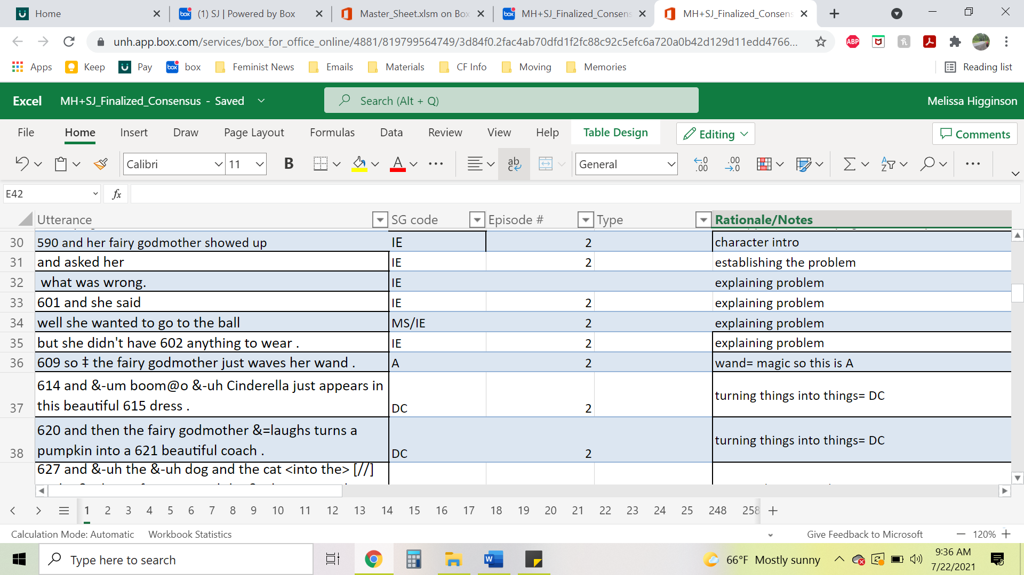

1. Assign episode numbers under “Episode #” column. Participants may poorly sequence their story, so keep this in mind when deciding episode numbers as they are not always linear like this example.

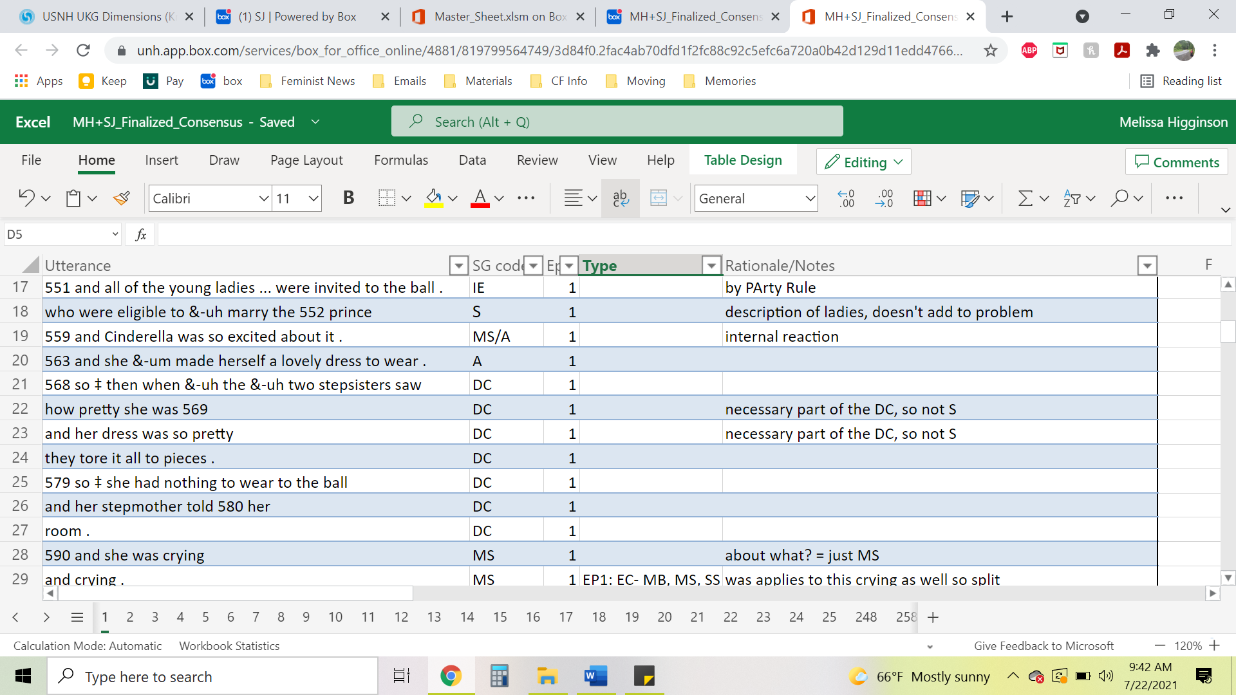

7. At the end of a numbered episode, assign the appropriate episode type on the line that matches the end of the episode under the “Type” column. Some episodes are poorly sequenced so ensure your episode type is entered on the correct line. Consult page 39 for the List of Episode Types.



# Splitting Utterances into Propositions

Each AphasiaBank or TBIBank video of a participant is paired with a written transcription of the participant’s story. Most transcripts have utterances separated into C-units (an independent clause + all modifying clauses OR splitting at noticeable pause breaks), but some do not. In most cases, utterances should be split based on the transcript, even if the transcript seems questionable. As a research coder, you code blind to participant diagnosis and time point; thus, you must assume that TalkBank transcribers have transcribed the story accurately. It is not your responsibility (nor is it within your purview) to review the video and update the transcription. If you find something in a transcript to be questionable (e.g., a word that does not make sense), you should consult with your research mentor, so that the original sample can be checked to confirm appropriate transcription.

The first step in splitting utterances into propositions is to identify independent clauses. Independent clauses can stand alone and still have meaning. They must consist of at least a subject (noun phrase) and a predicate (verb phrase). The predicate may be an isolated verb, or it may include a verb + object. Any unit with a subject and a verb should be separated from other units. In most cases, units without a subject and/or verb should remain attached to their main clause (for example, prepositional phrases).

Story grammar coding does not follow the rules for segmenting C-units exactly. When segmenting C-units, subordinating conjunctions signify a dependent clause and depend on the independent clause; therefore, they form one C-unit with the independent clause. However, proposition-level story grammar coding separates all clauses containing a verb phrase (or predicator) plus all related arguments (Roth & Spekman, 1986), even if they are dependent on a main clause to form a complete idea.

## How to Split Utterances into Propositions

1. Separate each proposition, putting it on its own line in the coding sheet. Each proposition gets a separate line, even if it would serve the same story grammar function as other propositions in the utterance.
2. Infinitives are not separated from their c-unit.
   1. However, compound predicates and/or compound infinitives *should be separated* and placed on their own line in the coding sheet.
   2. Examples:
      1. She wanted to go to the ball - “to go” is an infinitive that remains attached to this c-unit
      2. Cinderella arrived at the ball and danced with the prince - “Cinderella arrived at the ball” is one proposition; “and danced with the prince” is a second proposition
      3. Cinderella was forced to cook and clean for her stepfamily - “Cinderella was forced to cook” is one proposition; “and clean for her stepfamily” is a second proposition
3. In other cases, an utterance may be split ONLY if it serves 2 separate and obviously distinct story grammar functions, and the information is novel/has not already been stated within the episode previously.
   1. Example:
      1. So, she runs out.
      2. And in running out, she loses one of her glass slippers.
         1. The second line **is not** split for story grammar because “running out” has already been established and has already been coded for a separate story grammar function. It is not novel information.
      3. At midnight, Cinderella rushed out of the palace.
         1. “At midnight” **is** split for story grammar because it is the initiating event that sets off Cinderella leaving the palace.
4. Split utterances based on the transcript even if you question whether utterances were initially split correctly. The coders should assume that TalkBank transcribers have transcribed the story accurately. It is not your responsibility (nor is it within your purview) to review the video and update the transcription.

### Definitions

* Infinitive: the basic form of a verb, without an inflection binding it to a particular subject (Oxford Dictionary). Essentially, an infinitive is a verb that plays the part of a different part of speech. It can be easily recognized when the word “to” precedes it (e.g., to eat, to sleep, to love). However, infinitives can exist without the word “to”; for example, in the sentence “let’s eat”, “let” is the verb, “us” is the subject, and “eat” is the infinitive.
* Compound infinitive: two infinitives are linked to the same verb and subject.
  + Example: “I want to run and jump”
    - This sentence is understood as “I want to run, and I want to jump” which is why compound infinitives are split.
* Compound predicate: A subject in a clause is performing more than one action (the subject is shared by 2 or more verbs). An easy way to identify compound predicates is to identify two or more verbs linked by a conjunction (such as “and” or “but”).
* Auxiliary verb tenses where the “helping verb” (e.g., is, was, will, have, had) does not repeat but the participle (e.g., -ing, -ed, broken) repeats may be used as compound predicates.
  + Example: “She was crying and wailing” should be split as  1) She was crying, 2) and wailing.
  + Examples of auxiliary tenses:
    - Present/past/future progressive tense: “to be” verb + present participle (i.e., verb ending in -ing). Example: “Cinderella *was dancing and having a great time*” should be split as “Cinderella was dancing”, “and having a great time”
    - Present/past/future perfect tense: “to have” verb + *past* participle (i.e., usually ending in -ed, but irregular past participles exist as well, such as those that end in -en, like “broken,” “bitten,” “arisen,” etc.). Example: “Cinderella *had loved* *and wanted to marry* the prince all along” should be split as “Cinderella had loved”, “and wanted to marry…”
      * Note: “to have” verb + present participle (-*ing*) is *not* considered an auxiliary verb tense because “had” is considered the main verb and the present participles are used as adjectives. Example: “The stepmother had Cinderella washing and drying all their clothes” - In this case, “had” is the main verb; “washing” and “drying” are adjectives describing what the stepmother had Cinderella do. So, this is not an example of an auxiliary verb tense, and therefore, it is *not* a compound predicate and would not get divided. Table

        Description automatically generated
    - Conditional tenses: “would/could/should” + verb. Example: “The prince *should get married and produce an heir*” should be split as “The prince should get married,” “and produce an heir.”
* Prepositional phrase: a phrase consisting of a preposition (see examples in figure to the right), the preposition’s object, and any words modifying that object. A prepositional phrase does not qualify as its own clause because it modifies a verb or noun and does not have a subject or verb of its own, so prepositional phrases should remain attached to their proposition. Example: “The fairy godmother turned Cinderella’s rags *into a beautiful ball gown*.”

### Words that Can Signal the Beginning of Another Clause

* Generally, if an utterance has a subject and verb that makes sense on its own, it is its own proposition.
* This following list is not exhaustive, and these words do not always signal a new clause.

*Examples of subordinating conjunctions:*

| After  Although  And*  As  As if  As ___ as (e.g., as much as)  Because  Before  But | For*  How  If  Like  Nor  Or*  Since  So  So that | Than  That*  Though  Unless  Until  What  When  Whenever  Where | Wherever  Whether  Which  While  Who  Whom  Why  Yet |
| --- | --- | --- | --- |

* **“And**”- can be used to list things

* Examples of lists that *would not be split* because there is only one subject and one verb:
  + I like nostalgia, cats, and bad reality TV = 1 proposition (no split)
  + The Fairy godmother turned her rags into a ball gown, the mice into horses, and a pumpkin into a carriage = 1 proposition (no split)
* Examples of lists that *would be split* because there is one subject with multiple verbs:
  + The prince and Cinderella met, danced, and fell in love = 3 propositions

* **”Or”-** can provide an alternative name if the participant is unsure, or it can function as a comparison subject/object

* Examples of situations in which “or” *does not* signal a new proposition because there is only one subject/one verb.
  + They decided to have a ball or something = 1 proposition (no split)
  + She fell in love with the Prince or whatever = 1 proposition (no split)
  + The fairy godmother looked in the garden for a pumpkin or a gourd to turn into a carriage = 1 proposition (no split)
  + The slipper didn’t fit the stepmother or the stepsisters = 1 proposition (no split)
* Examples of situations in which “or” *does* signal a new proposition:
  + Cinderella had to be back by midnight, or everything would go back to normal = 2 propositions

* “**For”-** can also function as a prepositional phrase/ justification

* Examples of “for” as a preposition, which *does not* signal a new proposition:
  + The mice were friends with Cinderella for good reason.
  + The Prince chased after Cinderella for love.
* Examples of “for” as a coordinating conjunction, which *does* signal a new proposition:
  + The prince married Cinderella, for he had loved her since the first moment he saw her.

* “**That”-** Pay close attention to utterances that have mental state verbs. In these cases, the conjunction “that” may not be required.

* Examples in which “that” is omitted because it is not required (nonobligatory “that”):
  + “She thought it would be grand to go to the ball” = 2 propositions: 1) “she thought”, 2) “it would be grand to go to the ball”.
    - Note: “to go to the ball” has its own verb (infinitive) but no subject, so it should not be a separate proposition.
* NOTE: Some clauses/propositions are harder to find than others.
  + For example, “who” clauses are often embedded within other clauses and must be separated to receive their own codes. Example: “The stepmother who was evil made Cinderella do all the chores” should be split as “The stepmother … made Cinderella do all the chores”, “who was evil”.

### Special Considerations for Utterance Splitting

#### Striking Midnight

* Consider if “strike” is being used as a main verb, an infinitive, or a noun
  + Examples:
    - When the clock *strikes midnight*, Cinderella leaves.
      * “[S]trikes” is used as a main verb here, making this utterance two propositions (“when the clock strikes midnight”, “Cinderella leaves”)
    - Cinderella heard a clock *strike midnight.* 
      * This use of “strike” is not a main verb, so this utterance should remain one proposition.
    - Cinderella runs down the stairs at the *stroke of midnight.*
      * This use of “stroke” is a noun, so we rely on story grammar and novelty to determine whether this utterance should be split. If this information is new, then “at the stroke of midnight” should be split for story grammar purposes. If this information is not new, then it should not be split.

#### Implied Subjects

* Reference to Character
  + A sentence may appear like it has no subjects but multiple verbs. If the previous sentence used a proper noun or pronoun, it is assumed that the subject of the next sentence is implied and therefore, should be split at the verb(s).
    - Example:
      * The prince went out on a search.
      * Went looking around and tried finding Cinderella.
        + This second sentence should be split into two propositions (“went looking around” and “and tried finding Cinderella”) because the subject (“The prince”) is implied from the first sentence.
* Reference to Self
  + Propositions starting with “think” and “wonder” where subject of “I” is implied should be separated into two propositions. These references to self remove the listener from the story and get coded as Non-Story Grammar.
    - Example:
      * Think she lived with her stepsisters.
        + This would be split into two propositions: “think” and “she lived with her stepsisters”. Each proposition can be coded with its own story grammar elements.

#### Sorry

* “Sorry” within a proposition is an adjective. It is often said by participants to give a correction to their story. The subject “I” cannot be implied and separated out because there would be a lack of verb (e.g. “am”). Subjects can be implied, but verbs cannot.
  + Example:
    - Sorry the slipper fell off in the process of running down the stairs.
      * This is one proposition because “I am” cannot be implied. This gets coded as a story grammar element and not NSG.

#### Colloquial phrases

* Colloquial phrases *without* a subject and verb should not be split; colloquial phrases *with* a subject and verb should be split.
  + Examples of colloquial phrases that should not be split:
    - *for lack of better word*, *to make a long story short*, *or something*, etc.
      * Since these phrases do not have their own subject and verb, they remain part of the proposition and do not get assigned their own story grammar code (i.e., a single story grammar code is assigned to the proposition).
  + Examples of colloquial phrases that should be split:
    - *And it turns out*, *as the story goes*, etc.
      * Both would receive the code of NSG because they are considered commentary that distracts the listener from the story.

#### “Ends Up”

* “ends up” is a phrasal verb and should be treated as a main verb.
  + If there are -ing verbs following it, the -ing verbs are likely adjectives and should not be split
    - Example:
      * Cinderella ends up getting married and living happily ever after.
        + This is one proposition with “ends up” as the main verb; “marrying” and “living” are both adjectives in this sentence and should not be split.

# Assigning Story Grammar Codes

## Story Grammar Elements

All of a participant’s propositions must be assigned one of 7 story grammar codes. In general, codes are mutually exclusive, meaning only one code can be assigned to each proposition. The “mental state” code is the only exception; it can be combined with any other story grammar code.

The following are the operational definitions that are to be used to determine which story grammar code an utterance should receive. It should be noted that the examples used below are *not* separated into C-units and assigned separate codes, as they would be when coding a participant’s narrative production.

### Mental State (MS)

* Any statement of a character's internal thoughts, feelings, or responses. This may include internal reactions/responses to story events or a character's thoughts (cognitive), feelings (emotional), or desires (desire).
  + Examples of Mental States:
    - “Cinderella was so *excited* about [the ball].”
      * Any statement of a character's thoughts (cognitive), feelings (emotional), or desires (desire) is included under mental states.
    - “Cinderella’s *wicked* stepmother did not *want* her to go to the ball.”
      * “wicked” is a word that describes the stepmother’s temperament, representing her cognitive state
      * “want” is a word that signifies a character’s desires, and therefore receives a code of MS.
  + NOTE: MS is the *only* code that may be combined with another story grammar code. The circumstances in which combined codes may be used are explained in the coding rules on page 18-22 of this manual.
  + “So” before a proposition that would otherwise be coded as a MS only can be coded as a MS + other SG code if the “so” causally links the proposition to a problem, event, etc.
* A list of common mental state words based on review of Cinderella transcripts as well as research by Turkstra and colleagues (e.g., Byom & Turkstra, 2012; Bootsma et al., 2021), can be found [here](https://docs.google.com/spreadsheets/u/0/d/1Oz38L4hnTXLuVMr-YcWNQhX6YP4GYCjAGxV_1gihURs/edit), divided into the categories of cognitive, emotional, and desire terms. Note: a second sheet in this workbook provides examples of words/phrases that are *not* mental state words, which may be useful in making decisions about words that do not appear on these lists.
* If a word is not listed on this sheet (or you are in doubt for any reason), google the word’s definition and analyze it to see if it suggests a mental state.

* NOTE: Some propositions may contain mental state words within the context of a rote colloquial phrase associated with telling a fairy tale (e.g., “happily ever after”). Because these phrases are almost automatic in their association with fairy tales, they are not assigned an MS code.

**NOTE: Many words can be used to describe a mental state or a physically observable state/phenomenon. In these cases, coders must use context to determine which use was intended by the speaker. For example, *picks*/*chooses*/*selects* are only considered mental states if clearly supported by another accepted mental state word/phrase.

* Example:
  + After careful thought, the prince picked Cinderella – yes MS
  + The prince picked Cinderella – no MS

### Setting (S)

* According to Stein and Glenn (1975), “the setting creates the necessary conditions for the story to occur but does not directly cause the subsequent behavioral sequences” (pp. 11).
* A setting creates a reference for the story's location and the time during which the story takes place or introduces characters or relationships, typically at the start of a story. Setting statements are used to set the status quo, add description to the story, and describe habitual patterns of behavior.
* While there is often a large grouping of Setting statements at the beginning of a story, prior to the first Initiating Event, setting statements may occur at any point in a story.
* Once the episodic structure of the story has begun (i.e., initiating events, attempts, direct consequences), exposition and background information is given the code of Setting, as long as it serves no other episodic purpose (with the exception of Mental State). This exposition/background information may involve a reference to an established status quo (“, description of a physical state (e.g., “slipper that was made of glass”), or describe habitual patterns of behavior (e.g., “her stepsisters were always so mean” - after episodes have begun).
  + Examples of Setting statements:
    - "Cinderella's father married a wealthy lady in the community."
      * This statement serves as an introduction of characters but does not drive the plot.
    - "They make Cinderella do all the chores and all the cleaning and all the dirty work."
      * This statement demonstrates the relationship between Cinderella and her stepfamily but does not drive the plot.
    - “Everyone at the ball was like ‘who is that beautiful girl?’”
      * This statement does not contribute to episodic structure (IE, A, DC) in any meaningful way. It only establishes that Cinderella is beautiful, which is her status quo.
    - “…slipper, which was made of glass”
      * The description of the slipper as being made of glass provides background information about the slipper (i.e., a description of the slipper’s physical state).
  + NOTE: Setting statements are not required for an episode to be complete. If included within the episodic structure, setting statements add elaboration.

### Initiating Event (IE)

* An initiating event is an occurrence or event that causes the story to progress forward or results in an action or consequence. It drives the story toward its "point". This may consist of a problem that needs to be solved, an event that otherwise drives the main character's actions or drives the events of the episode, and/or an introduction of a new character. It is considered a “change in the status quo”. It *can* be indicated by a transition word (e.g. meanwhile), but that is not always true.
  + Examples of Initiating Events:
    - "Suddenly, the fairy godmother appeared."
      * This statement includes the introduction of a character and is an example of an initiating event because the appearance of the fairy godmother drives the story forward. The fairy godmother’s arrival signals the start of an episode that addresses Cinderella’s problem of being unable to go to the ball through the creation of a dress, shoes, and a carriage.
    - "Just then, the clock struck midnight."
      * The clock striking twelve is the initiating event that leads Cinderella to leave the ball.

### Attempt (A)

* An attempt involves the main character acting in response to the initiating event to solve whatever problem was presented. A character may produce several attempts before reaching a direct consequence or conclusion.
* In this coding scheme, plans are always coded as attempts. Internal plans/responses may be coded as MS/A, if they include or are dependent upon a mental state word.
  + Examples of Attempts:
    - "And then the fairy godmother turns a pumpkin into a beautiful coach, and the dog and the cat to footmen and the mice into horses."
      * This is an example of an attempt, which was a response to the initiating event of the fairy godmother appearing. This attempt (creating Cinderella's dress and carriage) will result in a direct consequence.
      * Note: If this proposition had indicated that the fairy godmother used magic to turn the pumpkin into a coach, then her use of magic is considered the attempt, and the pumpkin turning into a coach is considered the direct consequence of that attempt (see “**Magic Rule**” below for more details).
    - "So, she just takes off out of the castle, no real explanation."
      * This is an example of an attempt because it is the action Cinderella takes in response to the initiating event (i.e., it is driven by Cinderella realizing what time it is).

### Direct Consequence (DC)

* Direct consequences are the result/outcome of an attempt; they must directly follow and be causally attributed to the attempt. Direct consequences resolve (solving or failing to solve) the problem set up by the initiating event. There can be more than one direct consequence for an attempt.
  + Examples of Direct Consequences:
    - "So, Cinderella is whisked off to the ball."
      * This sentence is a direct result of the “fairy godmother” episode’s initiating event and attempt: The fairy godmother appears, so Cinderella gets a dress and coach, which causally results in Cinderella getting to go to the ball.
    - "And in the process of her hurry to get out of there, loses one of her glass slippers."
      * This proposition is a direct result of the initiating event and attempt in the “Cinderella leaves the ball” episode: The clock strikes twelve, so Cinderella hurries out of the castle, and as a consequence of rushing, she loses her slipper.

### Conclusion (C)

* Conclusions signal the story’s ending through "wrapping up" statements. The conclusion serves a similar function as the direct consequence; however, it is providing the overall result of all the story’s episodes, rather than being linked to a single initiating event. Once the conclusion statements begin, no ***new*** events or characterizations (Setting statements/MS alone) can be introduced, and ***old*** events can only be mentioned in the context of wrapping up the story. New events/characterizations presented after conclusions begin are coded as Non-Story Grammar (NSG). Also, internal responses of others (i.e., their reaction) to a concluding statement can be coded as a conclusion.
  + Examples of Conclusions:
    - "So [Cinderella] and the prince were married."
      * This proposition does not drive the plot forward; rather, it "wraps up" the story and gives it a feeling of completeness.
    - "The prince and Cinderella lived happily ever after."
      * This proposition also concludes or "wraps up" the story.
    - “Cinderella leaves her horrible stepfamily behind”
      * This proposition directly relates to Cinderella and wraps up the story in a meaningful way.
    - “The stepsisters were jealous of their marriage.”
      * This proposition describes the family’s response to Cinderella’s conclusion of being married, and therefore, it gets coded as a conclusion.
  + Examples of non-Conclusions:
    - “The sisters get angry.”
      * This proposition would have been coded as MS alone if told during episodic events, but because no reasoning is provided to explain why the stepsisters are angry, this mental state/internal response is not clearly causally related to Cinderella’s conclusion(s)
    - “The uglies get uglier.”
      * This proposition would have been coded as a setting statement because it further characterizes stepsisters and is not clearly causally related to Cinderella’s conclusion(s).
  + Example of old events/characterizations being mentioned after conclusions:
    - “The end of the story was” **Conclusion**

“that she was taking back to king's palace” **Conclusion**

“and then she got married to the prince” **Conclusion**

“because the slipper really was hers” **Setting**

“so she got married” **Conclusion**

* + - * “because the slipper was really hers” is coded as setting because it has already been established in the story so it is status quo, and it is relevant to the context of wrapping up the story
  + Examples of new events being mentioned after conclusions
    - “She's princess.” **Conclusion**

“And then he finds her.” **Non-Story Grammar**

“and they end up getting married.” **Conclusion**

* + - * “He finds her” is coded as Non-Story Grammar as it is a ***new*** event that was not previously established, and is stated after a conclusion. Any new events stated after conclusions begin are coded as Non-Story Grammar
    - “they live very happily ever after” **Conclusion**

“and they're even nice to the sisters” **Non-Story Grammar**

* + - * “and they’re even nice to the sisters” is coded as Non-Story Grammar as it is a ***new*** characterization stated after conclusions began
  + NOTE: The table below lists concepts that participants often use to conclude the story of Cinderella. These universally accepted statements *always* receive a code of C. Other propositions that wrap up the story can be considered conclusions but need to follow previously stated rules.

| Accepted Conclusions |
| --- |
| * They get married * She’s a princess * They take her to the castle/ leave in a coach * They’re in love * They’re reunited * All her dreams come true * They have a family/children * They live happily ever after/ everything turns out well/ the ending is happy * The end/ that’s about it/ that’s all/ that was it/ that’s all there was/ that’s the end/ there ain’t no more/ that was that/ that’s the story/ that’s all she wrote/ etc. |

### Non-Story Grammar (NSG)

* Non-story grammar (NSG) elements include any propositions that cannot be categorized as any of the story grammar elements listed above. A non-story grammar element is not part of the narrative and may include tangents/asides, personal anecdotes, references to self (e.g., I, we), references to the book/pictures (e.g., “by the book…”, non-content filler phrases, personal opinions, commentary on the story as if from an outside perspective, doubt/uncertainty, incredibly vague descriptions that cannot be understood based on the context provided, and/or abandoned utterances*.
  + Examples of NSG propositions:
    - “I’m kind of a Cinderella story myself.”
      * When speakers refer to themselves, this represents a break in their use of storyteller voice and the resulting proposition is tangential to the narrative. Therefore, it is not considered part of the narrative structure and coded as NSG.
    - “You know.”
      * This proposition is a “filler”, which may occur while a participant is attempting to remember a component of the story or to gain understanding from the listener. Because it has its own subject and verb, it constitutes a proposition. Since it serves no story grammar purpose, it would be coded as NSG.
* *NOTE: Abandoned utterances are easy to spot as they are denoted by codes including: trailing off (+…), self (+/.), and other (+//.) interruptions. See Abandoned Utterances Rules on page 23-24 as they are not always NSG.

## Element Coding Rules

### Where to Assign Codes

1. Code each proposition separately. It is possible for one C-unit to be divided into multiple propositions, each needing to be coded on their own line of the coding sheet.
2. Infinitives (see *Definitions* on pg. 3) are not counted as a separate proposition. They are considered to be part of a main/dependent clause that gets a single code.
3. Compound predicates and/or compound infinitives (see *Definitions* on pg. 3) should be coded separately as they are split which allows them to serve two different story grammar functions.
4. A clause may be split into two propositions ONLY if it serves 2 separate and obviously distinct story grammar functions and the information is novel/has not been stated within the episode previously.
   1. Example:
      1. So, she runs out. – Attempt
      2. And in running out, she loses one of her glass slippers. – Direct Consequence
         1. The second line is NOT split for story grammar. Even though the functions of “running out” and “losing her shoe” serve different story grammar functions, the information of her “running out” has already been established and has already been coded as an Attempt.
   2. Example 2:
      1. At the stroke of midnight – Initiating Event
      2. She runs out of the palace – Attempt

### Assigning Codes: Considerations, Special Rules, and Exceptions

#### Considerations

##### Code from Cinderella’s Perspective

* When in doubt about which code to assign, remember *that the story is first and foremost about Cinderella.* 
  + It is tempting to code the actions of other characters as separate story grammar elements, but it is necessary to take a step back and consider: *how are their actions relating to Cinderella?* 
    - This is especially pertinent during the episode when the prince goes out to find Cinderella. His actions may seem like plans (As), but in relation to Cinderella, they most often are IEs to find her.
      * E.g., “The prince makes a plan to search the entire kingdom” - from the prince’s perspective, this is a plan, but from Cinderella’s perspective, this is part of the initiating event that ultimately will lead to the prince finding her
  + Cinderella’s internal thoughts and/or future conditionals are the only ones that can include different story grammar codes (i.e., as her thoughts progress, you can code multiple different SG codes – potentially creating mini-episodes). All other character’s internal thoughts and/or future conditionals can only have one story grammar code (i.e., as other character thoughts progress, only one code can be applied).
    - Review “Assigning A Codes” section (p. XX below) for more information. 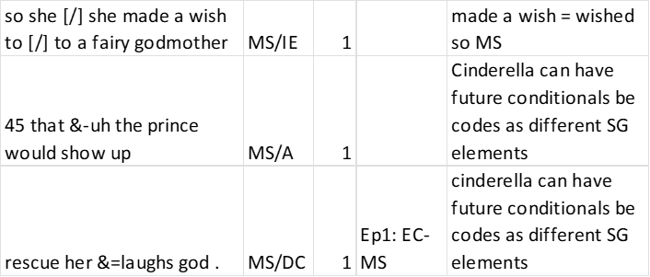

##### Alternate Tellings

* Be familiar with multiple versions of the Cinderella story (especially the wordless picture book used for the task, the Disney movie, and the version by the Brothers Grimm) as it may help determine story grammar elements for lesser known or seemingly random parts of the story. This may include elements like the stepsisters cutting off their toes to try to get their feet to fit in the slipper or the rationale behind the name “Cinderella.”
  + ***Knowing the wordless picture book can be especially important for identifying NSG codes***: If the coder suspects the participant is telling the pictures in the book, it can be coded as NSG.
    - Example:
      * They looked like -NSG
      * they felt jealous. -MS
        + “They looked like” cues the coder into that the participant is describing the pictures in the book, rather than truly telling the story. In this case “they looked like” serves as commentary, and therefore, this proposition would be coded as NSG.

##### Dependent Clauses

* If a dependent clause contains the same idea/serves the same function as the independent clause to which it is attached OR if it does not clearly serve a separate function on its own, it should receive the same code as the independent clause.

##### Assigning MS Codes

* All codes except MS are mutually exclusive. MS can be assigned on its own or in conjunction with any other code if the clause serves a dual purpose.
  + MS only codes apply if a proposition is not directly linked to explanation or description of MS
    - Examples of MS only:
      * Cinderella was invited to a ball. – IE
      * **She was excited. – MS** 
        + Although the listener can assume that Cinderella is excited about the ball, the speaker does not make that link explicit. Therefore, the second proposition receives the code of MS alone.
      * The stepsister ripped up her dress. – DC
      * **And she is crying. – MS** 
        + The “and” makes this proposition separate and unrelated to the clause before it. Additionally, there is no explicit explanation for why she is crying so this gets a code of only MS. (Note: if the speaker had said “*so she is crying*”, the “so” would represent a clear causal link to them ripping her dress, and the proposition would be coded as MS/DC)
  + MS in conjunction with another code can be used if the clause carries a dual purpose. Additionally, the combined codes should follow through to later propositions that explain the feelings or further describe the MS.
    - Examples of MS/Story Grammar code:
      * Cinderella was invited to a ball. – IE
      * **She was excited about it. – MS/A**
        + This would be coded as MS/A for a similar reason to the example above. “about it” provides a clear causal link between her excitement and the ball. Note: this example of an MS/A is considered to be an ***internal response*** according to Stein and Glenn (1979).
      * Cinderella was invited to the prince’s ball. – IE
      * **Cinderella decided – MS/A**
      * **that she would go to the ball – MS/A**
      * **and meet the prince. – MS/A** 
        + If “Cinderella decided” did not have a following explanation. It would have only received the code of MS alone. However, that is not the case here. Since the participant provided two additional propositions detailing and describing what Cinderella decided, all three propositions receive the code of MS/A. Together these three propositions constitute Cinderella’s ***plan*** (which is coded as A) in response to the initiating event of her getting invited to the ball.
* Dependent clauses following a mental state independent clause should also receive the code MS if they are dependent upon the mental state verb. These dependent clauses often explain or further describe the mental state.
  + Words that signal MS dependency include: because, that (even nonobligatory), what, where, when, who, whose, which, etc.
  + Example:
    - He goes around to find out
    - whose foot it fits
      * Both would receive the code of MS (“find out”) in addition to their story grammar element as the “whose foot it fits” provided further explanation for what the prince is trying to find out.
  + ***Exception:*** MS does NOT apply retroactively (backwards).
    - Example:
      * oh.
      * She thought.
        + “she thought” receives the code of MS, but “oh” does not.
  + **Note**: this approach to coding means that the total number of MS codes is not the same as the total number of mental state terms used in the narrative. If desired, coders can separately tally the number of mental state terms. Our lab is currently developing a coding scheme for this, which will be available in the future.

##### Assigning IE Codes

* Toward the end of the story when the prince is at Cinderella’s house fitting the shoe, participants may reintroduce Cinderella. Since character introductions are often coded as IE because they drive the story to a point, this reintroduction of Cinderella is also coded as IE.
  + Examples:
    - Cinderella comes out/down/in the room/stairs.
    - He sees Cinderella.
* Determining IE vs. DC
  + The whole story of Cinderella is causally related because that is the nature of a story. So, it can be tricky deciding if an event is an IE or a DC. The rule of thumb is to consider the previous IE to help the coder come to a conclusion.
    - If the event is related and/or sums up the overall issue of the episode, it is likely a DC of that episode.
    - If the event is unrelated or loosely related to the overall issue of the episode, it is likely an IE for a new episode.
      * See the Shoe Rule on p. 30 for an example.

##### Assigning A Codes

* In the current coding scheme, **plans** and **internal responses** are always coded as attempts.
  + Internal responses alone (e.g. Cinderella wants to go to the ball) are enough of an A to have a causally linked DC (e.g. The stepmom does not let her go). In other words, a character does not necessarily need to carry out the plan for it to result in a direct consequence.
* When trying to determine if an A code is appropriate, consider whether the episode’s DC is causally linked to the potential A. If not, one of the codes may not be appropriate.
* In general, propositions using *future or conditional tenses* can be coded as an A when used to describe a plan. All other uses should be evaluated on a case by case basis.
  + Review “Code from Cinderella’s Perspective” for more information.
  + ***Exception:*** In the Fairy Godmother episode, if the Fairy Godmother tells Cinderella “you will go to the ball” at the beginning of the episode before the transformations, this usually gets coded as DC.

##### Assigning NSG Codes

* If a proposition does not serve an obvious story grammar function, it should be assigned an NSG code. This includes any tangents, asides, or commentary on the story – anything that represents a break in the speaker’s use of “storyteller voice.”
* However, inaccurate, non-traditional, or personally upsetting/offensive contributions to the story do not necessarily get coded as NSG.
  + Examples:
    - There was a prince that had something to do with a monastery.
      * Inaccurate statement, but still a description. So, this proposition would be coded as S.
    - Cinderella spits out two princes when she is queen.
      * The way this proposition is phrased can be personally upsetting/ offensive to the coder, yet it wraps up the story in a meaningful and acceptable way. So, it should receive a code of C.
* If the overall narrative is not clearly or obviously the story of Cinderella and/or does not fit into any story grammar elements, it may be appropriate to assign NSG codes to most or all propositions in the narrative.

##### Assigning Codes with Dialogue

* Dialogue can be tricky as the back and forth nature of characters’ conversations may sway the coder to assume differing character dialogues are causally related. So, when coding for story grammar, it is necessary to consider the overall point of the dialogue. What basic concept is the participant trying to get across and how does that fit into Cinderella’s story?
* All propositions marked in a section of dialogue should receive the same code unless a proposition within the dialogue serves a distinct story grammar function.
  + Example:
    - 1627 but she said +"/.
    - 1630 +" the one thing (.) you cannot stay out after midnight.
    - 1635 +" so ‡ when the clock starts to strike you got to leave.
      * Since these propositions are all part of the dialogue, they should all receive the same code because they are what she (the Fairy Godmother) said. These are likely DCs as they convey the stipulations of the Fairy Godmother’s help.

##### Left-field Additions

* When a proposition feels out of place or confusing (or the coder is too “in the weeds”), take a step back and consider the context surrounding a proposition within the episode.
  + If it may be a DC…
    - Consider if it is causally linked to an A of that episode.
    - Consider if it directly solves the problem or concludes the event introduced as the IE of that episode.
  + If the story might be told out of order…
    - Consider the elements of other episodes that have been coded thus far.
      * Does this proposition help to paint a more complete picture of a different episode? Ensure to number as such.
      * Does this proposition seem like part of a new episode that does not go anywhere? It may be a lone story grammar element in an incomplete episode.

##### Narrative is Lacking

* *It is okay to not have all parts of an episode.*
* Some participants tell very short, unelaborated versions of the Cinderella story. This may make it challenging to determine which episodic events should be attributed to which episode.
  + In transcripts with limited episodic contexts (e.g., there are only DCs that seem to each be part of separate episodes):
    - Consider the roles each relevant proposition would play in the entire context of Cinderella and code episodes accordingly.
  + If there is a lack of an IE…
    - Consider if a novel, unrelated A and/or DC may be a new episode with an absent initiating event

#### Special Rules

WARNING: These rules were created for increased reliability of coding between clinicians/ research coders. However, it is crucial to think of these “rules” as guidelines and to consider each proposition individually and how it is used in each participant’s story.

##### Abandoned Utterances Rules and Exceptions:

* Abandoned utterances are often noted with the following conventions: trailing off (+…), self (+/.), and other (+//.) interruptions

###### General Rule:

* If the utterance/proposition ends in one of these conventions *and* *does not have enough context* to determine story grammar, assign a code of NSG.
  + Example: “takes +…”
    - On its own, there is not enough context to determine what was meant by this proposition, so a code of NSG should be assigned
* If the utterance/proposition ends in one of these conventions *but* *does have enough context* to determine story grammar, code with story grammar.
  + Example: “she thinks +…”
    - Can be coded as MS alone

###### Exception A: Self-Completions

* If an utterance ends in +/. Or +//. (self and other interruptions) and a later utterance begins with a +, (self-completion) they are considered one utterance together and each should be assigned the same code.
  + Example:
    - 31 twelve o’clock strikes +//.
    - 32 she ends up dancing with the prince.
    - 33 +, and then it strikes twelve o’clock.
      * CLAN codes from line 31 (+//.) and line 33 (+,) show that they are connected and form one finished thought. So, they should be coded with the same story grammar element.

###### Exception B: Character Establishment

* If the utterance is abandoned, but it includes a character introduction that is used as a referent later, assign story grammar codes to each.
  + Example:
    - The stepmother basically +//. – S
    - She treats her like a slave. – S
      * The first utterance is abandoned due to interruption, however “the stepmother” is a novel character that has yet to be named in this transcript. “the stepmother” provides the referent for the proposition “she treats her like a slave”. If the abandoned utterance was coded NSG, the line following it would not have a referent. So both lines would be coded with the same story grammar element, in this case S.
* If the utterance is abandoned, but the participant later restates the character name, code the abandoned utterance as NSG.
  + Example:
    - The stepmother basically +//. – NSG
    - The stepmother treats her like a slave. – S
      * The first utterance is abandoned due to interruption, but since the novel character introduction of “the stepmother” is restated on the following line, the abandoned utterance does not provide essential information for understanding the story; therefore assigned a code of NSG.

##### Book Rule:

* If the participant mentions the *book* or *story* in a way where you cannot split it into a legal proposition (splitting for story grammar does not apply), the proposition should be assigned an NSG code. This is because explicitly mentioning the book or story represents a break in the speaker’s use of “storyteller voice,” which detracts from the narrative. This rule can mean that a proposition with relevant and accurate information (unfortunately) must be assigned a code of NSG.
  + Example:
    - Somehow a Fairy Godmother enters the story.
    - By the book, the sisters tore off her necklace.
      * Both utterances are one proposition and mention the book or story. Thus, an NSG code is automatically assigned, even though they provide relevant details to the narrative.
  + ***Exception***: If the participant mentions the *book* or *story* at the very beginning or very end of the narrative, that is acceptable and can be assigned a story grammar code.
    - Examples:
      * The story begins with a girl named Cinderella.
      * The ending of the story is happy.

##### Chronological/Sequential Rule:

* Used to determine As and DCs during the Meeting the Prince at the Ball Episode.
  + The following events are interchangeable in terms of sequence: *falling love*, *having a wonderful time*, and *dancing*. So, if two or more of these events are included, they will be coded in order with the first one assigned a code of A, and the remaining propositions are assigned a code of DCs.
    - Example 1:
      * Cinderella arrives. - IE
      * She falls in love with the prince. - A
      * They dance. - DC
      * They have a wonderful time. - DC
    - Example 2:
      * Cinderella arrives. - IE
      * She dances with the prince. -A
      * They fall in love. -DC
    - Example 3:
      * Cinderella arrives. - IE
      * She has a wonderful time with the prince. -A
      * They dance. -DC
      * They fall in love. -DC
  + ***Exception***: If *Cinderella arrives at the ball* (IE), *meeting the prince* is an A. Everything that follows *meeting the prince* (*falling in love*, *dancing*, *having a wonderful time*) is assigned a code of DC.
    - Example:
      * Cinderella enters the ball. – IE
      * She meets the prince. – A
      * They dance the night away – DC
      * They fall in love – MS/DC
      * They have a wonderful time. – DC
    - See Meet Rule on page XX for more information.

##### Consistency Rule:

* Reiterations of the same information within an episode should be assigned the same story grammar code.
  + Example
    - She had to leave - IE
    - Because she knew –MS/A
    - She needed to go –MS/A
    - So yeah, she had to leave – IE
      * The information, *she had to leave*, was repeated later in the same episode, so both propositions are assigned the same story grammar code of IE.

##### Crying Outdoors Rule:

* Used to determine story grammar elements of Cinderella’s actions in response to the stepsisters ripping up her dress/jewelry and telling her she cannot go to the ball.
  + *Being outside* is assigned a code of S because it only describes the location.
    - Examples:
      * Cinderella is outside.
      * Cinderella is on the steps to the garden.
  + *Crying + location* (e.g., outside, in the garden) - assign a code of MS/S when both crying and the location are included in one proposition.
    - Examples:
      * Cinderella is outside crying.
      * Cinderella cries on the steps of the garden.
      * She cried in the garden.
  + If *Cinderella goes/ runs/ went outside* in response to stepfamily altercations, a code of DC is usually assigned.
    - Examples:
      * So, Cinderella goes outside.
      * Cinderella runs to the garden.
      * She went outside to escape the stepsisters.
  + If *Cinderella goes outside to cry*, assign a code of MS/DC.
    - Examples:
      * So, Cinderella goes outside to cry.
      * Cinderella runs to the garden to sob violently.
      * To cry, she went outside.
    - ***Exception***: If *crying* is separated from *going outside* (e.g., connected by “and”), *crying* is assigned an MS code, *going outside* receives a DC code - they do not receive an MS/DC because “and” does not suggest the events are causally related.
      * Examples:
        + Cinderella goes outside (DC) and cries (MS)

##### Exist Rule:

* If a character or object is not introduced, but instead **stated as a fact**, this simply establishes that they exist, so assign a code of S.
  + Example of a character introduction (IE):
    - Suddenly, her Fairy Godmother appeared.
      * The Fairy Godmother’s sudden introduction into the story is an active event that drives the story forward, so it is assigned a code of IE.
  + Example of a character existing (S):
    - Cinderella has a Fairy Godmother.
    - Cinderella has a pair of glass slippers.
      * The way these are phrased makes them seem like the character/object(s) just exists and is part of the status quo, so it is assigned a code of S.
  + ***Exception***: Propositions that seem to be worded as just existing (S), can be coded as A if they are causally related to a DC.
    - Example:
      * The stepsisters saw her. – IE
      * She had a pearl necklace. – A
      * They ripped it off her neck. – DC
        + The pearl necklace is stated like a setting statement. However, the passive A of having a pearl necklace causally connects the IE of the stepsisters seeing her to the DC of ripping the necklace off her neck.

##### Fairy Godmother (FG) Rule:

* Used to determine IEs vs. DCs between the “Fairy Godmother” episode and the “running away from the ball” episode.
  + If the speaker mentions the *Fairy Godmother* (or whatever the participant used to refer to her), *spell*, or *she was/is told/reminded* in reference to *everything disappearing* and/or *having to leave at midnight*, then assign a code of DC because it is part of the “Fairy Godmother” episode.
    - Example:
      * One of the caveats of the Fairy Godmother’s spell is – DC
      * That it ended at midnight. – DC
      * And the clock starts to strike twelve. – IE
  + If the speaker does not mention the *Fairy Godmother*, *spell*, or *she was/is told/reminded*, the proposition is likely setting up the problem for the new episode of her running away from the ball. In this case, assign a code of IE.
    - Example:
      * She has to leave at midnight – IE
      * Because that is when she turns back into her normal self – IE
      * And she will turn into a pumpkin – IE

##### IDK Rule:

* *I don’t know*/ *I don’t think*/ *I don’t remember* statements and what the speaker does not know/think/remember (often a conditional statement starting with *if*) - assign a code of NSG. The uncertainty in these statements makes the listener question why the speaker included them in the story and ultimately represents a break in the speaker’s use of “storyteller voice.”
  + Example:
    - I don’t know if the stepsisters ate a sandwich.
      * This is two propositions (*I don’t know*, *if the stepsisters ate a sandwich*). Both should be assigned a code of NSG.

##### Magic Rule:

* In the “Fairy Godmother” episode, any reference to *magic*, *wands*, or *spells* is assigned a code of A. As a result, any transformations following the magic/wand/spell is assigned a code of DC because they are causally related to the magic being done. *Doing*/*using magic* is an instance where the coder may have to split further for story grammar.
  + Example 1:
    - The Fairy Godmother appears. – IE
    - She uses her magic powers – A (split for story grammar)
    - To turn her rags into a dress and her pumpkin into a carriage. – DC
    - Cinderella goes to the ball. – DC
  + Example 2:
    - The Fairy Godmother appeared. – IE
    - She threw her wave of magic. – A
    - This managed to turn her dress beautiful. – DC
    - Cinderella goes to the ball. – DC
* If *magic* is not referenced, the transformation of things turning into things is coded as A.
  + Example:
    - The Fairy Godmother appeared. – IE
    - She turned Cinderella’s pumpkin into a carriage – A
    - And sent her off to the ball. – DC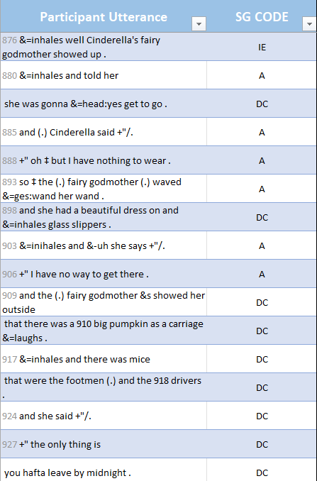
* ***Exception***: If multiple problems are introduced within the same episode (often due to dialogue), it may be unclear if *magic* is still being used. If this is the case, assign of code of A for transformations (turning things into things), even if *magic* was used previously.
  + Example (training participant 17, Episode 2)
  + Example (training participant 25, Episode 2)

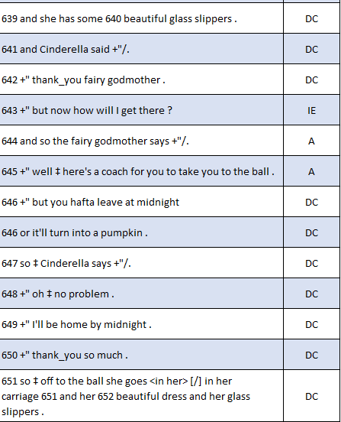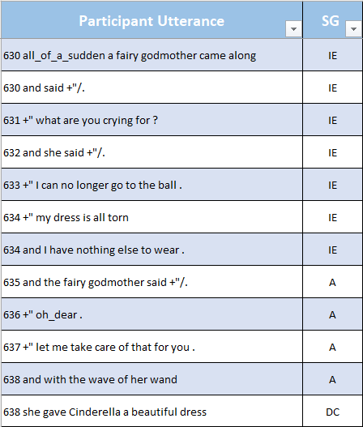

##### Meet Rule:

* Used during the “Ball” episode where Cinderella and the prince fall in love. Participants often say, *Cinderella goes to the ball*, to encompass both leaving and arriving at the ball, which makes it hard to assign one code. As a rule of thumb, going = leaving, so typically a code of DC is assigned for that proposition.
  + If *Cinderella arrives at the ball* (IE), *meeting the prince* is assigned a code of A. Then, everything that follows *meeting the prince* (*falling in love*, *dancing*, *having a wonderful time*) is assigned a code of DC).
    - Example:
      * Cinderella enters the ball. – IE
      * She meets the prince. – A
      * They dance the night away – DC
      * They fall in love – MS/DC
      * They have a wonderful time. – DC
  + If Cinderella does not *arrive at the ball*, *meeting the prince* is assigned a code of IE. Then, the “Chronological/Sequential Rule: (page XX) applies for the rest of the episode.
    - Example:
      * Cinderella meets the prince. – IE
      * They dance the night away – A
      * They fall in love – MS/DC
      * They have a wonderful time. – DC

##### MS Transcending the Period:

* Used to determine if a Mental State code applies to propositions in the next utterance (as decided by the transcriber).
  + A code of MS is assigned to a proposition(s) following an utterance delimiter (period) if it begins with a subordinating conjunction (dependent clause without a main clause) or a fragment.
    - Dependent clauses are clauses that begin with subordinating conjunctions, including: *because*, *that* (*and that*), *while*, *before*, *after*, *if*, etc. Search google for additional examples of subordinating conjunctions!
      * Example where MS transcends the period:
        + The prince wants to find Cinderella. - MS/IE
        + because they spent the whole evening together. – MS/IE

A code of MS is assigned to the dependent clause because it further describes why the prince wants to find Cinderella.

* + A code of MS is *not* assigned to a proposition(s) following an utterance delimiter if it is an independent clause/ begins with a coordinating conjunction
    - Independent clauses can stand on their own and therefore do not carry through an MS code. Independent clauses may begin with a coordinating conjunction (FANBOYS: *for*, *and*, *nor*, *but*, *or*, *yet*, *so*)
      * Example where MS does not transcend the period:
        + Her dream was – MS/S
        + that she would marry the prince. – MS/S
        + And he’d take her away. – S

While this reads like her dream included the prince taking her away, it is not assigned a code of MS. Since it is transcribed as a separate utterance (after a period), it begins with a coordinating conjunction (*and*), and it is an independent clause, MS does not transcend the period.

These propositions provided descriptive, “status quo” information at the beginning of a participant’s transcript, so a code of S was assigned to each.

##### Party Rule:

* Used to determine where setting statements stop and the first episode starts.
  + If Cinderella and/or the family *get an invitation* or *hear about the ball* (IE), everything before that is assigned a code of S.
    - Example:
      * so, he declares – S
      * that there be an invitation sent out to all the homes. – S
      * so that the prince can choose a bride. – S
      * and they get this invitation at Cinderella's house. – IE
      * and Cinderella was so excited about it. – MS/A
  + If Cinderella and/or family do not *get an invitation* or *hear about the ball*, *wanting/planning/announcing/declaring the ball* can be assigned a code of IE.
    - Example:
      * the prince of this little town became of age – S
      * where the father the king wanted him to marry. – S
      * and so, he had one of his servants announce – IE
      * that there would be a ball. – IE
      * and Cinderella was so excited about it. – MS/A

##### Shoe Rule:

* Used to determine DCs vs. IEs between the” running away from the ball” episode and the “prince’s search” episode.
  + If the prince does not *find the shoe*, it suggests that *the prince’s pining over* or *interest in Cinderella* is unrelated to the IE of it being midnight in the “running away from the ball” episode. In this case, *pining*/ *interest* is typically assigned a code of IE in the “prince’s search” episode.
    - Example:
      * It turns midnight. - IE
      * Cinderella runs away - A
      * And loses her shoe. - DC
      * The prince is so interested in this mystery woman. – MS/IE
      * So, he sets out on a search to find her. -IE
  + If the prince does find the shoe, *pining over* or *interest in Cinderella* is causally related to the IE of it *being midnight* and, therefore, is typically assigned a code of DC in the “running away from the ball” episode.
    - Example:
      * It turns midnight. - IE
      * Cinderella runs away - A
      * And loses her shoe. - DC
      * The prince finds the shoe. - DC
      * He is so interested in this mystery woman. – MS/DC
      * So, he sets out on a search to find her. – IE

##### Tense Rule:

* Think about verb tenses when assigning codes as a means of determining whether something has happened or not. If something is a plan (future tense) or in the process of happening (present progressive), this often is assigned a code of A. In contrast, if something already happened (past tense), it often is assigned a code of DC. This rule is especially pertinent in the “going to/arriving at the ball” episode and the “running away from the ball” episode.
  + Example
    - She is going to do it. - A
      * This proposition uses simple future tense (“is going”) and is read like a plan. All plans are assigned a code of A.
    - She is doing it. - A
      * This proposition uses present progressive tense and is read like she is actively carrying out a plan, so a code of A is assigned.
    - She did it. -DC
      * This proposition uses past tense and is read like something has already happened, so a code of DC is assigned.
  + ***Exception***: While tense is generally a good indicator for determining story grammar codes, it is always important to consider a proposition’s context when determining whether tense should inform coding.
    - Example:
      * By the time she gets out of there
        + This is a present tense verb, but the context of the phrase implies that it has already happened. So, a code of DC would likely be assigned (rather than a code of A) based on the context.

### Basic Narrative of Cinderella

The following is a generalized example of a Cinderella retell. Note that the utterances are *not* separated into propositions (as is required in this coding schema), but rather are separated by concepts. The intent of this example is to outline concepts that are often included in a Cinderella retell, along with the codes that are typically assigned to those concepts.

NOTE: These examples should be considered guidelines, not hard and fast rules for assigning codes. It is paramount to honor the way each participant tells the story and code their story according to the way they told it.

| **Cinderella story component** | **SG code** | **Rationale** |
| --- | --- | --- |
| After her mother died, Cinderella’s father got remarried to a woman with two daughters. | Setting (S) | Utterances are coded as S when they function to “set the scene” for a story. In the story of Cinderella, the setting is established through introducing key players, which should always include Cinderella and her stepfamily, and will sometimes include the King and Prince of the Kingdom. The stepfamily’s cruel treatment of Cinderella establishes the status quo for the story and gives us context for the characters’ relationships. Depending on how a participant presents the information, there may also be a setting statement about the King, Queen, and/or Prince. If the participant introduces the royal family independently before introducing the idea of the ball, then it is assigned a code of S (like in this example). |
| When her father leaves/dies, Cinderella is left with her new stepmother and stepsisters. | Setting (S) |
| The stepmother and stepsisters were exceptionally cruel to Cinderella. | Setting (S) |
| They treated her as a servant, making her complete all the household chores. | Setting (S) |
| In this kingdom where Cinderella and her stepfamily lived, there was a king and queen who had a son who had recently come of age. | Setting (S) |
| It was announced that there would be a ball and Cinderella’s family was invited. | Initiating Event (IE) | Once invites have been sent or the ball is announced*, this changes Cinderella’s status quo that has been established through the setting statements. Importantly, the story revolves around Cinderella as the main character, so when coding, always consider how each proposition functions in terms of story grammar with respect to *Cinderella*. This proposition is an IE because it changes Cinderella’s status quo.  *See Party Rule (page XX) |
| The stepsisters and Cinderella are all very excited about the opportunity to go to the ball and meet the prince. | Mental State (MS) and Attempt (A) | “Excited” is a MS term. When phrased this way, the proposition can also be coded as an A, because in this coding schema internal responses and plans are assigned a code of A. Discussing characters’ responses to an IE count as internal responses; discussing something happening in the future almost always counts as a plan. The only exception to the latter is in very specific situations, something happening in the future may be a direct consequence*.  *See Assigning A Codes (page XX). |
| However, Cinderella’s stepmother and stepsisters did not want her to go to the ball and told her she could not go unless she completed a long list of chores first. | Mental State (MS) and Attempt (A) | Because it says the stepfamily did not *want* Cinderella to go to the ball, a code of MS is assigned. Cinderella not being allowed to go to the ball may be discussed in one of two ways (or both, in a more detailed story). If Cinderella is not allowed to go to the ball *unless* she finishes all her chores, both utterances are assigned a code of A. If Cinderella is not allowed to go to the ball (with or without a reason presented), a code of DC is assigned (see below for an example). |
| With the help of her animal friends, Cinderella was able to finish all her chores, and was even presented with a lovely dress the animals had made for her to wear! | Attempt (A) | Participants rarely include this part of the story; however, if they do, it may either 1) be assigned a code of A (Cinderella is attempting to finish all her chores so that she can go to the ball in the future, which would be her DC), or 2) be included as an embedded episode with its own IE, A, DC sequence (e.g., Cinderella needed a dress to wear to the ball (IE), so her animal friends made a dress for her (A) and gave it to her (DC) after she finished her chores. |
| Upon seeing Cinderella in her new dress, the stepsisters became filled with rage and tore her dress and jewelry apart. | Mental State (MS) andDirect Consequence (DC) | The stepsisters’ “rage” is an MS term, and should be coded as MS. The other SG code assigned depends on how the information is presented. If (as in this story) there is an attempt on Cinderella’s part (making the dress), then the listed proposition would be assigned a code of DC (direct consequence of Cinderella making the dress). |
| Cinderella was left in tatters and could not go to the ball. | Direct Consequence (DC) | Cinderella not being able to go to the ball is always a DC, regardless of whether it is because her dress is ruined, because she didn’t get all her chores done in time, or because her stepfamily tells her she “can’t go” or “can’t go because X.” |
| The stepmother and stepsisters left for the ball without Cinderella. | Direct Consequence (DC) | The stepmother and stepsisters leaving for the ball is nearly always assigned a code of DC, as an extension of them destroying her dress (so she can’t go) and as a resolution to the IE of the ball invitation. |
| Cinderella, left alone in the garden in her ruined dress, sobbed into her arms. | Direct Consequence (DC) *as well as* Mental State (MS) | Any mention of Cinderella’s emotions, which includes mention of her crying (because *crying* is indicative of an emotional state), is assigned a code of MS. In this case, she is also crying because she was left behind, meaning a code of DC should be assigned*.  *See Crying Outdoors Rule (page XX). |
| Suddenly, in a burst of light, a fairy godmother appeared. She told Cinderella she was there to fix everything. | Initiating Event (IE) | The fairy godmother appearing is always assigned a code of IE, as it always changes Cinderella’s status quo. |
| With a flick of her wand, the fairy godmother turned a large pumpkin into a carriage, and several of Cinderella’s animal friends into horses to pull it and footmen to drive it. | Attempt (A) *AND/OR* Direct Consequence (DC) | If a proposition is phrased as the fairy godmother *using her wand/magic* to transform/ make something, the *wand/ magic use* is assigned a code of A, and the resulting transformations are assigned a code of DC. If a *wand/magic/spell* is not mentioned in the transformation, the proposition is assigned a code of A*.  *See Magic Rule (page XX). |
| The fairy godmother then used her wand to make Cinderella a beautiful, sparkling gown and glass slippers. | Attempt (A) *AND/OR* Direct Consequence (DC) |
| As Cinderella was about to leave in the coach, the fairy godmother warned her that the spell would only last until midnight, so she had to be sure to be home before then. | Direct Consequence (DC) | In this example, the future event that is mentioned is not a plan, so a code of A should not be assigned. Instead, the fairy godmother is warning Cinderella of what the consequences will be in the future if she doesn’t leave the ball on time. This proposition is a DC of the magic the fairy godmother performed to allow Cinderella to go to the ball. |
| Cinderella headed off to the ball in the coach. | Direct Consequence (DC) | If phrased as Cinderella *leaving*, a code of DC should be assigned because it resolves the IE of the fairy godmother helping her go to the ball. If phrased as Cinderella *arriving*, a code of IE should be assigned because it changes Cinderella’s status quo by starting the “ball” episode. |
| When Cinderella entered the ball, she met the prince. | Initiating Event (IE) | As stated above, Cinderella *arriving at the ball* is typically assigned a code of IE. If she does not first *arrive at/enter the ball*, *meeting the prince* can also be assigned a code of IE. However, if both *arriving* and *meeting* are mentioned, then a different set of rules apply*.  *See Meet Rule (page XX). |
| The prince asked her to dance, and he and Cinderella spent the entire evening dancing and talking. | Attempt (A) | Generally, whichever comes first in this episode is assigned a code of A*. The prince may fall in love with Cinderella at first sight (A), *so* he dances with her (DC).  *See Chronological/Sequential Rule (page XX). |
| The prince and Cinderella fell in love with one another over the course of the evening. | Direct Consequence (DC) and Mental State (MS) | *Falling in love* is a MS term, and is assigned a code of MS. Assigning additional story grammar codes (A/DC) will depend on the order of event presentation*, but *falling in love* is often presented as a Direct Consequence (of dancing).  *See Chronological/Sequential Rule (page XX). |
| Cinderella, however, had let herself lose track of time. When the clock struck midnight, she realized she had to leave immediately. | Initiating Event (IE) *as well as* Mental State (MS) *OR* Direct Consequence (DC) | *Realized* is a MS term, and is assigned a code of MS. The *clock striking midnight* is a change in status quo, so it should be assigned a code of IE – unless there is reference to the Fairy Godmother, in which case it is assigned a code of DC (for drawing the “Fairy Godmother” episode to a close*).  *See Fairy Godmother Rule (page XX) |
| Cinderella ran down the stairs, the prince giving chase. | Attempt (A) | Cinderella *running away from the ball* is almost always assigned a code of A. If the participant mentions the prince chasing after her, that is also assigned a code of A. |
| As Cinderella ran, one of her glass slippers fell off on the stairs. | Direct Consequence (DC) | This proposition is causally related to this episode’s IE (*the clock striking midnight*) and A (*running down the stairs*) – because Cinderella is in such a hurry to leave, she loses one of her slippers. |
| The prince found Cinderella’s slipper. | Direct Consequence (DC) | This proposition is not consistently included, but is typically assigned a code of DC, as it is causally linked to Cinderella’s A (*running down the stairs*)*.  *See Shoe Rule (page XX) |
| As she ran, her clothes became ragged and worn once again, her carriage returned to its former pumpkin state, and her footmen and horses were back to being little mice. | Direct Consequence (DC) | These propositions should be assigned a code of DC, as all are causally linked to Cinderella’s A (*running down the stairs*). If phrased as what happened following her running away, it is a DC of the “running from the ball” episode. If phrased as a condition (what *would* happened; e.g., at midnight, her carriage would turn back into a pumpkin), these propositions could be drawing the“fairy godmother” episode to a close (i.e., as part of the fairy godmother’s warning). |
| Cinderella returned to her life as a servant to her stepmother and stepsisters. | Direct Consequence (DC) | Any mention of Cinderella returning to her normal life or any “fallout” from the ball is causally linked to her going to the ball and then running away, so a code of DC would be assigned. |
| The prince, determined to find the girl he’d already fallen in love with, began a door-to-door search of the kingdom. | Initiating Event (IE) and Mental State (MS) | *Falling in love* is a MS term, and should be assigned a code of MS. The prince (or any royal servant/advisor) beginning the search for Cinderella is typically assigned a code of IE, as it introduces a new (potential) change in Cinderella’s life*.  *See Code from Cinderella’s Perspective (page XX). |
| The prince arrived at Cinderella’s house. | Initiating Event (IE) | The prince arriving at Cinderella’s house is a change in the status quo and, therefore, is typically assigned a code of IE. |
| Cinderella was quickly locked in her attic bedroom by the wicked stepmother. | Initiating Event (IE) | This proposition is rarely included, but would likely be assigned a code of IE, as it represents a new problem for Cinderella. If included, this often gets numbered as a separate, embedded episode within the “prince’s search” episode. |
| Each stepsister was told to try on the glass slipper; if their feet fit, it meant they were the one the prince was looking for. | Attempt (A) | In some cases,these propositions would be considered a plan, where plans are assigned a code of A in this coding schema. Anyone trying on the slipper at Cinderella’s house is also typically assigned a code of A. |
| The stepsisters’ feet were too large to fit into the dainty slipper. | Direct Consequence (DC) | This proposition is assigned a code of A if *they are trying on the slipper*, and a DC if *the slipper does not fit*. |
| Cinderella’s mice friends broke her free from the prison. | Attempt (A) or Direct Consequence (DC) | Again, this proposition is rarely included. A code of A or DC could be assigned, depending on the specific story context. Further, this proposition would be assigned the same episode number as *Cinderella being locked up*. |
| Cinderella came down the stairs. | Initiating Event (IE) | If this is included in the story, it is assigned a code of IE as it reintroduces Cinderella – a change in the status quo. It also is typically assigned a new episode number. |
| Cinderella tried on the slipper. | Attempt (A) | Anyone *trying on the slipper* at Cinderella’s house is assigned a code of A. |
| The slipper slid easily onto Cinderella’s foot, and the prince knew she was the one he’d fallen in love with. | Direct Consequence (DC) *and*Mental State (MS) | “*Knew*” is a MS term, so a code of MS should be assigned. If Cinderella’s identity is revealed and/or the slipper fits, a code of DC should be assigned. |
| The prince whisked Cinderella off to the castle to get married. | Conclusion (C) | These two concepts are different from an episodic DC, because they wrap up the entire story. Therefore, these propositions are always assigned a code of C. |
| They lived happily ever after. | Conclusion (C) |

# Story Grammar Episodes

## Background

For an episode to be considered complete, it must consist of an Initiating Event, Attempt, and Direct Consequence that are directly related to one another. Mental States and Setting statements may be included within an episode but are not considered to be critical elements to episodic structure. Three potential relations exist to connect both elements within episodes and to connect episodes to one another. These relations are “and”, “then”, and “cause”.

The “and” relationship labels components or episodes as being related, without attributing cause and effect or establishing a linear temporal relationship. The “and” relationship is often used in setting statements to connect habitual actions or behaviors. It can also be used to connect multiple attempts, initiating events, and/or direct consequences. (e.g., “the fairy godmother turned the pumpkin into a carriage *and* turned the mice into horses” – both would be coded as attempts). The “and” relationship can also describe two episodes that are happening simultaneously, although the participant may use words like “meanwhile” to describe this relationship.

The “then” relationship labels components as being temporally related. There is not necessarily cause attributed to the connected elements or episodes, but there is a clear order that the elements or episodes follow. “Cinderella and the prince danced together and fell in love. *Then*, the clock struck midnight.” This is a relationship that connects two episodes together, with “danced together” coded as an attempt and “fall in love” coded as a direct consequence for the same episode. The *then* relationship connects these elements temporally to the initiating event for the next episode: “the clock struck midnight”.

The “cause” relationship is the one present the most within episodic structure but can also exist to connect two episodes. *Because* Cinderella ran down the stairs and left the ball (leaving her slipper behind), the prince must search the kingdom for her. This demonstrates two episodes with a causal relationship.

This can make telling the difference between causally linked episodic elements that make up one episode hard to distinguish from causally linked episodes. It is important to remember that any change in the status quo (caused by outside forces or by a character) that causes a response by another character and results in some sort of action or result is a complete episode. It is also important to note that episodes can be embedded within other episodes. For example, some participants will tell the fairy godmother episode without mentioning the consequences for Cinderella not arriving home by midnight, but will bring it back up later, after the ball episode is completed, by saying that the fairy godmother had warned her the spell would end at midnight. This makes the ball episode an embedded episode within the fairy godmother episode.

## Episode Coding Rules

### General:

For an episode to be considered complete, it must consist of at least one of each of the following basic elements: Initiating Event (IE), Attempt (A), and Direct Consequence (DC), with all directly relating to one another. Mental States (MS) and Setting (S) statements may be included within an episode, but are not required for an episode to be complete. In other words, MS and S codes are not considered critical elements to the episodic structure.

### Numbering

Episodes should be assigned a number based on the order of their appearance within the story. The numbers are assigned to track the total number of episodes, regardless of completeness. Therefore, an episode should receive a number assigned to it regardless of its completeness or complexity. The episode that occurs first after the initial setting statement should be assigned the number 1, the next episode 2, and so on.

In numbering, it is important to note that participants do not always tell episodes in order.

### Labeling Types

On the last line of a given episode, the episode should be assigned an *episode type* code. The figure below illustrates the hierarchy for identifying and assigning an episode type code.

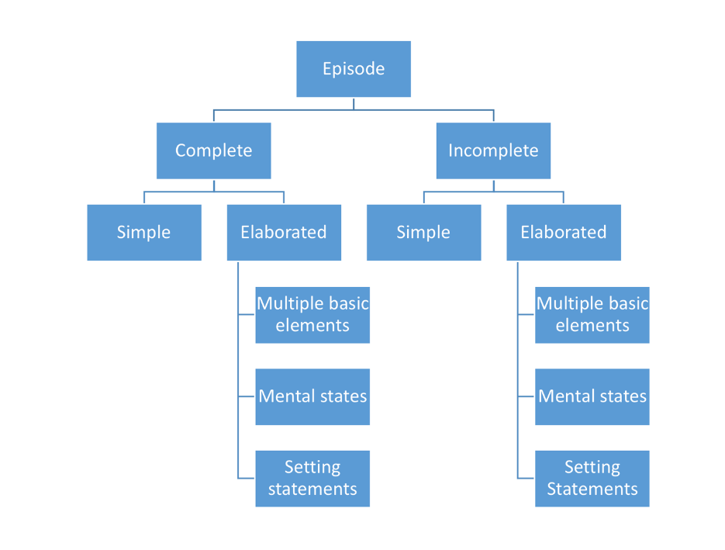

* An episode may be complete or incomplete.
  + Complete episodes have at least one initiating event (IE), at least one attempt (A), and at least one direct consequence (DC)
  + Incomplete episodes lack at least one of the three basic elements (IE, A, DC).
* An episode may be simple or elaborated.
  + A *simple complete episode* has one IE, one A, and one DC. This is the basic structure of an episode.
  + A *simple incomplete episode* lacks one of the basic elements, but has a single proposition coded as one or both of the other two basic elements (e.g., the episode has one IE and one A, but no DC).
  + *Elaborated episodes* include one or more of the following types of elaboration:
    - Multiple Basic Elements (MB): the episode has more than one IE, more than one A, and/or more than one DC.
    - Mental States (MS): one or more of the episode’s propositions were assigned a code of MS.
    - Setting Statements (SS): one or more of the episode’s propositions were assigned a code of setting (S).

*Elaborated episodes* can include more than one type of elaboration. For example, a participant’s episode could include multiple IEs, one A, one DC, and one MS. This episode would be coded as Elaborated-Complete, with Multiple Basic elements and Mental States (**EC-MB, MS**). A complete list of possible *episode type codes* may be found below.

#### List of Episode Type Codes

* Simple Complete: [Ep#: SC]
* Elaborated-Complete (multiple basic elements): [Ep#: EC- MB]
* Elaborated-Complete (mental states): [Ep#: EC- MS]
* Elaborated-Complete (setting statements): [Ep#: EC- SS]
* Elaborated-Complete (multiple basic, mental states): [Ep#: EC- MB, MS]
* Elaborated-Complete (multiple basic, setting statements): [Ep#: EC- MB, SS]
* Elaborated-Complete (mental states, setting statements): [Ep#: EC- MS, SS]
* Elaborated-Complete (multiple basic, mental states, setting statements): [Ep#: EC- MB, MS, SS]
* Simple Incomplete: [Ep#: SI]
* Elaborated-Incomplete (multiple basic elements): [Ep#: EI- MB]
* Elaborated-Incomplete (mental states): [Ep#: EI- MS]
* Elaborated-Incomplete (setting statements): [Ep#: EI- SS]
* Elaborated-Incomplete (multiple basic, mental states): [Ep#: EI- MB, MS]
* Elaborated-Incomplete (multiple basic, setting statements): [Ep#: EI- MB, SS]
* Elaborated-Incomplete (mental states, setting statements): [Ep#: EI- MS, SS]
* Elaborated-Incomplete (multiple basic, mental states, setting statements): [Ep#: EI- MB, MS, SS]