Edmonton Narrative Norms Instrument (ENNI)

Phyllis Schneider1, University of Alberta
Rita Vis Dubé, Calgary
Denyse Hayward, University of Alberta
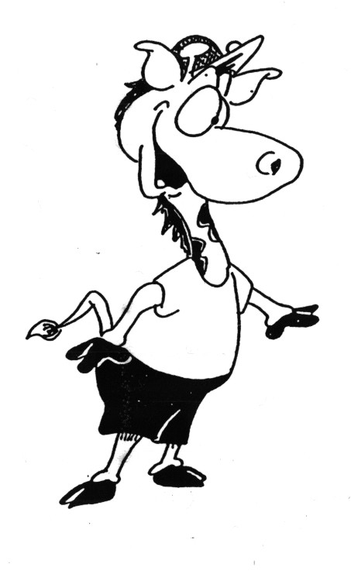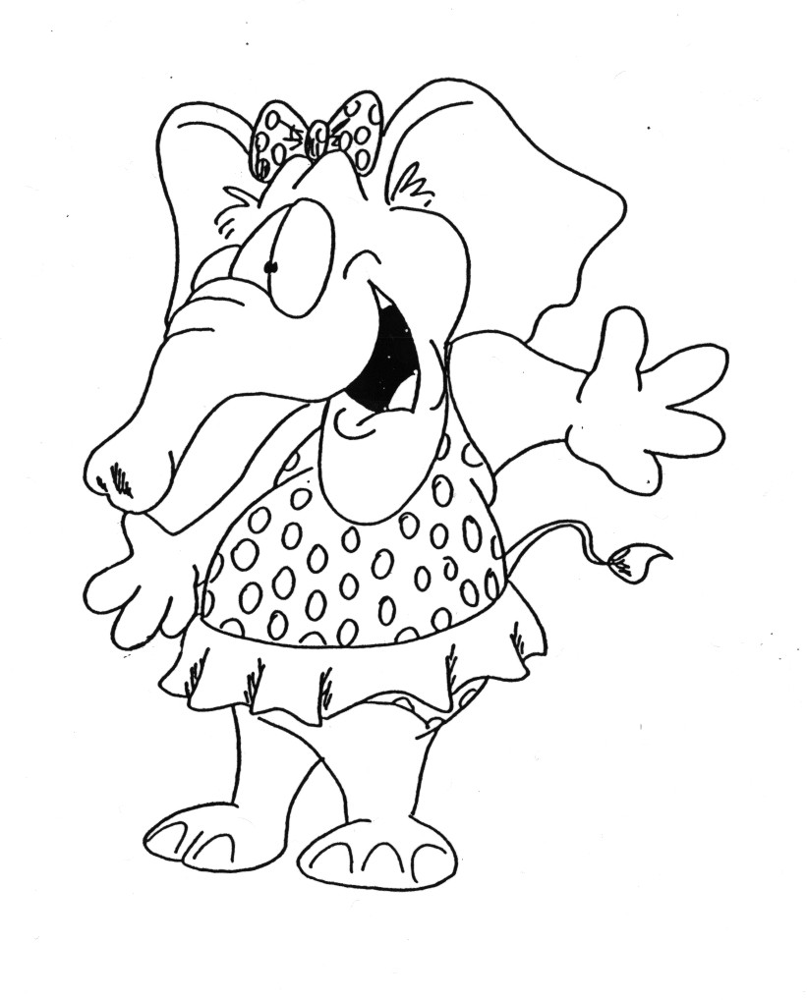
The ENNI was developed with the assistance of a grant from the
Children's Health Foundation of Northern Alberta.
The ENNI is an assessment tool for collecting language information from children aged four to nine years old through storytelling. Pictures that portray a story are presented to a child, who then tells the story to the examiner. Picture sets were drawn by a professional cartoonist; they range from a simple story with two characters to a complex story with four characters.
Local normative information was collected from 377 children in Edmonton, Canada. Norms from this sample are included for a number of analyses, including story information, referring expressions, and standard language analyses such as number of different words, mean length of communication unit, and subordination index. The manual provides information on the rationale for the ENNI, development of the pictures, the normative sample, the norming procedure, and administration instructions.
The ENNI is copyrighted, including the pictures and all other materials. You are welcome to download, print, and use any of the materials for clinical, educational, or research purposes. None of the ENNI materials may be altered in any way or included in publications without permission from the first author.
When citing this website, please use the following format:
Schneider, P., Dubé, R. V., & Hayward, D. (2005). The Edmonton Narrative Norms Instrument. Retrieved from University of Alberta Faculty of Rehabilitation Medicine website: www.rehabresearch.ualberta.ca/enni.

