Story Grammar
Stories are coded for the information that they contain that correspond to a story grammar (SG) unit. SG units are units of information that are characteristic of stories judged by adults and children to be "good" stories (Stein & Policastro, 1984). (See the first section of the Manual for a more complete explanation of the Story Grammar model.) The analysis uses only Story A1 and Story A3. The basic units are described below.

Story Grammar Scoring Sheets
- Story A1 (two-character story)
- Story A3 (four-character story)

Story Grammar Normative Tables
- Story A1
- Story A3

Instructions for Scoring Story Grammar

Story Grammar
Stories are coded for the information that they contain that corresponds to a story grammar (SG) unit. SG units are units of information that are characteristic of stories judged by adults and children to be "good" stories (Stein & Policastro, 1984). The basic units are described below.

Story Grammar Units
Setting
- Characters in the story
- Location, activity, and/or habitual state or characteristic ('he was always hungry'; 'she liked to read')
- Initiating Event [IE] -- event that sets off the story's events -- will cause the protagonist to respond in some way, evokes an immediate response
- Internal Response [IR] -- reaction of protagonist to the initiating event. It can be expressed in dialogue, e.g., oh no! expresses an internal response
- Internal Plan [IP] of protagonist to deal with the IE
- Attempt [ATT] to obtain the goal
- Outcome or Consequence of the attempt
- Reaction [R] -- how the character(s) feel or think about the outcome, or how they react physically (e.g., run away)
In the ENNI, stories A1 and A3 have been analysed for Story Grammar (Schneider, Hayward, & Dubé, 2006). The Story Grammar scoring sheets specify what should count as each unit in these stories.
An important aspect of Story Grammar is the notion of goal-directed activity. Thus many of the units are coded with regard to goal-directedness. For example, a character may have an emotion at any time in the story; it is only scored as Internal Response if it is related to the Initiating Event of the story (even if the child does not provide the IE), or as a Reaction if it is a reaction to the Outcome (again, even if not explicitly stated by the child). If it is an emotion that occurs elsewhere, it is not scored.
Three SG Units are considered to be "core" units: Initiating Event, Attempt, and Outcome. For this reason they are scored 2 points rather than 1.
The reason for using Story Grammar is to capture the elements that need to be included in the story for it to be considered an adequate story. The concern is whether or not a child is telling a story that will be understandable to the listener. Some children may tell stories that include much more detail; while these might be preferred on esthetic grounds over simpler stories, the score may not turn out to be higher for such stories because the scoring focus is on basic SG information.
Note that the emphasis is on relating what the child says to the scoring system. You may feel that a unit is actually being used as a different SG unit than the one in the scoring sheet (e.g., what we call "setting" is functioning as IE in the child's story). However, it should still be scored as it is listed on the scoring sheet.
The scoring sheets for each story give typical acceptable responses for each SG unit. The list is not exhaustive. If another response is given credit, note it down.

Scoring conventions for particular SG units

Characters
Give credit if a noun (not a pronoun) is used to mention a character for the first time, regardless of the noun chosen. Proper nouns are acceptable. The only pronoun that is acceptable is if the child puts him/herself into the story and uses I/me, as in: "Me and the elephant were by the pool one day".
Score wherever the character is first mentioned, even if late in the story.

Distinguishing IP from Attempt
IP is an indication of planning, e.g., the character decides to... or thinks he will....
Attempt is an indication of action to attain the goal, including movement towards the action, e.g., the character tries to...., goes to...., is going to.....
Internal Response and Reaction: Accept any plausible emotion or response, as long as it is a response to an IE (for IR) or outcome (for Reaction). The IE or Outcome do not have to be provided for the child to get credit for IR or Reaction. Emotions can be inferred from speech; for example, She said, Oh no! implies that a character is upset.
There could be other emotions or responses that occur in other parts of the story; for example, the elephant could be worried that the giraffe will drown when getting the ball. That does not get credit for any story grammar element.

General scoring conventions

Scoring very 'sketchy' transcripts: Keep in mind that you are scoring the stories as expressive language samples, not as a comprehension task. Therefore the child should get credit for a story grammar unit only if the listener would be able to understand. If a child has provided incomplete units, judge them according to whether a listener could understand them without knowing the story or seeing the pictures. For example, if a child says "bouncing" for the first picture, do not give it credit as setting, since there is not enough information. However, if a child says "happy" or "thank you" at the end of the story, give credit for Reaction, since it is at least clear that someone is happy or grateful.
Scoring utterances with unclear referents: If a child provides something that qualifies as a story grammar unit but it is not clear which character was involved, generally you can still give credit for the unit. For example, if a child says, "he jumps in the water to get it", without having previously mentioned the giraffe, you can give credit for Attempt. Even if the child does not use a pronoun (e.g., "jumps in water"), you can still give credit for Attempt without any indication of who made the attempt. (Of course, if you are scoring for a character, then a pronoun is not normally acceptable - see above.)

Scoring Examples
Below are some examples of Story Grammar scoring. We would recommend that you try scoring the stories and then compare your scoring to ours.
- Bob's Story A1
- Bob's Story A3
- Jean's Story A1
- Jean's Story A3

Scoring Examples
Below are some examples of Story Grammar scoring. We would recommend that you try scoring the stories and then compare your scoring to ours.
- Bob's Story A1
- Bob's Story A3
- Jean's Story A1
- Jean's Story A3
"Bob", aged 4;8 (typically developing child)
- C Once a horse met elephant.
- C And then they saw a ball in a pool.
- C And then the horse tried to swim and get the ball.
- C And (the) then the elephant gave him the ball.
- C And then the horse was wet.
- C And the elephant was holding the ball.
- C The end.
Below is the scoring sheet for Bob's A1 story. He scored seven points, which earns a standard score of 10 (right at the mean for his age group). Bob earned points for the characters, initiating event, attempt, and reaction for character 1 (giraffe). He was not given the points for outcome because he said that the elephant gave the ball to the giraffe, which is not a logical outcome of the giraffe trying to get the ball. He also is not given credit for a Reaction for the elephant, because merely holding the ball is not counted as a reaction. He does not have an internal response or plan, but it is typical of younger children to leave them out. Overall, Bob's story is typical for a four-year-old.
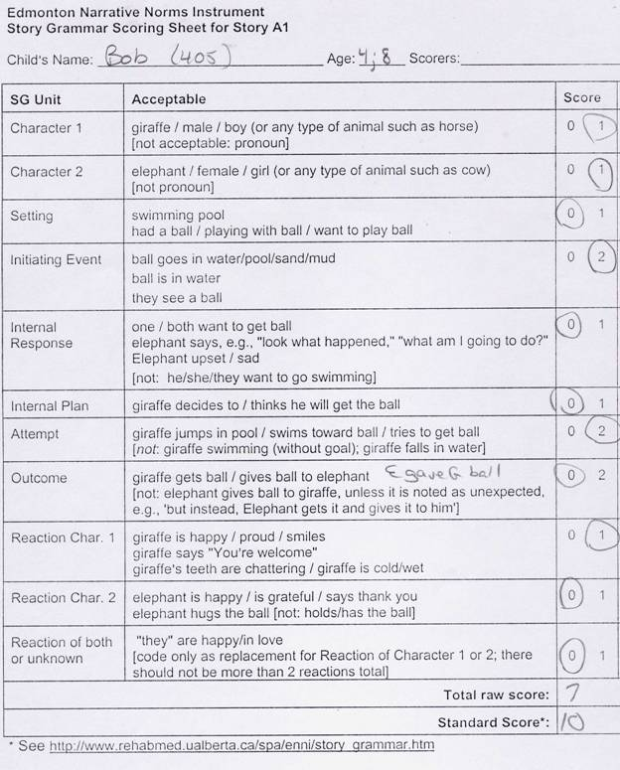

"Bob", aged 4;8 (typically developing child)
(: indicates a pause; [!] indicates emphasized word)
- C Once : that horse : and elephant was happy near the swimming pool.
- C (Oh) and then the horse had an airplane to play with : (a) which : had (ss : ah) something coming down : the bottom.
- C And the elephant went like this [gestures plane movement].
- C Then he[!] tried it.
- C And the horse went like this [gestures again].
- C Then they put it : in the water.
- C And then the elephant went like this [gestures again].
- C And then the horse was mad.
- C And then the lifeguard went like this [shaking finger to indicate disapproval].
- C Then the elephant talked to him a little bit.
- C And then : the lifeguard tried to : get it.
- C But he could not.
- C And the horse cried.
- C (an :) and then a elephant with a net came.
- C And she caught[!] it.
- C And then she gave it back to the horse.
- C And : then the horse went like this [moves arms and shoulders vigorously].
- E What does that mean?
- C They love it.
- E oh, good.
- C And the end.
Scoring for Story A3 is shown below. He received credit for most core Story Grammar units (Initiating Event, Attempt, and Outcome). An exception is in Episode 2, in which he gets credit for Character 3 but not for the Initiating Event, because the character does not arrive but is just suddenly participating in the scene. He got credit for the Initiating Event ("he[!] tried it") because he had indicated the giraffe's flying of the plane (nonverbally) and then emphasized "he" to indicate a reference switch to the other character. He is not given credit for a final Reaction ("They love it") because it is in response to a clarification request by the Examiner (which she should not have made). His statement and gesture before that were not interpretable as a Reaction. Again, he does not include Internal Responses or Plans, which is typical for his age. Bob had a raw score of 23, which yielded a standard score of 13 - one standard deviation above the mean for 4 year olds
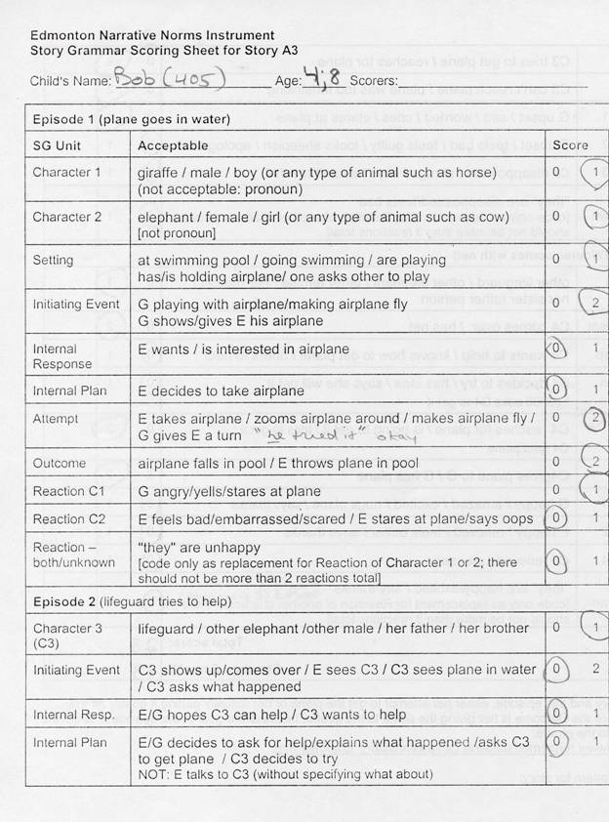
"Jean", age 4;7 (child with language impairment)
At the time of the ENNI normative data collection, Jean was attending a special preschool program for children with language delays. On the CELF-P, Jean scored 83 on Receptive Language, 65 on Expressive Language, and 72 on Total Language.

- C Is playing bubbles.
- C it big bubbles coming.
- C is throw them down.
- C is : say thank you.
- C happy.
- C the end.

Scoring for Jean's Story A1 is on the following page. Jean was given credit for the Setting, despite her using the term "bubbles" rather than "ball". She was also credited with the Reaction of Character 2, even though we do not know exactly who said "thank you" to whom. No other credit was given. She does say that something is thrown down, but this is not clearly equivalent to something going into the pool, so it is not given credit. Her raw score of 2 is equivalent to a standard score of 5, which places her story at about 1.6 standard deviations below the mean.

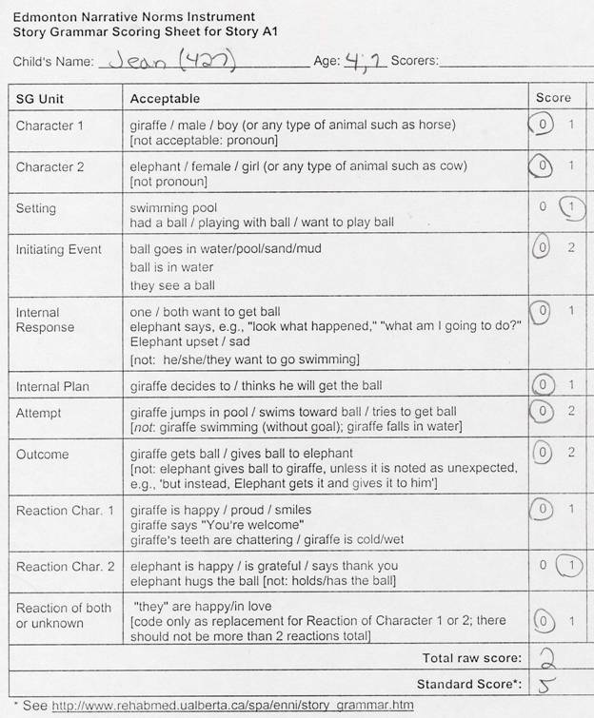

"Jean", age 4;7 (child with language impairment)
- C Is happy.
- C is playing.
- C is like it.
- C (it bro) it's under the water.
- C say : [makes growling sound] I : mad.
- C because : hmm.
- C what did it (um) you.
- C is : screaming.
- C is do it.
- C can't do it.
- C I : got it.
- C [makes growling sound] I got it.
- C thank you.
- C so happy.
- C the end.
Scoring for Jean's Story A3 is similar to the scoring for A1. She received points for Setting ("is playing") and two Reactions ("I mad", "thank you…so happy"). While she seems to be trying to express the Initiating Event ("it's under the water"), she was not given credit for this unit because the plane was never mentioned and thus it is not clear to a naïve listener what happened. Jean's raw score of 3 is equivalent to a standard score of 3, more than 2 standard deviations below the mean for 4 year olds.
