PERMISSION TO DISTRIBUTE TRANSCRIPT DATA
THROUGH TALKBANK
Carnegie Mellon University

Carnegie Mellon University is participating in a data-sharing program known as TalkBank that was established through federal and foundation grants to Brian MacWhinney at Carnegie Mellon. For the program to function properly, contributors will be asked to and will give permission for their work to be made available to other researchers. With a full understanding of the aforementioned, I hereby give permission to TalkBank to make and circulate electronic copies of the language transcripts and media that I describe below. These copies may be distributed to scholars and other responsible parties. I warrant that this use of the data is in accord with Human Subjects review procedures at my institution and that participants have given informed consent to have their data available to researchers. I also warrant that there is no copyright restriction over the transcripts and media being circulated. Any further restrictions that I wish to place on the use of these data are listed under (2) below. I do not hold Brian MacWhinney or Carnegie Mellon responsible for the enforcement of these further restrictions and indemnify and render harmless both Brian MacWhinney and Carnegie Mellon University against any actions at law or in equity or in similar courts of any jurisdictions arising from violations of these restrictions.

- General description of the data set, and IRB Approval # (if available): The data set documents a single-subject longitudinal case study of a highly educated bilingual (Chinese-English) woman with Primary Progressive Aphasia from late 2004 through May 2007, including the videotapes of ten testing-and-interview sessions, the English and Chinese language test data from eight sessions, transcripts of the production sections of the language tests (Naming, Cookie Theft narrative, personal narratives, etc.), medical records, e-mail correspondence between the participant and the team members, and other documents including the participant’s published autobiography. Supplementary materials include the refereed publications resulting from the study.

The medical school does not require IRB approval of single-case studies. This study was initiated by the participant and was conducted in accordance with strict ethical standards by experienced clinicians, with analyses carried out by the clinicians or assistants working under their direct supervision.

2. Restrictions to be placed on the use of the data: No restrictions are placed on the use of these data (Access Level 1), except that any medical records must be under general password protection (Access Level 6) and made available only to bona fide research teams that include a qualified M.D. as participant or consultant.

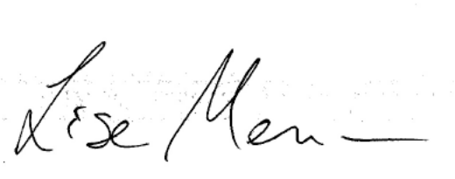
Signed _____________________________ __ Date ___7 December 2021______

Printed Name ______Lise Menn___ Institution __U. of Colorado/Boulder_

Please mail this signed form to: Brian MacWhinney, CMU-Psychology, 5000 Forbes Ave. Pittsburgh, PA, 15213, USA or send a scanned signed copy to macw@cmu.edu

