PERMISSION TO DISTRIBUTE TRANSCRIPT DATA
THROUGH TALKBANK
Carnegie Mellon University

Carnegie Mellon University is participating in a data-sharing program known as TalkBank that was established through federal and foundation grants to Brian MacWhinney at Carnegie Mellon. For the program to function properly, contributors will be asked to and will give permission for their work to be made available to other researchers. With a full understanding of the aforementioned, I hereby give permission to TalkBank to make and circulate electronic copies of the language transcripts and media that I describe below. These copies may be distributed to scholars and other responsible parties. I warrant that this use of the data is in accord with Human Subjects review procedures at my institution and that participants have given informed consent to have their data available to researchers. I also warrant that there is no copyright restriction over the transcripts and media being circulated. Any further restrictions that I wish to place on the use of these data are listed under (2) below. I do not hold Brian MacWhinney or Carnegie Mellon responsible for the enforcement of these further restrictions and indemnify and render harmless both Brian MacWhinney and Carnegie Mellon University against any actions at law or in equity or in similar courts of any jurisdictions arising from violations of these restrictions.

1. General description of the data set, and IRB Approval # (if available):

The TCD corpus in SLABank includes transcripts with audio and video of child learners of French in Paris 1982.

2. Restrictions to be placed on the use of the data:

Signed 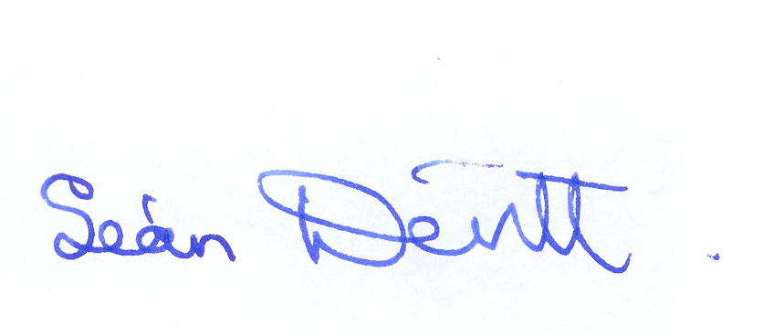 ___Date __November 16 2020________________

Printed Name _Seán Devitt Professor emeritus ______________________ Institution University of Dublin, Trinity College._______________________

Please send a signed copy to macw@cmu.edu or mail to: Brian MacWhinney, CMU-Psychology, 5000 Forbes Ave. Pittsburgh, PA, 15213, USA

